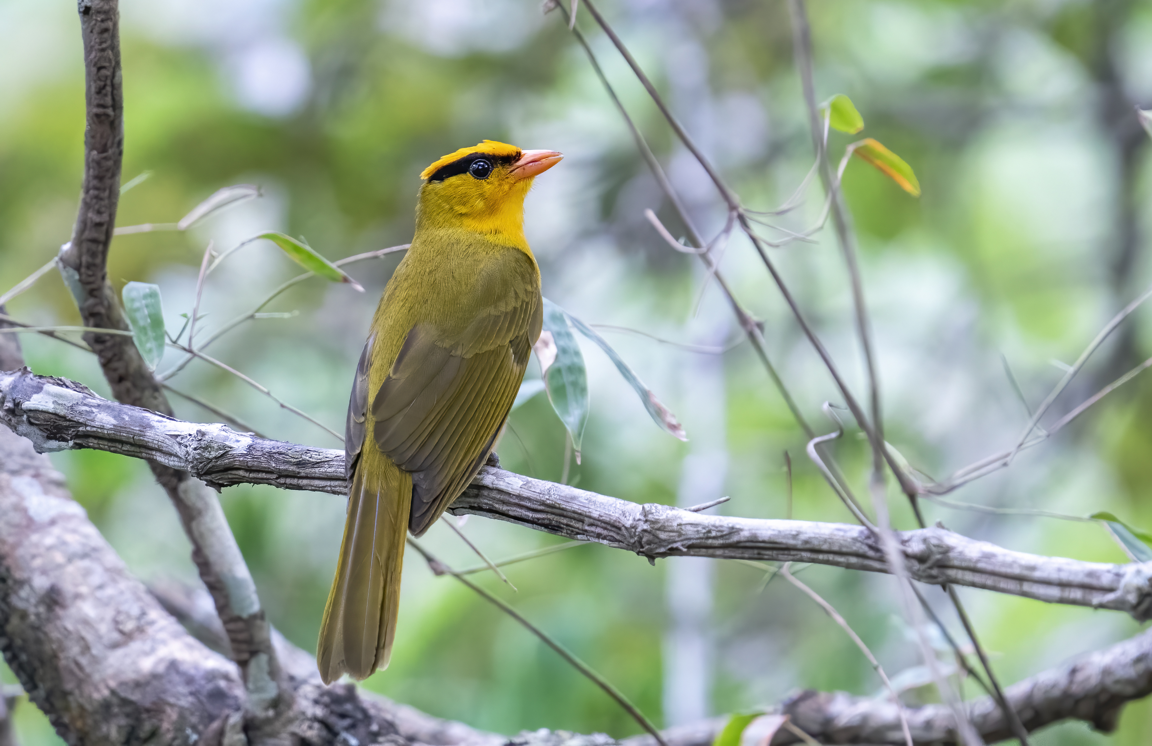
Introduction
About us
Bird & Mammal Trip Report Bolivia
(Jul - Oct 2022 & Sept 2023)

Rob Jansen
Romy Jansen-Houtzager

Birds and Mammals report
(COUNTRY) 2019
We are two enthusiastic nature lovers who travel the world together to search for stunning birds, fascinating mammals and incredible nature. Our world travel started in October 2021 in Chile, where we bought a car to drive through South America in search of birds and mammals for about 2 years.
Rob Jansen is biologist and wildlife photographer, and thus has a lot of knowledge about species and ecology. He is enthusiastic about all that’s in nature, but mainly photographs birds and mammals.
Romy Jansen-Houtzager is marketing professional. Our social media accounts, the look and feel of this report and the website are her work. In the field, she is an excellent spotter and very patient (give me some of her patience …and hurry!).

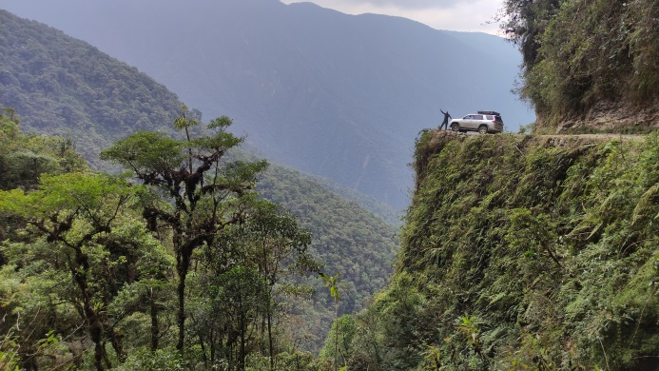 | 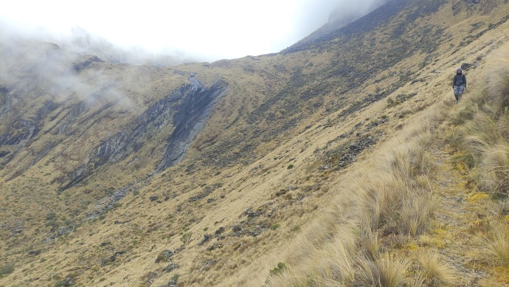
Rob with Forrest on the Death Road | Romy walking the trail in Pongo Valley

Information and how to use this trip report
This trip report covers the country Bolivia, mostly focussing on the region between Santa Cruz and La Paz, including El Beni region. We travelled this part in about 2.5 months from the 26th of July until the 12th of October 2022, including about 2 weeks of rest in hotels (so ±2 months birding). In September 2023 we passed again through Bolivia, this time visiting some places in the far north (around Cobija and Riberalta). For all photos of our Bolivia trip, comments, compliments, any specific questions, visit and/or contact us via our website. We would love to hear from you!
www.robjansenphotography.com/bolivia www.instagram.com/robjansenphotography

Species are highlighted in this trip report: blue for birds, red for mammals and green for herpetofauna. Target species which we missed at a specific spot are written in italic. This gives you an idea which species to pay extra attention to. All observations made by us in Bolivia can be found on Observation.org. We observed a total of about 836 bird species and 47 mammal species in Bolivia. Click here for the: total bird list, total mammal list or the total species list.

For more trip reports see our website: www.robjansenphotography.com/trip-reports
Map and specific locations

Map 2022
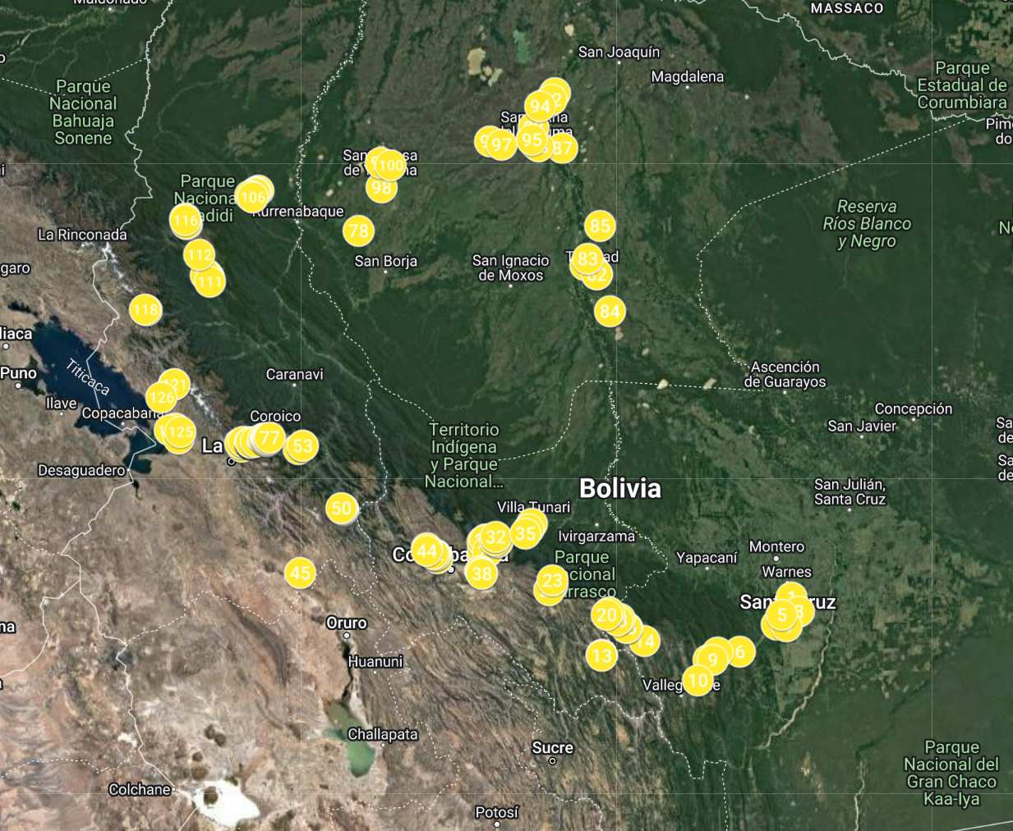
Riberalta & Cobija
Apolo – Machariapo Valley
Madidi NP
La Palizada – Comarapa (R7)
Aten
Sorata
La Paz Region
Apa Apa Reserve
Lake Titicaca
Cochabamba
Inquisive
Chapare Road (R4)
Red-fronted Macaw Cliff
Samaipata Region
Refugio Los Volcanes
Santa Cruz
Oriente de Yacuma
Santa Rosa de Yacuma
Trinidad Region

Map 2023
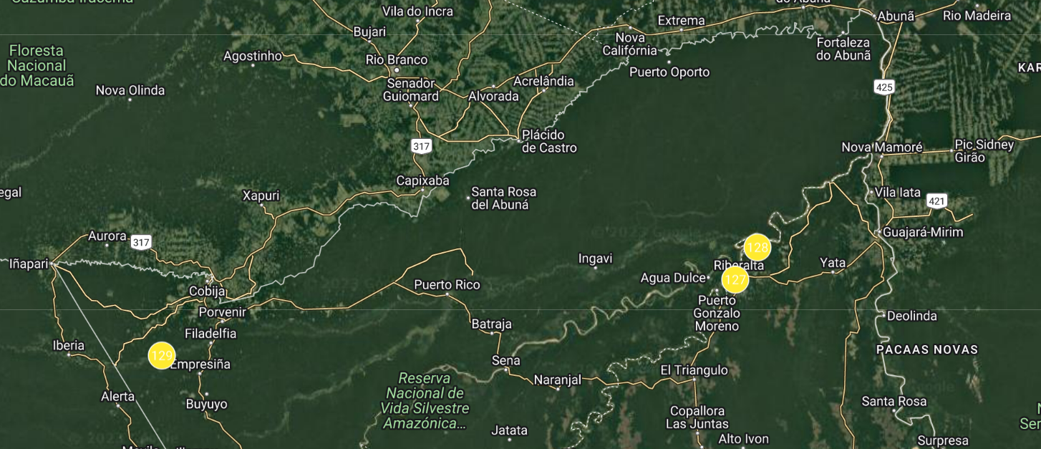
Cobija - Tahuamanu Station
Riberalta

After bird- & mammalwatching large parts of Chile, Argentina, Brazil and Paraguay (see previous trip reports), we decided to cross to Bolivia. We crossed in the south of Bolivia, but skipped the whole Chaco region because of its similarities to the Paraguayan Chaco where we just came from. After birding Peru, Ecuador and Colombia we passed again through Bolivia on our way back south to Chile.

We made a map in Google My Maps with pointers of interesting trails and places and specific bird and mammal locations. You can view this map, download the points and add them to your own map (click on the three dots above the legend and download the KML file and drag this to your own map), or add them in the app ‘Maps.me’. Maps.me has most walking trails on it and is usable offline. Route navigation by car doesn’t always work great and it’s better to use Google Maps for that purpose.

Weather and timing
We visited Bolivia as part of our world travel from the 26th of July till the 12th of October 2022 and again from 13th – 26th of September 2023. The weather really depended on the region, with most days being generally warm during the day (20-35 °C in the mountains, 30-40°C in the lowlands) and quite warm at night (below 0°C near La Paz in the mountains, but generally between 10-15°C in the mountains and 20-25°C in the lowlands). We only had a few days with rain (Siberia and lowlands), but this only made it impossible to bird for 1.5-2 days total. Fog made birding in the mountains of Siberia and La Paz difficult sometimes, but this is normal year-round.

Transportation
Our transportation in Bolivia was of course our Toyota 4Runner SR5 4.0 2010 (2WD) called ‘Forrest’. We bought this car in Santiago (Chile) and got it converted so that we could sleep in it as well. Our 2WD did well in Bolivia and we barely had any problems on the road. Only a few times after rain roads got worse, which made them really muddy with big water pools (lowlands) and/or really slippery (Siberia and lowlands). For places like the La Paz region, the Cochabamba region towards Villa Tunari and around Santa Cruz, a normal 2WD with high clearance will do most of the time. For the lowlands of Beni a 4WD is essential when rain is expected, but without rain a 2WD with high clearance is fine. Keep in mind that driving many slippery (mountainous) roads with a 4WD is also not very pleasant, but gives a bit of extra security. If the price difference is not too big we would definitely recommend renting a 4WD. We mentioned the state of the road at certain places in the report below, so that you have an idea whether you could drive it after rain or not. Keep an eye on the weather forecast and take enough supplies with you just in case (also in case of strikes).

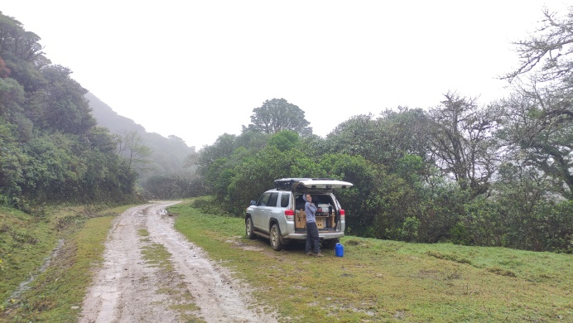 | 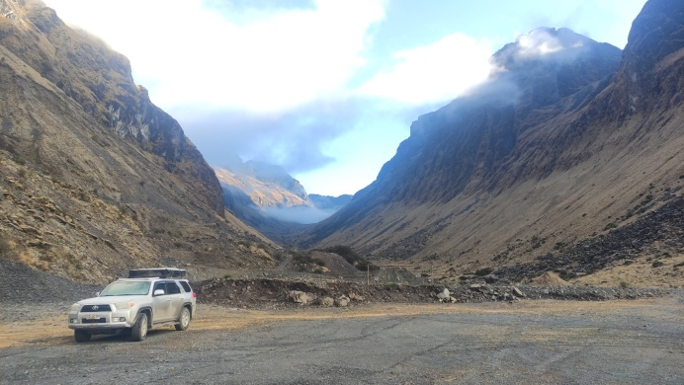
Our loyal friend Forrest at Siberia | Forrest in the Pongo Valley

Literature
- Birds of Bolivia - Field Guide. Herzog, Sebastian K., et al. Asociación Armonía, 2016. A nice guide, which has a very handy quick family index in the back, English and Spanish bird names and easy altitude references for species. The drawings aren’t always that great unfortunately; especially for Tanagers and Hummingbirds you might need some additional sources to ID a bird for certain.
- Merlin app for the birds sound. Just amazing that this app is free. Most species have sounds in there (except for e.g. Scimitar-winged Piha). Note that lots of times the song recordings are made in Venezuela or Ecuador, and the birds simply do not respond (well) to them.
- BirdNet app for recording the bird sounds. If you don’t know all the sounds, BirdNet can give a possible ID. It helped us a few times when we were frustratingly searching for a bird we heard deep inside the shrubs. A sure ID of a bird from BirdNet saved us some time here and there ;)
- iOverlander app for camping places. This app gives nice information on where to camp or buy stuff.
- Website birdbolivia.com. Although some descriptions are out-dated and the route descriptions are dreadfully complicated and long, it is still a good start resource to prepare a trip to Bolivia.
- Add this number to your contacts: +54 9 11 5349 5987. You can forward Spanish voice messages you get in WhatsApp and it will transcribe and translate to the language of your choosing!

Equipment
Photography: Sony A9 II + 200-600mm + 1.4x converter + Sony 24-105mm, GoPro Hero 9
Binoculars and telescope: Swarovski EL 8x32 WB, Eden 8x32 XP, Swarovski 65HD + 25-50mm
Heat scope/Thermal imager: Lahoux Spotter Elite 35V (lahouxbirding.com). A great heat scope from a company in The Netherlands. I owned other brands, but we are super happy with the sharpness, modes and light weight of this heat scope! More here: robjansenphotography.com/lahouxbirding
Spotlighting: Fenix HT18 Long Distance Flashlight (powerful, very focussed and my preferred choice for open areas), Fenix TK35 2018-edition (less powerful and focussed than the HT18, but still very strong and nice for spotlighting!), Fenix FD41 Focus Flashlight.

Use of cell phones in Bolivia
We decided to get two different SIM cards, one from Entel and one from Tigo. Both SIMs were easy to obtain and can be obtained literally anywhere (although activation was hard at the border in Cobija, better get one at the airport or in Santa Cruz)! Even food stalls in Pongo have Entel cards available (make sure it is activated however!). Tigo was only better at Refugio Los Volcanes and at all other places Entel was better, so we would recommend Entel. Putting credit on the SIM was less easy, and we were referred to official Entel stores in the big cities. As we try to avoid cities as much as possible we recharged our credit via MobileRecharge. You pay a small fee, but for us this was worth it and way more convenient.

Paying in Bolivia
Paying in Bolivia is often done in cash (e.g. most gas stations). Only the better hotels and places in cities have a machine for cards. Be sure to bring enough cash! Banco Nacional de Bolivia/BNB and Banco Mercantil was a bank that didn’t charge us a fee for a cash withdrawal. Some banks give you the option to withdraw with quota (a proposal for a conversion which is in their favour), so be sure to choose without quota/sin quota.

Getting Fuel in Bolivia
Fuel is heavily subsidised in Bolivia, and locals get the subsidised price (for the last 10 years 3.74Bs per litre gasoline, except for some remote locations). Foreigners with a foreign car however are officially supposed to pay the unsubsidised price, which is about 2.5 times higher (8.68Bs). Sometimes gas stations refuse foreigners with foreign cars/without a local ID because of all the paperwork that goes with it. Other times you can negotiate a price somewhere in the middle between the unsubsidised and subsidised price. Parking your car around the corner and bringing a jerry can, will get you the local price. If they ask for your ‘carnet’, just give 6 random numbers or ask to fill ‘sin factura’. We are not sure how it would work if you have a Bolivian rental car but not a local ID… The app iOverlander gives a good overview which gas stations are not so strict on the rules and will fill directly in the tank or bidon for local price. To help other foreigners, give a nice tip (10-20Bs) if they fill up directly in your tank or bidon for local price. During the 2.5 months we were in Bolivia we always paid the local price, sometimes only after multiple or even many ‘por favors’.

Strikes/Paros
Bolivia is known for its strikes. They can arise anywhere and seriously ruin your holiday. Potosí and Sucre are specifically known to have strikes, but they can occur anywhere. The first time we got through Bolivia without any strike for 2.5 months, which seems exceptional as striking is the national sport. The second time we had a strike in the north, holding us hostage; stuck between the borders of Peru and Brazil on one side and the only road to the rest of Bolivia on the other side of the blockage. We were only allowed to pass after waiting for more than 50+ hours. It can be something simple a local indigenous community wants, and they can block the road for days even though nobody on the road can do anything about their problem. The government has one website which shows some of the problems (but not all): transitabilidad.abc.gob.bo.

Water-to-Go
To reduce plastic usage on our travels we bought Water-to-Go water bottles. Read about our experience with Water-to-Go on our website: www.robjansenphotography.com/water-to-go. The bottle and filters are not too expensive, and you will have your investment back within one holiday. If you order with the voucher RJANSEN15 you will get 15% discount as well! Check the website here: www.watertogousa.com (United States of America, Canada), www.watertogo.eu (United Kingdom) or www.watertogo.shop (most countries in the EU).

If you enjoy my wildlife photos and trip reports, support my creative journey by buying me a coffee. Your generosity brings me closer to capturing impressive wildlife and untold stories
Visited sites
Santa Cruz -17.64828, -63.14015
Visited dates: 26-31 July 2022

Landhaus el Fuerte -17.87365, -63.27098
This place is both a restaurant (only open for lunch between 12.00-15.00. During the week a day menu costs 25Bs; recommended!), and a camping area (70Bs per motorhome/tent). We found it nicely located on route towards and from Santa Cruz and stayed 3 nights. The 10 obese dogs are a bit of a nuisance when arriving/leaving, but it’s still a nice place. Our first mammal of Bolivia was Bolivian Squirrel, which was quite common here. Bolivian Grey Titis/White-eared Titis were seen every day, although they were a bit shy. We also heard them calling from the adjacent Yvaga Guazú Ecological Park, which might be a nice alternative and more on route than the Botanical Gardens.

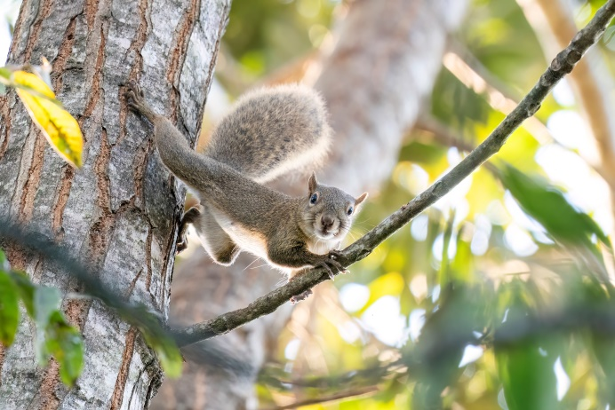 | 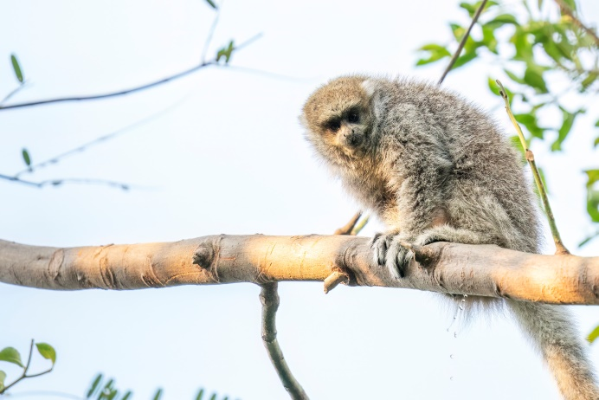
Bolivian Squirrel | White-eared Titi

Santa Cruz de la Sierra Botanical Garden -17.76453, -63.07032
The botanical gardens are open 09.00-17.00; admission fee 10Bs p.p. The gardens can get busy in weekends. During our round in the botanical gardens we soon found 5 Southern Amazon Red Squirrels chasing after each other. In the forest part we had a group of 6 Black-tailed Marmosets, 2 Brown-throated Three-toed Sloths and a group of ±8 Azara’s Capuchins. Back in the garden part we had another group of ±6 Capuchins, but in spite of a lot of searching we couldn’t find any White-eared Titi Monkeys. The left (northern) trail in the forest had some nice shrubs next to it, and there we observed Fawn-breasted Wren. Bolivian Slaty Antshrike, White-backed Fire-eye and Mato Grosso Antbird are observed here as well, but we didn’t put a lot of effort in seeing them, as we had seen them before in the neighbouring countries.

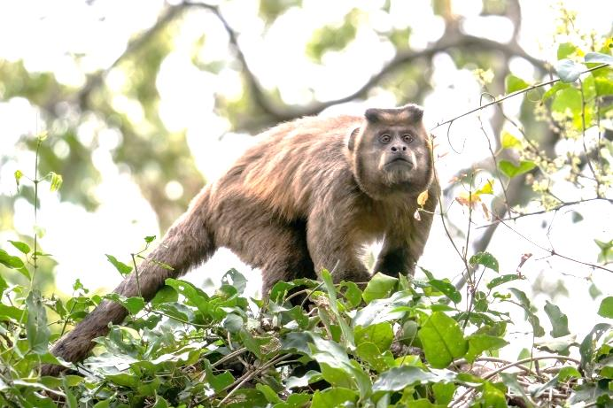 | 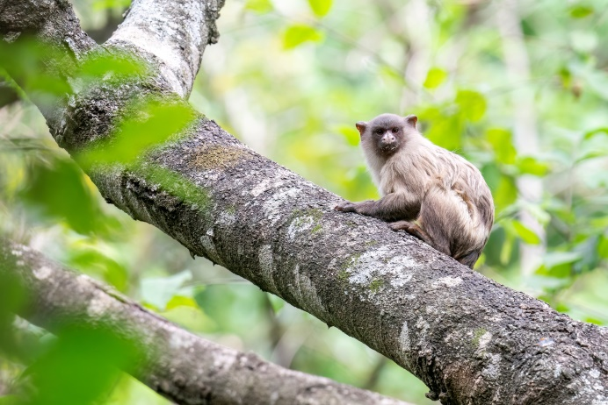
Azara’s Capuchin | Black-tailed Marmoset

Parque Natural Lomas de Arena -17.89034, -63.17963
The official entrance gate is about 2.5km farther down the road. The park is open from 08.00 – 16.00; entrance fee is 20Bs p.p. A 4WD is recommended for this park, as the road consists mostly of very loose sand. We were allowed to camp inside the park with our motorhome, but parked it on the open field not far from the entrance because our 2WD might get stuck farther down the road. We had our first South American Coati of Bolivia in the park, but no other mammals. We hoped to see the White-bellied Nothura in the grassland near the dunes (4/5km walk from the camping area), but only heard Red-winged Tinamou. Nice birds were Plain Tyrannulet, Jabiru, Crane Hawk, Chaco Puffbird and multiple White-banded Mockingbirds.

Curichi La Madre Park -17.79275, -63.22476
We wanted to visit this park as well, as it is a good place for White-eared Titi Monkey. Unfortunately it is momentarily only opened during the week and closed in the weekend, which seems to be Covid-related. Be sure to check the opening times on Google Maps.

Refugio los Volcanes -18.10516, -63.5983
Visited dates: 1-3 August 2022
General Information: A reservation is necessary to visit this place, which can be done through their website or via WhatsApp (+591 73166677). Payment has to be made by bank transfer or PayPal, but upon request we were allowed to pay in Bolivianos on arrival.

The entrance to Refugio los Volcanes is about 5km from the main road (-18.11996, -63.60867), and this part is a bit steep at times. The habitat only becomes better about 1km before the entrance (in case this place is full but you still want to bird the surroundings). You will get picked up by car and if you have your own car you have to park it at a local farmer (20Bs p.n., not included with your booking). The viewpoint/mirador near the entrance provides amazing views of the lodge and the surroundings. Mitred Parakeets, Andean Slaty Thrush and Dusky Green Oropendolas were seen from here. The Oropendolas have nests hanging from the cliffs about 50m farther on the main road past the entrance of Refugio.
We had the lodge pick up our luggage at 07.00 in the morning and walked the road down to get right into birding (thanks for the tip Lennart Verheuvel!). Walking down we picked up nice species like Golden-rumped Euphonia, Grey Tinamou (HO), Chestnut-backed Antshrike and Ochre-cheeked Spinetail. Best were two different Short-tailed Antthrushes, which we observed walking on the forest floor below the road. At some dense vegetation our eye caught some movement, and not much later we saw a couple of Slaty Gnateaters. Photographing these two, Bolivian Tapaculo started to call from behind, and we were even able to observe it in between the branches. After we passed our cabins (which were located 1km/30min walk before the lodge) and crossed the stream we passed a lek of Great-billed Hermits. Plumbeous Black Tyrant was observed next to the river.

In the afternoon we walked the Sirari trail, which goes through some nice forest. Only birds of note we observed were Yungas Manakin (relatively common on the trails), Grey-throated Leaftosser and Yellow-backed Tanager. At night we walked back to our cabins after dinner and heard Rufescent Screech-owl right after the first wooden bridge. Even after half an hour of searching we didn’t manage to see it.

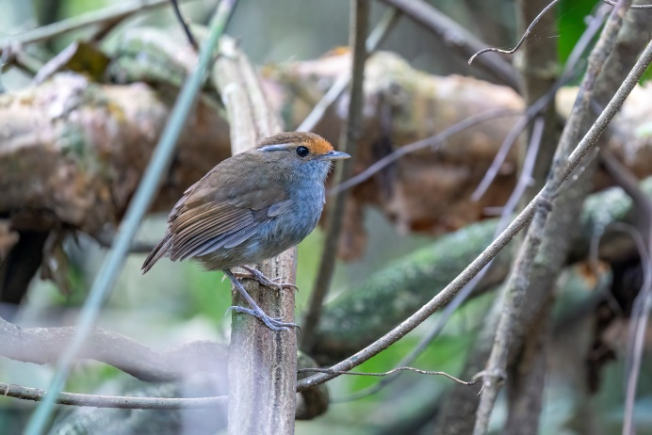 | 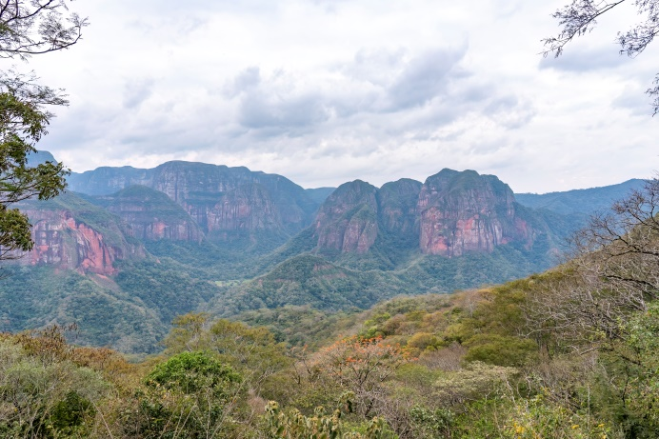
Slaty Gnateater (female) | Refugio Los Volcanes seen from the viewpoint

The next morning we woke up early to search for owls and nightjars, and again heard the Screech-owl at the same spot, and again didn’t manage to see it. Common Potoo was calling from far away. After breakfast we walked the Condor Trail (badly signposted). Tufted Capuchins were seen at the beginning of the trail, picking seed pods from the outer branches, walking back to the bigger branches and knocking the pod on the branch about 4-5x. If it didn’t open by then, they would drop it and go back to pick another one. It was generally quiet, but when a flock came through we observed (amongst more common species) White-winged Tanager, Slaty-capped Flycatcher, Bronze-green Euphonia, Blue-naped Chlorophonia and Blue-browed Tanager! Blue-throated Piping Guans (White-throated) flew from the canopy higher up on the trail.
In the afternoon we walked the short version of the Loro Trail (with the steep shortcut half way). You need some agility, a decent level of fitness and maybe a good life insurance to do this trail. Some parts are quite steep and landslides made some parts really narrow. The Refugio didn’t bother to put any ropes on these parts. We hoped to find Bolivian Recurvebill (e), which has been seen at the beginning of the trail and along the entrance road, as well as on the condor trail. We didn’t manage to see or hear it during our time at the Refugio. We did hear Yungas Dove and saw White-backed Fire-eye in between the bamboo. A flock on the Loro Trail produced more or less the same species as that morning, with the addition of Sclater’s Tyrannulet and Chestnut-tipped Toucanet. The viewpoint turned out to be the best place to observe Military Macaws, flying through the valley. On our way back we saw multiple Brown Tinamous and one Slaty Gnateater just before dusk. Too much wind prevented any owling that night.
Walking towards the lodge before dawn the next morning we observed Short-tailed Anthrush walking on the trail and some rustling between the leaves turned out to be another Grey-throated Leaftosser. At breakfast we heard Rufous-breasted Wood Quails calling from the mountain side just behind the dining area. After this we walked the whole Loro Trail. Another flock produced more or less the same species, but this time with 3 Blue-browed Tanagers. The Orquideas Trail in the afternoon produced exactly one orchid blooming and a few Yungas Manakins, but not much else.

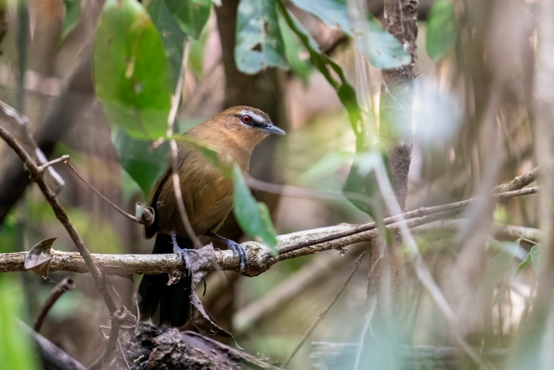 | 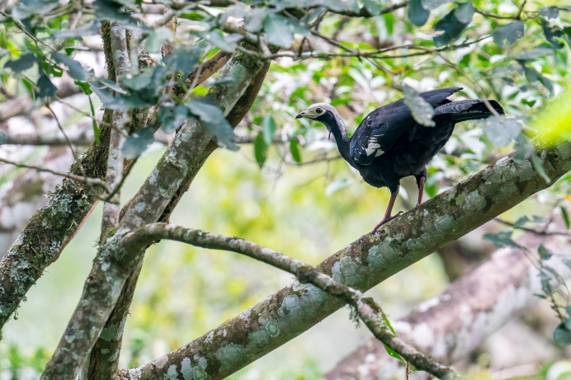
Western Fire-eye (female) | Blue-throated Piping Guans (White-throated)

Samaipata region -18.17416, -63.87491
Visited dates: 4-7 August 2022

Amboro NP - Paredones - Elfin Forest road -18.11623, -63.80052
An at times steep dirt road leads up to the edge of Amboro NP, where you can park the car and walk the road. Right on arrival we had 7 Blue-banded Toucanets calling near our car and we able to observe them beautifully. Red-billed Parrots with their deep wing beats flew overhead and a male Masked Trogon sat quietly in the low shrubs. Walking the road (right one at the fork) for about 1.5km we managed to observe Andean Guan, Crimson-mantled Woodpecker and a flock containing Three-striped Warbler, Bolivian Brushfinch (e) and White-browed Brushfinch. Bolivian Tapaculos called from multiple places along the road. The main reason for driving up here were Black-winged Parrots, which are seen quite regularly here. We saw 3 of them flying back and forth a few times.
We slept at the beginning of the road and birded here again the next morning. It was even more foggy and drizzling than the afternoon before, but bird activity wasn’t any less. Blue-winged Mountain Tanagers, Buff-winged Tyrannulets and Saffron-crowned Tanagers were in a flock next to the car. The strange but distinguishable call of White-eared Solitaire was heard many times and the bird was observed later too. White-throated Antpitta called from the first valley on the right. After the rain the drive back was quite slippery, and it is at times like this we regret not buying a 4WD.

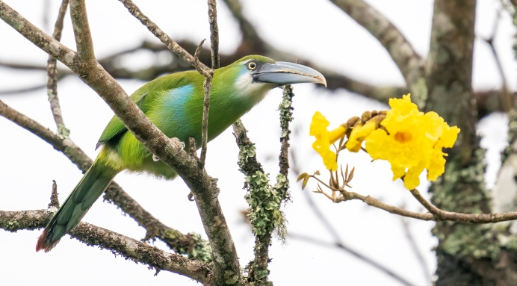 | 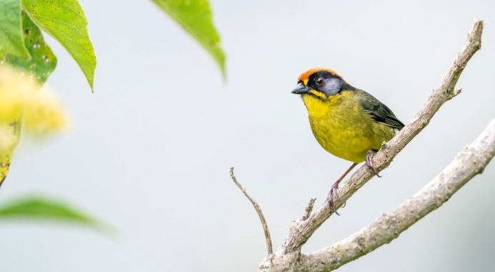
Blue-banded Toucanet | Bolivian Brushfinch

El Refugio de los Colibris -18.17244, -63.84203
This modest garden is full of native trees and flowering plants and attracts about 25 different species of hummingbirds over the year. According to the owner the crew changes a lot over the year, and when we visited only about 4-5 species could be (and were) observed: White-belied Hummingbird, Planalto Hermit, Fork-tailed Woodnymph and Glittering-bellied Emerald. Not really species to pay 25Bs p.p. for, but with a decent coffee we had a good morning anyway observing Ultramarine Grosbeak from nearby. We saw multiple Bolivian Squirrels in the shrubs in the garden. Giant Antshrike has been observed relatively often around this garden, so keep your ears tuned.

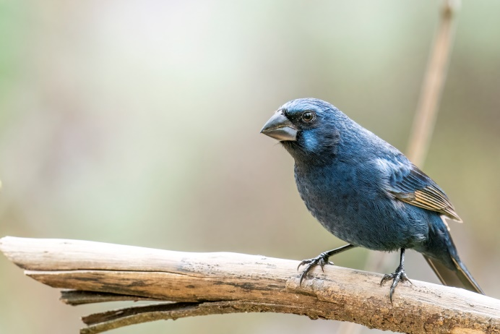 | 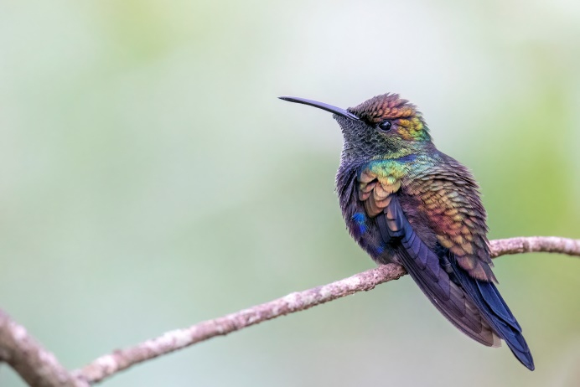
Ultramarine Grosbeak (male) | Fork-tailed Woodnymph
Quirusillas - Laguna Esmeralda -18.35048, -63.974
The drive to Laguna Esmeralda took about 1.5h from Samaipata, and the road is mostly pretty good, except for the last 5km uphill. When it’s not too wet this is driveable with a 2WD. Laguna Esmeralda is a nice lake on top of a mountain, surrounded by some nice forest. The lake and surrounding forest are a reserve for the Tucuman Parrot (Alder Parrot). Birding mainly involved walking the road. It was very cold and foggy when we visited, but activity was still ok. The views got better in the morning, and this is when we saw Tucuman Parrots flying over the valley, and even shortly sitting in a tree close to the camping ground. We also saw a group of 5 Red-faced Guans flying into a tree next to a small agricultural field. Nice birds we picked up outside the flocks were Ochre-faced Tody-flycatcher, Speckled Hummingbird, Highland Elaenia and Blue-crowned Parakeets. Other good birds that are seen by others here are Green-throated Tanager, Bolivian Tyrannulet and White-throated Antpitta. Be sure not to visit on weekends (Sat-Sun) as lots of Bolivians come to the lake, with motorcycles, music etc.

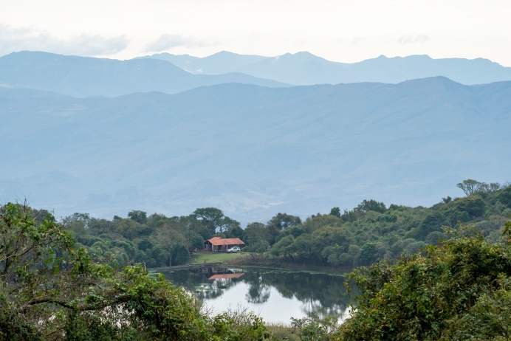 | 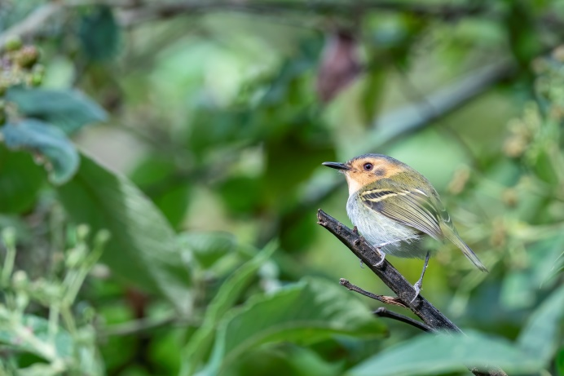
View of Laguna Esmeralda | Ochre-faced Tody-flycatcher

Red-fronted Macaw Cliff -18.13661, -64.82828
Armonía, the Bird Conservation Organisation in Bolivia, has set up a lodge opposite of the cliff in which endemic Red-fronted Macaws nest. The lodge is the only hotel nearby, but a tad expensive (about 150USD p.p.p.n.). Part of the money goes to the community and the rest is used for other conservation work in Bolivia. A very good cause and a good way to support Armonía! If this lodge is above your budget, you could opt to sleep in Saipina (where we saw our first Red-fronted Macaws flying already!), or to camp somewhere next to the river along Ruta 5 like we did. Wherever you stay, we would advise to drive up in the afternoon around 16.30 and watch the birds from above the cliffs. There is a parking next to the road above the cliffs, but a fence makes it impossible to get above the cliff itself at that point (unless you stay at the lodge). A bit farther up one can also park next to the road (-18.13687, -64.83286) and walk back towards one of the cliffs (-18.13795, -64.8305). Here you have the sun in your back in the afternoon and the Macaws sometimes fly very close by. We saw 18 Red-fronted Macaws, and it was outside breeding season. We saw another 32 following the valley southwest once the sun had already set above our camping place farther west. Other nice birds that can be seen here are Cliff Parakeets, Mitred Parakeets, Andean Condor (up close!) and Grey-headed Parakeets. The light and activity was way better in the afternoon. If you would sleep somewhere else we would suggest to visit in the afternoon and drive back after dusk.
A walk the next morning through the village didn’t yield much, but we did observe Grey-crested Finch, White-tipped Plantcutter and the endemic Bolivian Blackbird (e).

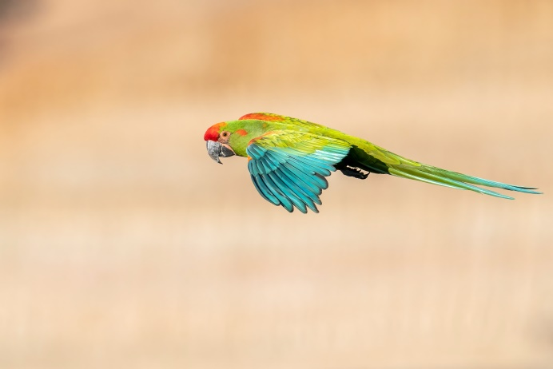 | 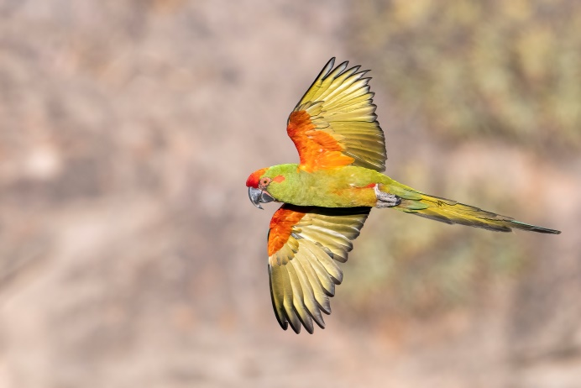
Red-fronted Macaw | Red-fronted Macaw

La Palizada – Comarapa (R7) -17.8442, -64.69289
Visited dates: 7-12 August 2022

Tambo -18.01306, -64.45112
We visited Tambo shortly after we already tried many places in between the Red-fronted Macaw cliff and La Palizada for Bolivian Earthcreeper, but without success. In Tambo we parked the car at the coordinates above and had Bolivian Earthcreeper (e) directly after stepping out of the car.

Torrecilla -17.90197, -64.60516
South of Torrecilla is a turnoff to the left. A steep road goes upwards (which should be good for Olive-crowned Crescentchest according to a local bird guide), and another road goes to the right. We parked on the big open area just after the turnoff and walked both roads, but had nothing on the steep road due to strong winds. We had lots of activity in the shrubs along the right road (-17.90191, -64.60998). Here and in the surrounding fields we observed Black-and-chestnut Warbling-finch, Rufous-sided Warbling-finch, Ringed Warbling-finch and Bolivian Warbling-finch (e)! We also saw Light-crowned Spinetail (Buffy-crowned), Great Pampa Finch and Spot-breasted Thornbird in this bend of the road.

Serrania de Sibería – First road -17.8272, -64.66633
On the left/south side of the R7 there is ample space to park your car or you can drive down and park a bit lower. This is the first cloud forest which can be birded that is not along the main road. It was really foggy and quiet, and the flock we encountered had mostly common flock species of this altitude; Common Bush Tanager, Bolivian Brushfinch (e), Brown-capped Redstart and Spectacled Redstart, but also contained Barred Becard. We also spotted Bolivian Squirrel in the shrubs. The part of the road that goes through cloud forest is not that long, and we decided to go to the second road.

Serrania de Sibería – Second road -17.8442, -64.69289
After passing an elevated football field on the right and a little house on the left, there is a crossroad. Going to the right here leads to accessible good cloud forest. The road can be birded at a lot of different altitudes, but we mostly focussed on the higher elevations. A 4WD is needed to go all the way down after rain. The first day was pretty decent, but the second day it rained the whole day and temperatures went below 0°C at night. The third morning there was a total change, as the sky was blue, sunny and no clouds or fog (very unusual weather for cloud forest!). We heard Rufous-faced Antpitta (e) and Trilling Tapaculo at many spots along the road (but only managed to see the Tapaculo). A group of Andean Guans was feeding in a fruiting tree and the peculiar sound of White-eared Solitaire was heard often. Farther down the valley we saw Pale-footed Swallows flying just above the trees. The hummingbirds were very quick, but we still managed to identify Tyrian Metaltail, Blue-capped Puffleg and Violet-throated Starfrontlet. Masked Flowerpiercers were regularly seen (a common flock member), and on the third day we managed to see Grey-bellied Flowerpiercer. The many flocks we encountered here often contained Citrine Warbler, Pale-legged Warbler, White-throated Tyrannulet and Pearled Treerunners besides the species mentioned in the paragraph above. Less regular members of flocks were Light-crowned Spinetail (Buffy-crowned Spinetail), Capped Conebill, Blue-backed Conebill, Montane Woodcreeper, Blue-capped Tanager, Blue-winged Mountain Tanager and Mountain Wren. Around dusk we heard Spotted Nightingale-thrush and later at night Rufous-banded Owl. The only mammal we saw here was Bolivian Squirrel.

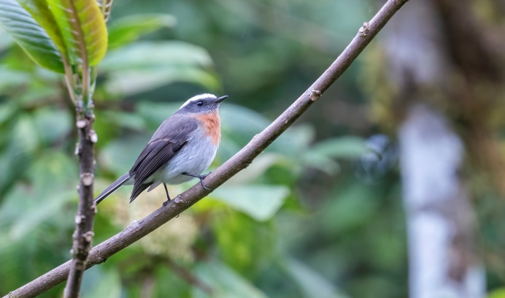 | 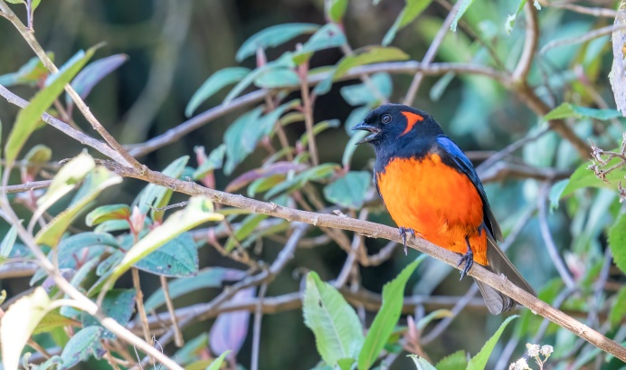
Rufous-breasted Chat-tyrant | Scarlet-bellied Mountain Tanager

Carahuasi -17.77257, -64.76267
At Siberia we met Jacob and Tini Wijpkema, a Dutch couple that has been living and birding in Bolivia for 10 years already. We were very happy to join them the next day (and in the end all the way to Villa Tunari) as they might just be the most experienced birders in Bolivia, having visited almost every possible corner of the country. We joined up with them at Carahuasi. The entrance to the road is to the right (north) (-17.79223, -64.7898), 20km after the second road of Siberia. The road first climbs up to an antenna, and afterwards descends all the way to some decent forest (around here: -17.77043, -64.76438). Locals unfortunately harvested all the big trees (like everywhere in Bolivia), but there is still decent birding here. We had great views of many hummingbirds in the morning, amongst which Lesser Violetear, Long-tailed Sylph, Blue-crowned Puffleg, Speckled Hummingbird and Rufous-capped Thornbill! Jacob & Tini showed all the birds they already saw that morning, including Maroon-belted Chat-tyrant and we obtained good views of Spotted Nightingale-thrush. As the skies were clear again all day we managed to see birds of prey, the best being White-rumped Hawk, Black-and-chestnut Eagle and a (migrating) White-throated Hawk. At night we heard Rufous-banded Owls along this road.

The first afternoon and second morning we birded at different altitudes along the road going back to the R7. Best birds seen were Barred Fruiteater and Band-tailed Fruiteater. Besides these were heard White-throated Quail-dove and Barred Anthrush. At night we saw a couple of Band-winged Nightjars on the road.

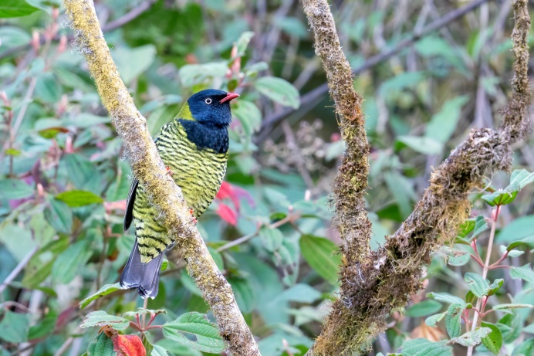 | 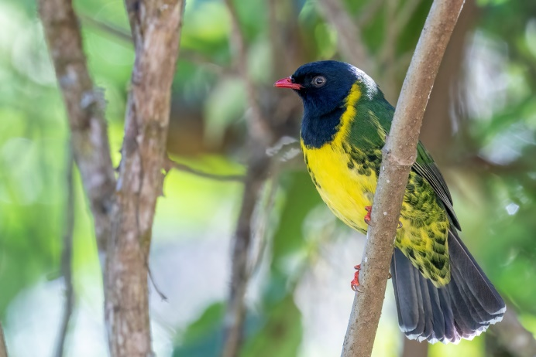
Barred Fruiteater | Band-tailed Fruiteater

PN Carrasco -17.54113, -65.27082
The road towards PN Carrasco is a good road, as they are building a hydro-electric dam. This makes for lots of traffic (busses with Chinese and Bolivians) on the dusty road, which in turn makes birding along the road less pleasant. After entering from the R7 (-17.58554, -65.30213), we observed Andean Lapwing and Andean Ibis along the higher parts of the road. Farther down in the valley we observed Golden-headed Quetzal, Amethyst-throated Sunangel and had prolonged views in the morning of a white morph Hook-billed Kite and Sierran Elaenia! The river itself had White-capped Dippers and Torrent Duck (which the other Dutchies saw). There is a trail going into the forest for better birding on the right just before the bridge (-17.497, -65.27248). We observed Maroon-banded Chat-tyrant, White-collared Jays, and had Buff-banded Tyrannulet and Blue-and-black Tanager in some flocks. Somebody from the park said we had to get permission to bird here, but he was fine with it after all. Explain to them you will do that next time, or just walk the trail in the forest and don’t bird along the road.

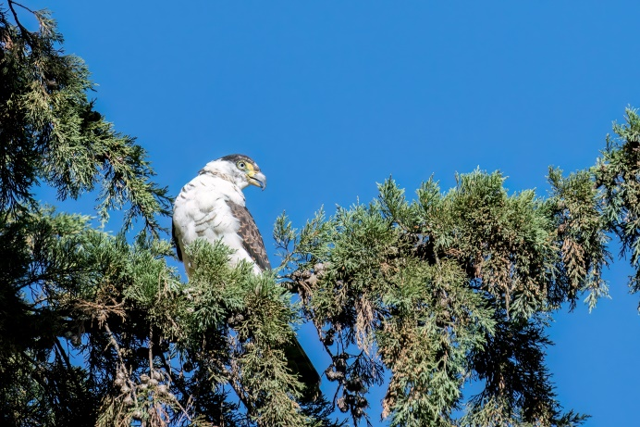 | 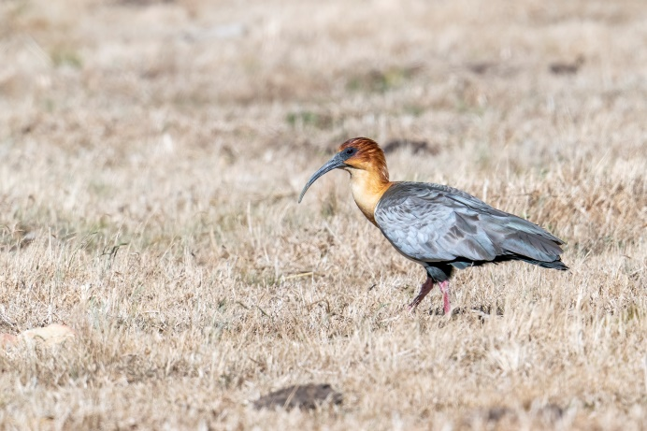
Hook-billed Kite | Andean Ibis

Chapare Road (R4) -17.25452, -65.89404
Visited dates: 12-21 August 2022

Corani Dam -17.25452, -65.89404
We quickly visited the Corani Dam on route. There wasn’t too much activity at the water front, except for the more common species like White-necked Stilt, Yellow-billed Pintail, Yellow-billed Teal, Andean Gull, Andean Lapwing and quite some Puna Ibises. North of the dam is a good place for Black-hooded Sunbeam (e) and Maquis Canastero, but due to time shortage we didn’t go here. Puno Tapaculo has a southern population here that might be a future split.

Corani Forest -17.1715, -65.88955
As the weather was still really sunny the Corani road going up was in pretty good state, and we were able to drive it with our 2WD all the way up to a plateaux at 3000m where we camped (-17.14856, -65.8646). Walking farther the road bifurcated and we birded the afternoon and next morning along the left road. We observed the cute Black-throated Thistletail (e), and heard both Diademed Tapaculo and Bolivian Antpitta (e). Different flocks contained nice species like Three-striped Hemispingus, Orange-browed Hemispingus and Streaked Tuftedcheek. A flock of Hooded Mountain Tanagers brought (Southern) Mountain Cacique with them. Around the camping spot we found Rufous-bellied Bush Tyrant, which we encountered a few more times along the road going down. We had 4 White-throated Screech-owls and 2 Yungas Pygmy-owls near the camping spot.
The second afternoon and the next morning we made different stops to bird along the road going down. Slaty Finch was surprisingly common, singing everywhere in trees along the road. We also had Paramo Seedeater at different altitudes singing from the sides of the road. Hooded Mountain Toucan called, was subsequently lured in and posed perfectly. In between the shrubs we found Kalinowski’s Chat-tyrant. Black-winged Parrots and Plum-crowned Parrots flew by, the latter shortly posing in a nearby tree. A group of Pale-footed Swallows foraged just above the canopy. Early in the morning we saw Fulvous Wrens, heard Barred Anthrush and had Superciliared Hemispingus in a flock. We slept around 2800m on the side of the road (-17.15602, -65.87179), and observed White-throated Screech-owl and heard Yungas Pygmy-owl again.

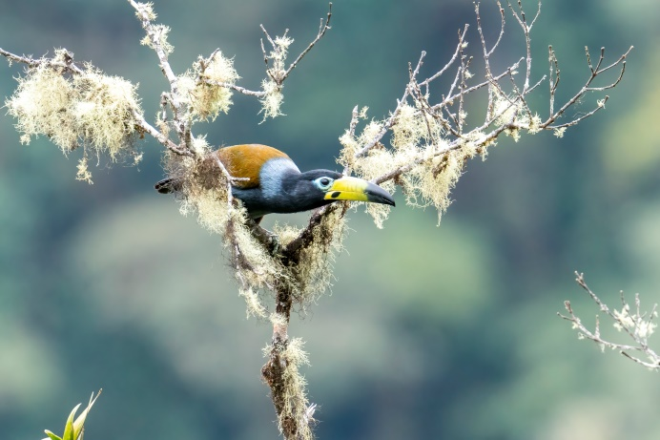 | 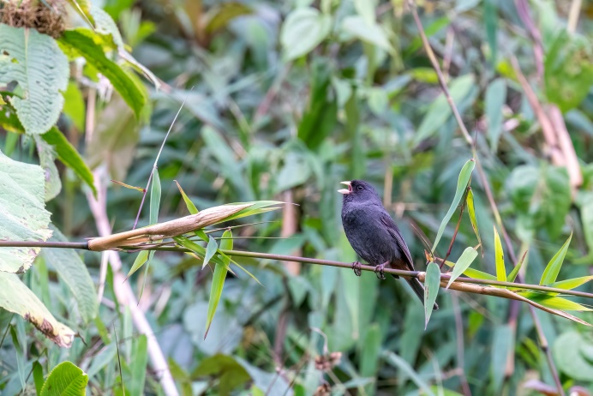
Hooded Mountain Toucan | Paramo Seedeater

Corani – Aquaduct Road -17.25758, -65.84954
The aquaduct road at Corani is not too good, and a 4WD is advised to drive this bumpy and at parts muddy road. Because the weather was clear and dry, we managed to drive all the way up to the top at 3300m (the road is in Maps.me and directions given are correct if you put the top as end destination). Again Rufous-bellied Bush Tyrants were surprisingly common. Birding the road around 3100-3200m we observed Great Sapphirewing and Black-hooded Sunbeam feeding on different flowers. Brown-backed Chat-tyrants were observed perching nicely in the low vegetation besides the road. Different flocks held White-browed Conebill, Streaked Tuftedcheek and Rust-and-yellow Tanager. At our camping spot around 3000m we observed Yungas Pygmy-owl (also the next morning in broad daylight) and heard White-throated Screech-owl. In the morning we heard Undulated Antpitta and Stripe-faced Wood-quail. We also saw Red-crested Cotingas, even raising their red crest! Afterwards we drove up to the top to search for Scaled Metaltail. After seeing multiple Tyrian Metaltails (far more common) we managed to find this target and were able to take some good photos! Brown-bellied Swallows flew overhead, while Huayco Tinamous called from the surrounding mountains. Crimson-mantled Woodpeckers were found on the way back down.

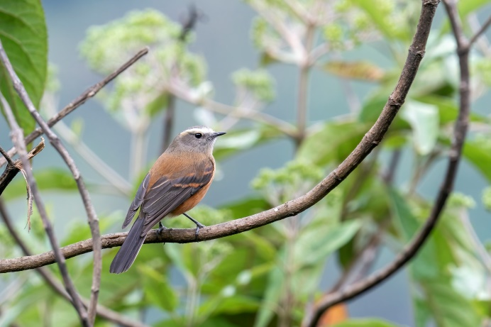 | 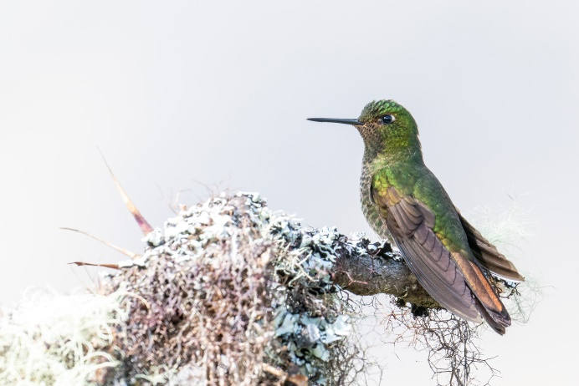
Brown-backed Chat-tyrant | Scaled Metaltail

San José – Miguelito Substation Road -17.16985, -65.75733
We birded the Miguelito Substation Road at three different parts. The road is paved with pebbles, and can easily be driven with a 2WD, even in rainy season. The first stop (and camping spot) was about 1km down the road around 1950m altitude (-17.16985, -65.75733). A trail into the forest on the opposite side of the road yielded both Yungas Tody-tyrant and Black-streaked Puffbird. Along the road we encountered Montane Foliage-gleaner, Olivaceous Siskin, White-eared Solitaire and an obliging Crested Quetzal. Flowering Cecropia trees attracted flocks of tanagers, including Golden-naped Tanager, Saffron-crowned Tanager, Blue-browed Tanager and even Green-throated Tanager! Versicolored Barbets were also seen sitting in Secropia trees and turned out to be quite common here. There is a small trail going down into some forest (-17.16921, -65.75861). Don’t let the metal chain at the start stop you. On this path we managed to observe Olive-backed Woodcreepers, Black-eared Hemispingus and Unadorned Flycatchers (big thanks to Tini and Jacob!). While searching for the latter a family of South American Coaties crossed the path. At night we managed to observe Rufescent Screech-owl at the camping spot. In the morning Barred Forest-falcon called and flew just past the car.

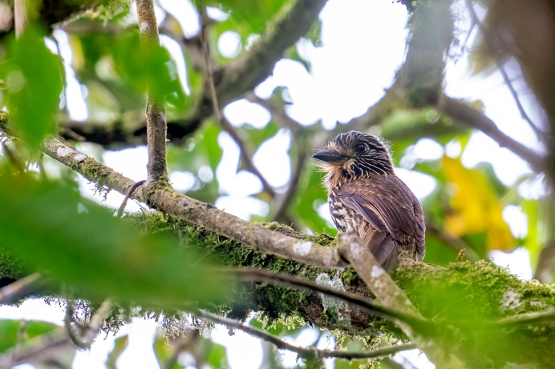 | 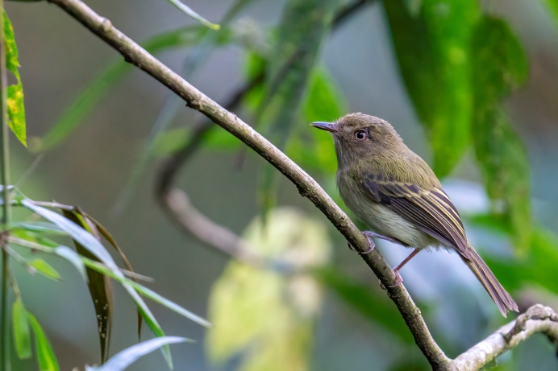
Black-streaked Puffbird | Yungas Tody-tyrant

As lots of forest had been destroyed we decided to drive farther down. A small stop yielded Stripe-chested Antwren in the shrubs next to the road and Chestnut-collared Swifts flying overhead. The next stop to camp and bird the afternoon and next morning was made farther down, around 1500m (-17.15586, -65.78111). We walked the trail on the opposite of the street multiple times, starting on the left side of the energy company’s encampment. We walked the trail both in the afternoon and morning up to a very steep path going up. Not far into the trail we heard Upland Antshrike and two times we encountered Rufous-breasted Wood-quails, quickly running back into the forest. Just before entering some better forest we encountered Bolivian Tyrannulet (Tini and Jacob had seen it there the day before too) and Yungas Tody-tyrant posed well. In the forest we observed Strong-billed Woodcreeper, heard Andean Solitaire and saw Bolivian Tapaculo running on the forest floor. Spotted Barbtail picking some moss from a branch was spotted on both walks. An Antwren high up in the trees responded to the right sound, but only after Tini managed to get pictures we could ID this as Yellow-rumped Antwren for sure. A rare bird! We heard an unfamiliar sound, Jacob recorded it and after analysis this turned out to be Lanceolated Monklet, quite rare too in Bolivia! Back at the start of the trail we saw a hummingbird stealing nectar from some flowers. This hummer turned out to be Geoffroy’s Daggerbill! Another rarity in Bolivia! We also had Speckled Hummingbird here, and we were happy to get pictures of both, as the head pattern appeared similar from a distance.

The last stop was made even farther down the Miguelito Road, around 1150m altitude (-17.12852, -65.77446). We spent two nights here. Birding involved walking the main road again, and traffic wasn’t too much of a nuisance here. We encountered some good flocks here, and these contained birds like Orange-eared Tanager, Ashy-browed Spinetail and Montane Foliage-gleaner. Other good birds encountered were Amazonian Umbrellabird, Andean Cock-of-the-Rock, Rufous-crested Coquette, Wing-barred Piprites and Marble-faced Bristle Tyrant.

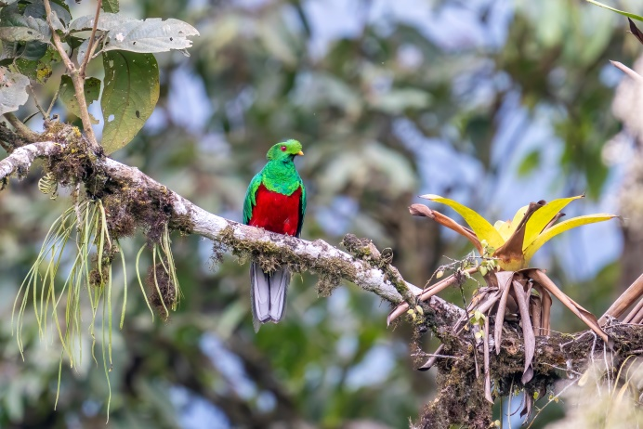 | 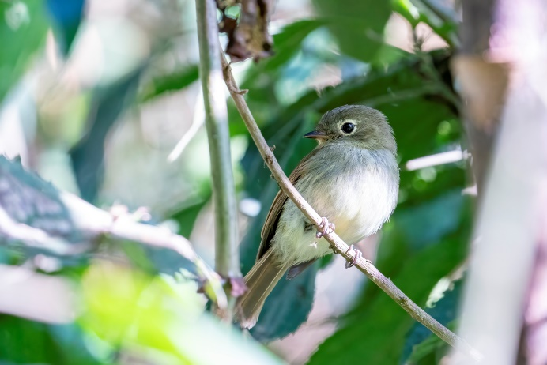
Crested Quetzal | Unadorned Flycatcher

Villa Tunari -17.10189, -65.5087
As we were a bit pressed for time, we went ahead on our travel companions and drove to Villa Tunari one day before them. Villa Tunari is the cocaine producing region of Bolivia, and some Ministries of Foreign Affairs might advise against visiting this region. We felt perfectly safe though, and everybody was super friendly (even the guys on their motorcycles with shotguns). Keep in mind that Corani is the last option to get fuel until Villa Tunari, and that gas stations regularly run out of fuel because it is used for the cocaine extraction. Ashy Antwren/Yungas Antwren has allegedly been seen in this region, so we tried several spots, but never found good habitat with bamboo (to be fair, we found the species later in our travel away from bamboo too!). There are two areas that we birded. To get to both, enter the road on your right about 5km before Villa Tunari (-17.01428, -65.45612). Drive this road until the crossing (-17.06509, -65.48547). We observed Azara’s Agouti crossing the road here. Going west for 3km and then south towards El Palmar the road goes over a mountain. There are some great patches with forest, but a lot of it has been destroyed recently for the realisation of an electricity network to the small town. Jaguarundi crossed the road and we got amazing views, but unfortunately no pictures. We birded the roadside on several places and encountered Yungas Tody-tyrant and Round-tailed Manakins. Buff-throated Foliage-gleaners, Southern Nightingale-wrens and Pectoral Sparrows were heard everywhere, but were only spotted after some effort. A flock produced Carmiol’s Tanager, Golden Tanager and Green-and-gold Tanager amongst other things.

Going south from the before mentioned crossing you pass a bridge where we observed both Sunbittern and Fasciated Tiger Heron. This road is the old road to El Palmar, of which the end part collapsed, preventing anybody from driving it all the way to El Palmar. Driving towards the end in the morning we had another Jaguarundi crossing our path! The end of the road does have very nice birding habitat (-17.10189, -65.5087, follow Maps.me). After parking the car one can cross the steel bridge going over the river and bird the path there, or continue walking the (overgrown) old road towards the end. This part turned out great for lots of Antbirds, and thanks to Jacob’s knowledge we managed to hear and see Southern Chestnut-tailed Antbird, Black-faced Antbird, Plain-winged Antshrike and Pygmy Antwren. Bright-rumped Attila was calling and lured in with playback. We saw multiple Bolivian Squirrels during the walk. Back at the car there were White-bellied Pygmy-tyrants as our final species before we said goodbye to Jacob and Tini.

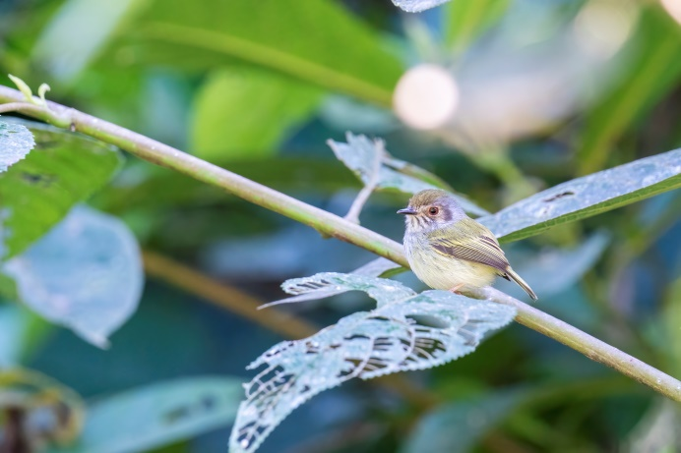 | 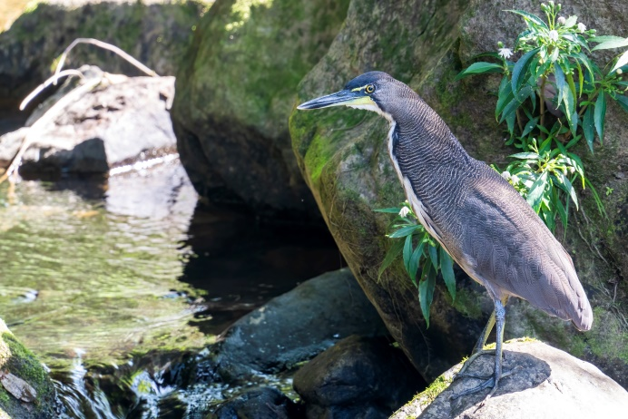
White-bellied Pygmy-tyrants | Fasciated Tiger Heron

Cochabamba -17.30918, -66.29408
Visited dates: 21-24 August 2022

Chaupi Melga – Rio Tuti Mayu -17.43918, -65.90092
On route towards Cochabamba we birded this location from 12.00-15.00. Turn off towards Chaupi Melga from the R4 (-17.42545, -65.91526) and just drive the main road (don’t follow Maps.me) until you get to the first coordinates (-17.43918, -65.90092). We parked along the main road and walked the bumpy road going into the small valley for about 200m. Here we encountered Rusty-vented Canasteros and an obliging Rock Earthcreeper. Cochabamba Mountain Finch (e) is observed here too, but we couldn’t find any. Driving a bit farther (-17.44409, -65.89636) we observed our first Rufous-bellied Mountain Tanagers/Rufous-bellied Saltators, Tufted Tit-tyrant, Black-hooded Sierra Finch and Brown-capped Tit-spinetail. We wouldn’t advice to bird this place during a normal vacation, and to keep it as a back-up if you missed any of these species at Cerro Tunari.

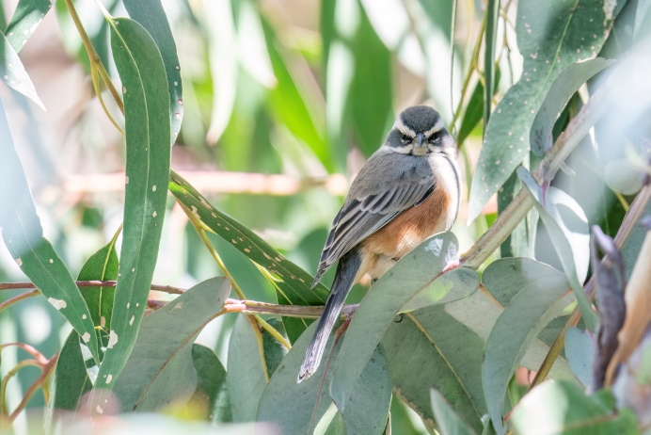 | 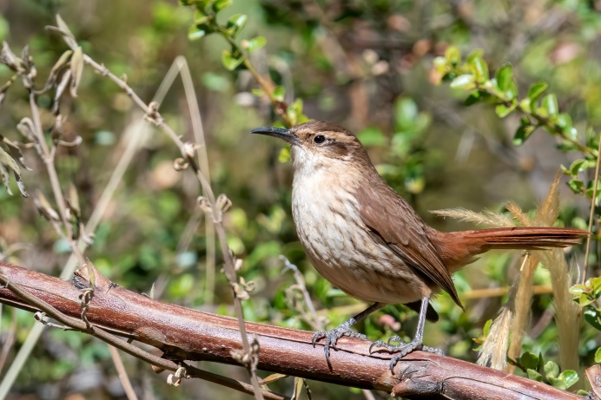
Rufous-sided Warbling-finch | Rock Earthcreeper

Cerro Tunari – Tambo (3300m) -17.28448, -66.31055
Northwest of Cochabamba lies the famous Cerro Tunari, a popular birding destination. The road can be driven with a 2WD, but has some deep potholes and distances are therefore a bit deceiving. After passing the more populated lower parts the habitat changes and Polyepsis (remnants) can be found on the hillsides. Here we saw Common Yellow-toothed Cavy on the side of the road under the bushes. A good first birding stop is just after a hairpin turn, where you can park on the right side of the road (-17.28448, -66.31055) and walk the road going opposite to there (you can also drive that road for about 300m and even camp there). We birded this place one afternoon and one morning. The road makes for easy walking (better than the next two places) and the sun reaches this spot early in the morning too. In the afternoon we had a dark Cavy crossing at the beginning of the path, which might be Montane Guinea Pig. Albeit in the right distribution range, there are no confirmed sightings in this region, so we can’t be sure without a picture. The agricultural fields at the beginning were heaven for the many Bare-faced Ground Doves. Other birds we encountered farther up the trail were Bolivian Warbling Finches (e), Rock Earthcreeper, Streak-fronted Thornbirds and Grey-hooded Parakeets. Maquis Canastero responded to playback but did not get out of the shrubs. As there were more flowers blooming than at higher altitudes, this location had all the hummingbirds: Giant Hummingbird, Red-tailed Comet, Lesser Violetear and best of all: Wedge-tailed Hillstars (e). In the early morning we observed 2 Yungas Pymgy Owls calling and being mocked by little birds.
We camped 500m farther (-17.28373, -66.31466) and birded there one morning too. About 50m farther up the road is a fairly open patch on the left side of the hill. We encountered most of our target birds in this patch: Bolivian Warbling Finch (e), Cochabamba Mountain Finch (e), Olive-crowned Crescentchest (high altitude ssp.), Brown-backed Mockingbird and Maquis Canastero. Some rustling beneath a bush turned out to be an Andean Tinamou (which is most likely the Tinamou species we flushed many times on Cerro Tunari). This is also the place where we had our first Wedge-tailed Hillstar (e)!
Spotlighting here is at own risk. Only 5 minutes into spotlighting we were surrounded by a car and 2 motorcycles, which turned out to be Policía. Of course they couldn’t believe that 2 Dutch people were travelling for 2 years just to see birds and mammals and that we didn’t have any drugs with them (nor that we didn’t use at all). After asking 10 times if we really didn’t smoke, where our Chilean friend was (because of our car) and a thorough inspection of the car we were allowed to be on our way again. Needless to say we didn’t continue walking with our strong flashlights along this road after this.

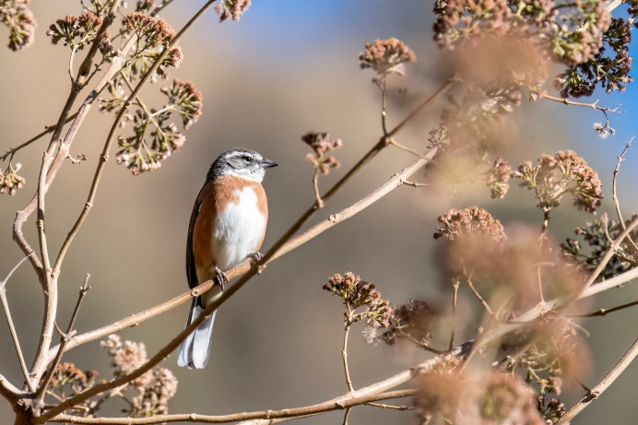 | 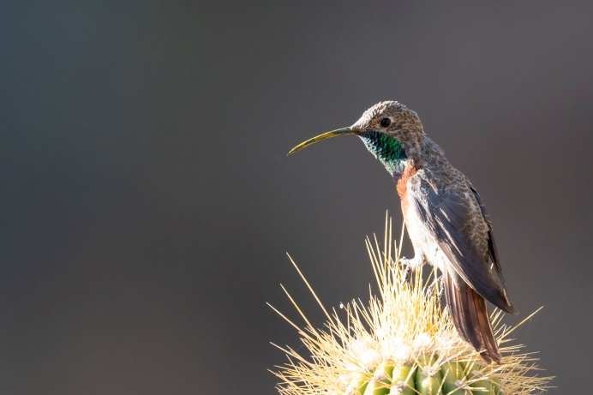
Bolivian Warbling-finch | Wedge-tailed Hillstar

Cerro Tunari – San Miguel (3600m) -17.2758, -66.33031
Farther up the hill is the little settlement of San Miguel. One can park on the right side, before the bridge over the river. Scanning the river we observed White-capped Dipper and a small family of Torrent Ducks, even though the stream was quite small at the moment. The hill on the left side has good Polyepsis forest, and one doesn’t have to climb far up the hill to see good species. Already from our parked car we observed Giant Conebill right next to the road on our second visit to this place (around 07.30 in the morning), as well as Cinereous Conebills. Rufous-bellied Mountain Tanagers/Saltators were quite common along the roadside. A bit farther up the hill we observed Cochabamba Mountain Finches (e). While watching the top of the tree they used just before, another 2 Giant Conebills came to that very same tree and Red-crested Cotinga was observed in the distance. Tawny Tit-spinetails were a pleasant variation to the way more abundant Brown-capped Tit-spinetails. Even farther up the hill we encountered Streak-throated Bush Tyrant and another Rock Earthcreeper.

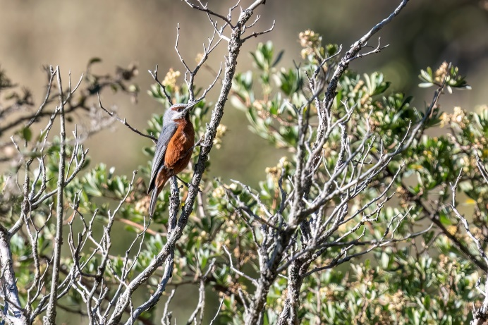 | 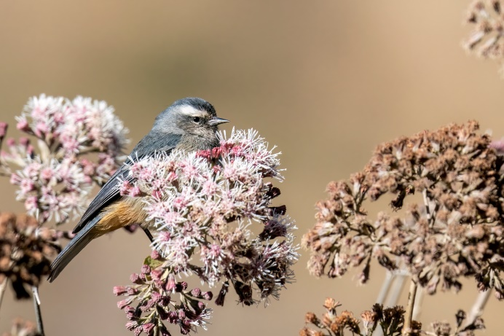
Giant Conebill | Cinereous Conebill

Cerro Tunari – Tawa Cruz (4500m) -17.22735, -66.38708
Most of the targets were already found within a few hours on our first morning and because it was getting very hot (no clouds in the sky), we decided to drive all the way up towards Tawa Cruz and taking the road just before that (R25) towards Misicuni (-17.24771, -66.3938). During the drive up we observed Bright-rumped Yellow Finches, Black-billed Shrike-tyrant and Andean Hillstar feeding on the very few flowers at this altitude. Water levels were very low, but the lakes held the more common high altitude species, including Crested Duck and Puna Ibis. We hoped to find Boulder Finch, but only encountered White-winged Diuca Finches. The grassy hillsides were teeming with birds, a couple of Slender-billed Miners, some Cordilleran Canasteros, but mostly many Ground Tyrants. We managed to see 6 species: Cinereous Ground Tyrant, Ochre-naped Ground Tyrant, Cinnamon-bellied Ground Tyrant, Puna Ground Tyrant, Spot-billed Ground Tyrant and Taczanowski’s Ground Tyrant.

Inquisivi -16.90725, -67.1359
Visited dates: 31 August 2022

Inquisivi is best approached from Cochabamba via the R4, taking a right turn at Konani towards Quime (-17.43838, -67.51807). This road is way better than the R25, and it saves you a river crossing (which might even be impossible depending on your car). Towards Quime the road is paved, after Quime the road is gravel but doable. If you are not planning on visiting Apa Apa Reserve, we recommend driving the same way back to the R4 and continue your route from there.

Inquisivi is best known for the Bolivian Spinetail/Inquisivi Spinetail (e), only discovered in 1993. We arrived in the small town around 14.00 and worked our way down the switchbacks below town. The first habitat encountered was all converted to plantations and agricultural fields, but the farther down you get to the river the better the habitat. We made several stops along the way at promising patches, but only encountered our first Bolivian Spinetail quite far down (-16.8964, -67.14109). Going farther down we made several stops and heard and/or saw Spinetails at almost every stop (-16.8898, -67.1396, -16.8886, -67.1467 and -16.8838, -67.1491). In total we observed 8 Bolivian Spinetails in a time span of about 2 hours under the intense hot sun. They seem to be quite abundant here (still).

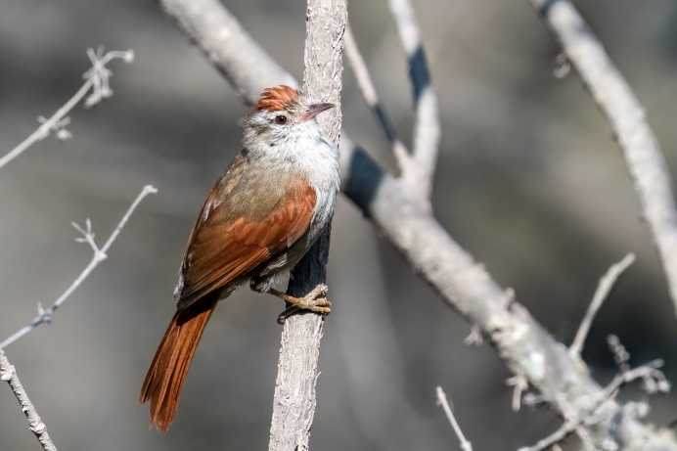 | 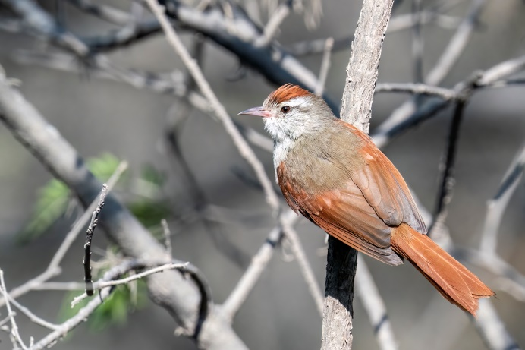
Bolivian Spinetail | Bolivian Spinetail

Apa Apa Reserve -16.34678, -67.49793
Visited dates: 1-3 September 2022

From Inquisive you can continue towards Apa Apa Reserve via the R25, which is a bumpy roads with lots of turns, but doable. This stretch took us about 7.5 hours in dry conditions! The road to Apa Apa Reserve begins in the village (-16.37741, -67.5329) and it’s about 10km to the top at 2400m. At the top there is a small track to the right where we camped. There is also a water pool (-16.34713, -67.4977) where someone reported Oilbirds coming to drink right after dark (Sep-Mar). We waited for more than an hour but saw nothing that night. We checked it a few times later that night, but saw and heard nothing. Probably we were still too early in the year. Spotlighting the main road southwards we heard Rufous-banded Owls a few km from the top. Back at the top we walked a bit of the road on the other side and soon encountered Cloud-forest Screech-owl!

In the morning we walked the road going north for a couple of kilometres and mainly observed a beautiful coloured cast of birds we had already seen at other places like Blue-banded Toucanets (quite abundant here), Crested Quetzal, Versicolored Barbets, White-eared Solitaires, Andean Solitaire (finally we got a visual!) and other more common birds. Hooded Tinamous called all day long, but as expected we didn’t see them. After playing tape every now and then we finally heard Scarlet-breasted Fruiteater responding around 09.30. It called a couple of times, with large intervals, but never came closer unfortunately. Cinnamon Flycatcher posed nicely besides the road, and we managed to get a glimpse of Bronzy Inca in between the shrubs. While watching this bird Rob heard some berries drop from a dense bush above the road. These berries turned out to be feaces and in fact there was a family of at least 5 Bolivian Night Monkeys (Azara’s Night Monkey ssp. boliviensis) in that bush! Walking back to the top we first heard and then saw Bolivian Squirrel, making a lot of fuss about us walking by. At our car Golden-headed Quetzal posed perfectly in a tree! Not long after, it started to rain, and it rained until the next morning. When it finally became foggy and began drizzling instead of raining, we decided to make one more round. We walked the road going south, listening to Rufous-faced Antpittas (e) calling, and about a km down we saw a bigger bird going through the shrub. This turned out to be the much hoped for Scimitar-winged Piha, a very rare bird which is more commonly seen in Apa Apa! A great end to our stay here!

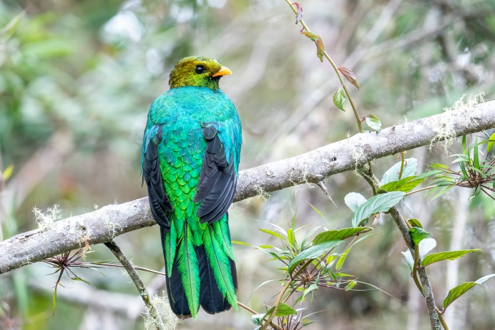 | 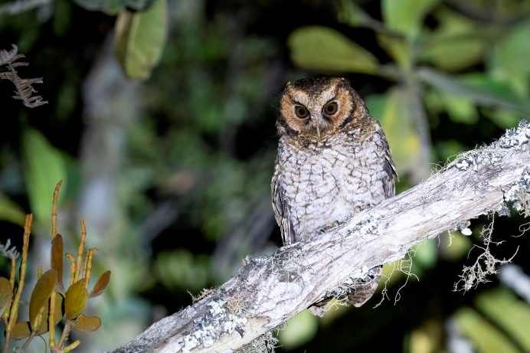
Golden-headed Quetzal | Cloud-forest Screech-owl

La Paz region -16.3382, -68.04021
Visited dates: 3-9 September 2022

Unduavi – Rio Pongo (3140m) -16.3142, -67.91018
The 80km drive from Apa Apa Reserve towards here took longer than anticipated. The road was still driveable despite the rain that had fallen, but the bumpy and sometimes narrow road made for slow driving. It took about 3.5 hours to get to Unduavi from the top of Apa Apa. We wanted to visit the AceroMarka reserve, as there have been many sightings of Black-hooded Sunbeam and multiple species of Antpitta, but the gate was closed. Make sure to have a reservation. We continued along Ruta 3 and pulled off the road to sleep at the riverside (-16.3142, -67.91018). We walked the path going up and heard both Undulated Antpitta (near the river) as well as Rufous-faced Antpitta (e).

Cumbre (4650m) -16.3382, -68.04021
A little before the Cumbre (coming from La Paz) there is a side-track towards some bogs (turn-off here: -16.3602, -68.04185). Unfortunately most of the bog has been destroyed (not a surprise in Bolivia) by draining it and digging it up (like peat). We still observed Common Miners, Grey-breasted Seedsnipes and two White-fronted Ground-tyrants during our visit.

Right at the cumbre is a big lake which holds some nice species like Giant Coot, Andean Duck, Crested Duck and Yellow-billed Teal (ssp. oxyptera, likely to be split as Inca Teal). When we visited lots of Brown-bellied Swallows and Andean Swallows were catching insects just above the water.

We followed the road towards the Camino el Choro trail (up to here: -16.33056, -68.05178). The lakes that we passed had more or less the same species, and on top of that some Baird’s Sandpipers, Andean Lapwings and Puna Ibises. A dedicated search might be futile with so much good habitat, but we were lucky enough to have Rufous-bellied Seedsnipes flying over our heads!

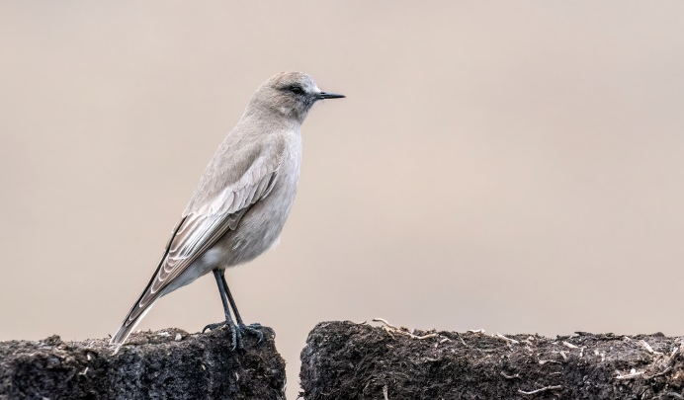 | 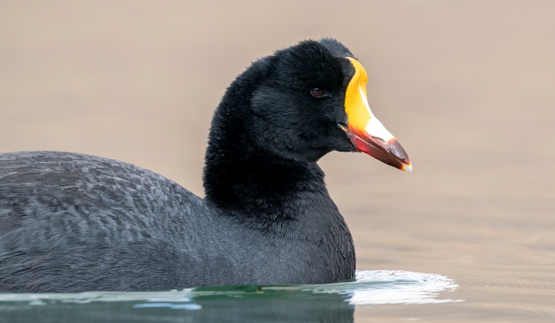
White-fronted Ground-tyrant | Giant Coot

Pongo – Stop 1 (4300m) -16.31554, -68.02439
A small turn-off in a bend of the road (-16.31554, -68.02439) makes for a nice quick stop, even if it’s very foggy like during our visit. We immediately encountered both Scribble-tailed Canastero and Puna Tapaculo. Both were seen more often during the next stops, but they cooperated best at this spot. Streak-throated Canastero has been observed here too, but we couldn’t find it.

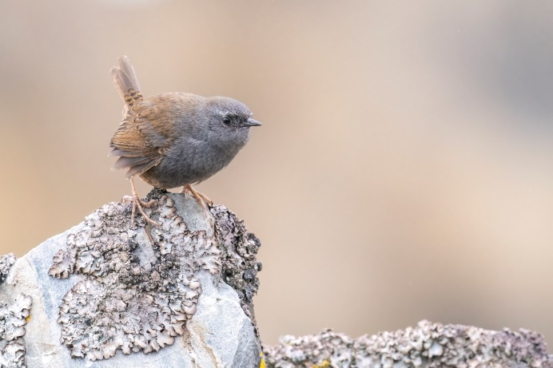 | 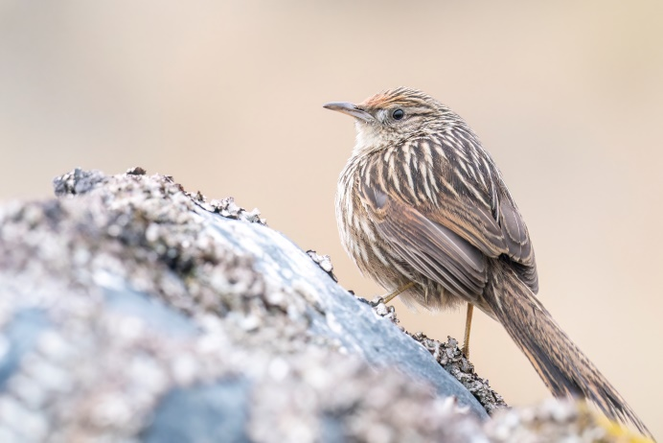
Puna Tapaculo | Scribble-tailed Canastero

Pongo – Stop 2 (3800m) -17.89034, -63.17963
Park at the side of the road (-16.32901, -67.96635) or drive through the small opening between the boulders (-16.32863, -67.96759) towards the soccer field (-16.32461, -67.96824). This was our camping spot for three nights, but most of it was spend in our car as it was very foggy for 2 days (visibility 20-50m and less). There is some nice vegetation here where Tawny Tit-spinetail might be seen (we didn’t put any effort in this species here). We did observe Puna Tapaculo, and on a boulder field close to the river we had great observations of Stripe-headed Antpittas!

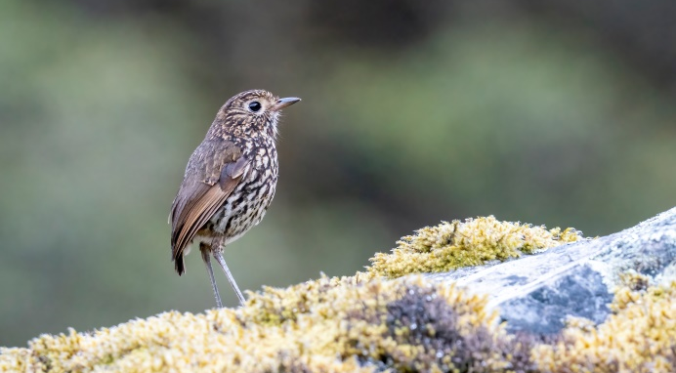 | 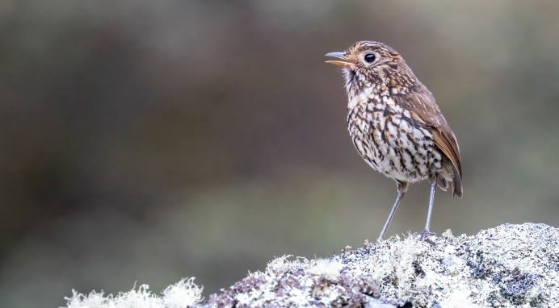
Stripe-headed Antpitta | Stripe-headed Antpitta

Pongo – Choquetanga Valley (3700-3800m) -17.89034, -63.17963
This is the most famous birding stop, known as Pongo Valley or Choquetanga Valley. A strenuous climb leads up to some Polyepsis forest remnants. Be sure the weather conditions are good, that you have the right footwear and clothing (weather can change quickly in the mountains) and that you are acclimated enough to the high altitude. Take the coordinates below in case it gets foggy and you don’t have a view of the whole valley and route to follow.
To get to the Polyesis forest, park your car or get dropped off at the food stalls at Pongo (-16.3274, -67.95514). After that walk back about 50-100m (towards La Paz). On the left side of the waterfall there is a very steep trail going up the rocks, at 3750m (starting here: -16.326928, -67.955852). You will pass along the left side of the little fenced area with the weather station and continue to climb, following the worn track towards an artificial pool on the first level at 3810m (-16.325272, -67.956377). This was the steepest and hardest part, and because it had been foggy for days and freezing at night the stones were very slippery. It took us about 20 minutes to do this first stretch. You see a big and high waterfall at the end of this first level. The top of that waterfall is going to be level 2 and your next goal. Cross the dam of the pool and continue straight, following the path in between the grass. You will climb gradually towards a kind of ridge (passing this point: -16.32554, -67.954). On the way we had Scribble-tailed Canasteros. Again following the sometimes narrow track you will get to a boulder field, where we had our first Line-fronted Canasteros! After this boulder field you encounter a stone wall (-16.321872, -67.954561), meant to stop cattle from reaching the second level and destroying the forest. Dung on the second level proves that this only added an extra hurdle to your already tiring climb. Climb over the wall and shortly after you will reach the second level at 3990m, with the waterfall just on your left (-16.321249, -67.955805). Scanning the areas where the grass is lower yielded Taczanowski’s Ground Tyrant, but might even yield Olivaceous Thornbill. Follow the trail for a couple of 100 metres farther until you reach the beginning of the Polyepsis ‘forest’ at just above 4000m (-16.319093, -67.956681), which is nothing more than a few trees scattered around a boulder field. It took us about 1.5 hours in total to reach it. Even though the forest might not look like much, we promptly encountered Ash-breasted Tit-tyrant! While sitting on the boulders to get a better look at them, Romy spotted Boulder Finch/Short-tailed Finch (watch out to not confuse them with Plumbeous Sierra Finches that are common here). Another bird on top of a rock farther down turned out to be another Stripe-headed Antpitta. While sitting there for a while Blue-mantled Thornbill suddenly flew by and against all odds sat down on a branch just in front of us!

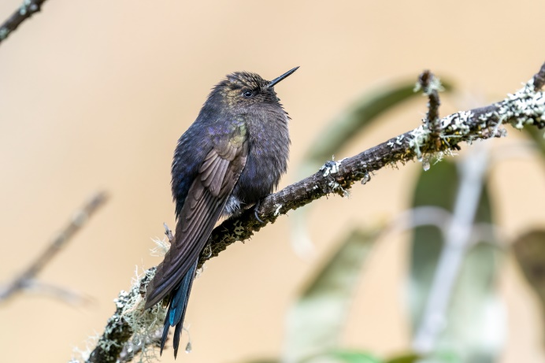 | 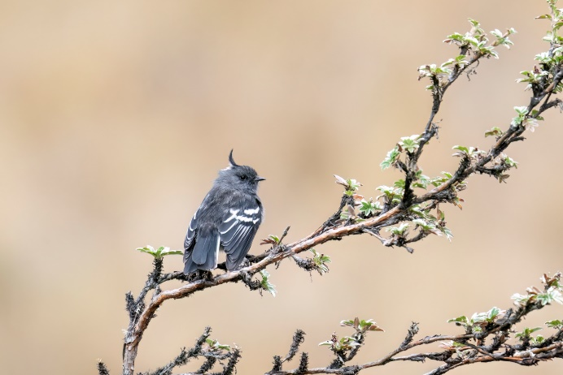
Blue-mantled Thornbill | Ash-breasted Tit-tyrant

Other birds of note seen in the forest were Brown-backed Chat-tyrant and White-browed Conebill. The way back down was way easier as the sun had warmed up and the ice on the rocks had disappeared. Back at the pool on the first level White-browed Ground-tyrants hopped on the ground and Line-fronted Canastero on a bush.

Once down be sure to celebrate at one of the food stalls with a Pongo Trout lunch (20Bs). The community has declared to no longer burn the grass and protect the forest. Mention you watched birds up the Choquetanga Valley to help this goal, and help the Bolivian bird organisation Armonía in reforesting the area and developing eco-tourism.

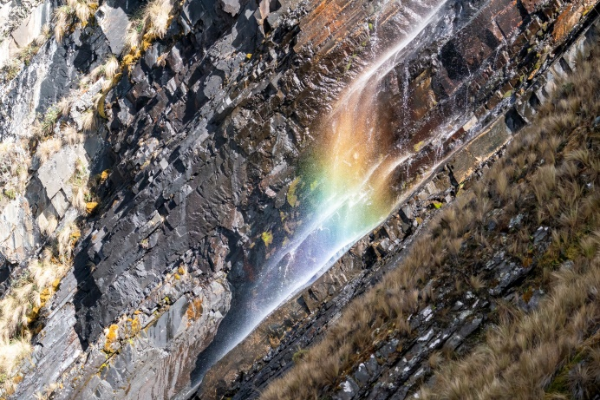 | 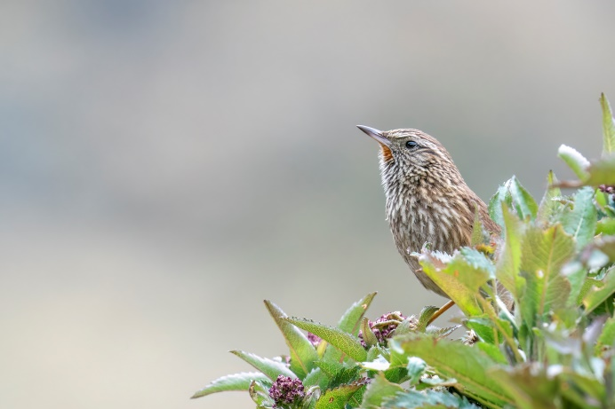
Part of the waterfall between level 2 and 1 | Line-fronted Canastero

Cotapata Trail (3200m) -16.28667, -67.84953
We wanted to walk the Cotapata Trail behind the petrol station, but met an employee from the mining company who said it was forbidden to enter the property and bird the road. The gate was left unlocked, but did have (quite new looking) signs on them that it is forbidden to enter the premises.

Coroico / Death Road – Railway Track (3050m) -16.28919, -67.82723
The Railway Track is a perfect way to avoid the cyclists/adventurers racing down the Death Road (mostly between 10.00 – 13.00). On top of that it’s a more or less flat walk, which is a very pleasant change from most mountainous birding places! At the first village, Chuspipata, turn right (-16.29931, -67.81898) and follow the road as it goes left/east (parallel to the Death Road). After about 1km you pass a barrier with a guard house on the left side. The barrier was open and the guard house unattended when we passed, but otherwise tell them you want to bird the ‘Via de Ferrocarril’ and they will most likely let you pass (possibly on foot though). Drive or walk farther, past the old railway station and turn left going uphill (-16.3046, -67.81553). After a few switchbacks, for which you need high clearance, you will get on a more or less flat road. Drive past the first houses and park on the left (-16.30853, -67.81375). From here it makes a nice and comfortable walk, with stunning views of snow-capped mountains on clear days. We encountered multiple flocks during our 3 hour walk, and the first already contained our prime target: Plushcap! Even though we already birded this elevation thoroughly along the Chapare Road, we still added some new species like Yellow-billed Cacique, Bar-bellied Woodpecker, Gould’s Inca, Grass-green Tanager and we finally got views of Bolivian Antpitta (e)! Other birds of note encountered in the flocks are Orange-browed Hemispingus, Superciliared Hemispingus, Fulvous Wren and Chestnut-bellied Mountain Tanager. On top of this already very productive list we heard Rufous-faced Antpitta (e) and Diademed Tapaculo.
We walked the trail again in the afternoon and encountered a very obliging Black-throated Thistletail (e). After 19.00 it was dark enough to do a night drive on this road for a couple of km, and we found 2 Swallow-tailed Nightjars, one of them a male and resting on the road! We heard multiple distant Yungas Pygmy-owls, but had no luck in luring them closer. Driving down towards our camping spot, passing the village Chuspipata, we heard more Swallow-tailed Nightjars singing just before the village. There was not much traffic, but there were some patches cleared for agriculture and housing. This might intensify in the near future, but for now this is still a good road to bird.

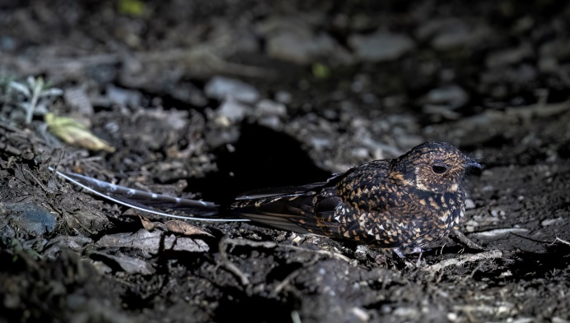 | 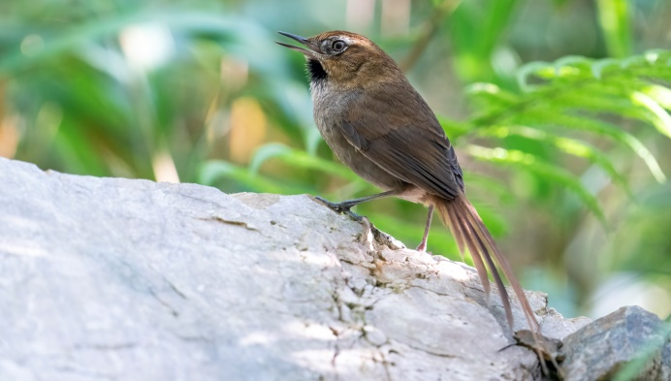
Swallow-tailed Nightjar | Black-throated Thistletail

Coroico / Death Road – Mining Trail (3000m) -16.29965, -67.81962
The Mining Trail is a little bit lower than the Railway Track, but is another one of those flat and comfortable walks. The path used to be overgrown and lead to a small mining camp. When we visited however, they were clearing the path and broadening it by cutting down vegetation on the sides. Apparently to make it passable for cars as a detour in case of a landslide on the main road, the R3, and to let the road dry up more easily after rain. It had rained a lot and rubber boots were a must. Despite the human activity, noise and it being a hot afternoon, we still had some good activity. Especially one flock was great as it had Plushcap, Drab Hemispingus and Ochraceous-breasted Flycatchers!

Coroico / Death Road – Main Road (2820-2770m) -16.2916, -67.811
We spotlighted our way down towards our camping spot, and heard multiple Swallow-tailed Nightjars singing in the valley below. The only owl we encountered was Burrowing Owl, which we didn’t expect at this habitat and altitude. We camped on a nice flat patch of gravel on the safe side of the road (-16.2916, -67.811). The next morning we walked down the road for about 2km, descending ±100m in altitude. We soon observed multiple flocks, which included Golden-collared Tanagers. Barred Fruiteaters were calling from close by and we had stunning views of these spectacular birds. Activity was decent, but mostly common birds. Farther down we had Golden-crowned Chat-tyrant fly by, resting just long enough for an ID. A bit farther still, just before we turned around (-16.29077, -67.80476), we observed a pair of Slaty-backed Chat-tyrants (Maroon-belted Chat Tyrant). We had the road to ourselves the whole morning! The first cyclists and cars only arrived after 11.15 this day, and most of them were gone again after 14.00. We used this time in between to rest and search for raptors and swallows, but there were few. Best was a Black-and-chestnut Eagle, of which we saw another individual while driving down the road to the next spot in the afternoon.

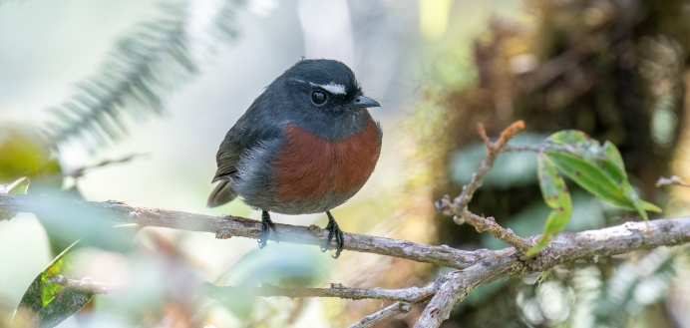 | 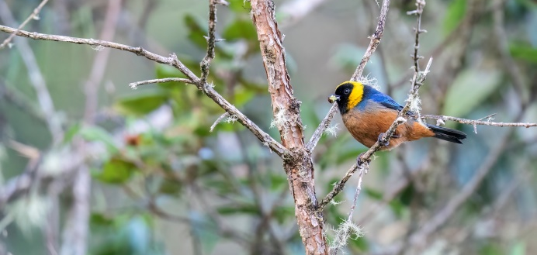
Slaty-backed Chat-tyrant | Golden-collared Tanager

Coroico / Death Road – Main Road (2350-2450m) -16.27631, -67.79213
Driving towards this spot we stopped a couple of times, with Pale-footed Swallows being the best species. We parked (and camped) at a nice pull-off from the road (-16.2763, -67.79213) and walked a couple of 100m up the road. We soon heard Rufous-faced Antpittas (e), and by crawling in the shrubs we finally managed to see one! Trying our luck even further we taped in Diademed Tapaculos that were calling and one actually came towards an open part of the bush! Watching this we were startled by a loud wingbeat, which turned out to be a White-throated Quail-dove that shortly sat right in the open on a branch! White-eared Solitaire made an appearance, but after the previous three species his efforts were only rewarded with mild enthusiasm from our side. A flock with many Tanagers drew our attention, with Rust-and-yellow Tanager and Golden-naped Tanager as the best species. While watching this flock we suddenly saw Hooded Mountain Toucans not too far away. Photographing these we finally heard the sound of a bird for which we scanned already 100’s of treetops at different places (Upper Death Road, Apa Apa Reserve, Siberia). Suddenly it flew towards us and sat on top of a tree: Chestnut-crested Cotinga! Very content with this afternoon activity we walked back and past our car for a couple of 100 metres. Another flock produced Blue-and-black Tanager, and another Chestnut-crested Cotinga flew to a perch close by.

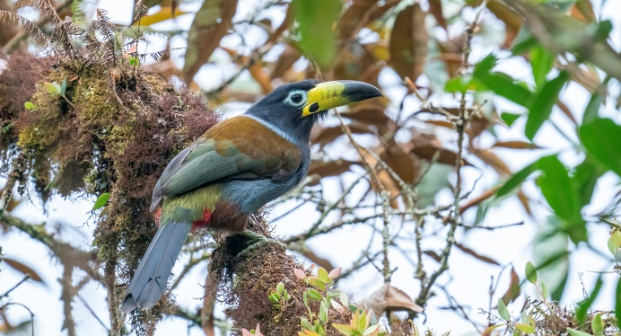 | 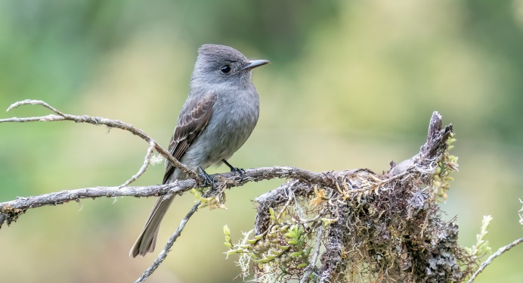
Hooded Mountain Toucan | Smoke-colored Pewee

Back at the car for a celebratory beer we observed Chestnut-collared Swifts fly over and had Blue-banded Toucanets calling from the surrounding slopes. That evening produced no mammals during a night walk, but did yield another Swallow-tailed Nightjar and a species of Screech-owl (we initially though Rufescent, but others had Cloud-forest Screech-owl and White-throated Screech-owl here). The next morning we observed some of these same (great) species as the day before, so they seemed to be locally hanging around. The only new species was a simple but elegant Smoke-colored Pewee.

Oriente de Yacuma -14.50056, -66.99635
Visited dates: 10-11 & 21 September 2022

Along Ruta 3 towards Trinidad lies San Borja. About 50km northwest of San Borja sits the small town of Oriente de Yacuma. Recently it has been discovered that the distribution of the rare and endemic Olallas’ Titi Monkey not only ranges along Rio Yacuma, but reaches further south. After carefully matching Google Maps with the research paper I was able to pinpoint the location of the observations, about 7km southeast of Oriente de Yacuma. This matched with other people seeing the species around Monte Carlos, about 10km northwest of Oriente de Yacuma, and reporting that they already saw the Titi Monkey along the way 45 minutes before reaching Monte Carlos (Thompson, 2021). After driving 2/2.5 hours over a very sandy and later very very bumpy road (driveable only in the dry season, best with a high clearance 4WD) we finally arrived north of El Carmen at the forest where the Titis were supposed to be found (-14.53107, -66.96218). The west side of the road was heavily deforested for the realisation of power lines. The forest on the east of the road was quite high and full of palms, and it was evident that lots of the trails going into the forest led to either illegally logged trees or chopped and burned down parts of the forest. We walked most of the trails going east into the forest, but only observed a couple of South Amazon Red Squirrels, South American Coati and two troops of Tufted Capuchins. After about 4-5 hours/15km of walking and searching we decided to drive along the road. Not far south of Oriente de Yacuma the forest changed and was significantly lower, which seemed better for the Titis as far as we understood from the literature. A beautiful big tree with pink blossom caught our eye and Rob thought he saw something in the top of that tree. It was hidden behind the flowers, but a couple of metres lower there it was; an Olallas’ Titi Monkey!! We worked our way into the forest and got relatively close to the group of 3 adults, one of them even carrying an infant!:) We got some nice sound recordings and pictures. After this we drove on towards Oriente de Yacuma and celebrated with a cold drink and an early dinner at the only restaurant in town (-14.50056, -66.99635). It turned out we were her first international customers, but they knew of more people coming for the Titi and seemed to know and care quite a lot about it. We camped in front of the restaurant as we had made an appointment with Gilbert, the owner of the restaurant, to search for the Olallas’ Titi the next morning again at 06.00. They said there are about 4 family groups around the town. In the distance we heard Bolivian Red Howler howling. We went into the forest and waited till 07.00, and then heard a group of Olallas’ Titis calling quite far away. We hoped the family group that is usually near the house would respond, but they didn’t. Later we tried to localize the other group by walking towards the vocalizations, but it turned out it came from quite far away. After getting 500m closer they stopped calling and we couldn’t localize them anymore. We then went to the area where we found the Titis the day before, but only heard the group vocalizing far away.

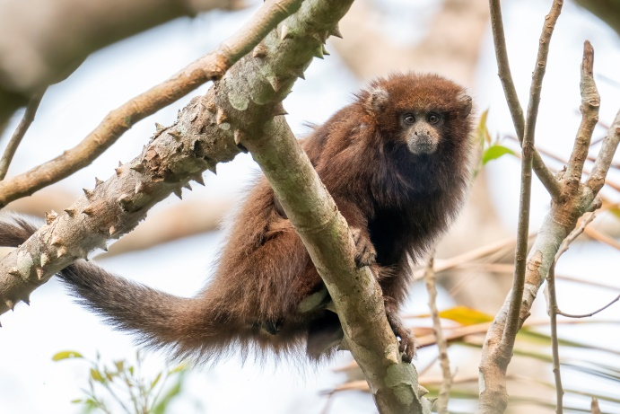 | 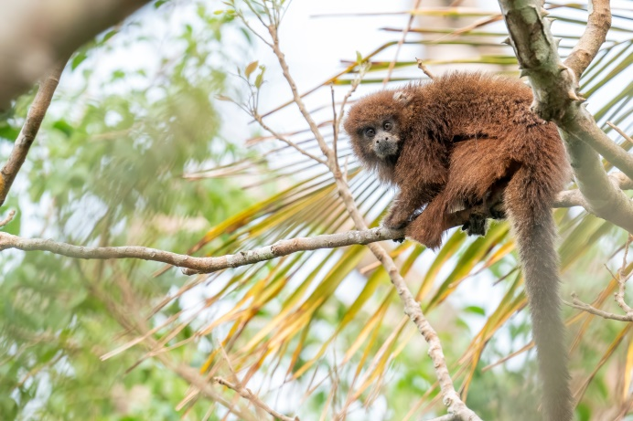
Olallas’ Titi Monkey | Olallas’ Titi Monkey

Walking the trails going into the forest again we found Tufted Capuchins, and one group was mixed with a group of Bolivian Squirrel Monkeys. Birds of note observed in the forest were Dull-capped Attila and Red-stained Woodpecker. On the drive back we had quite some Sunbitterns on the edge of the roadside pools, and 2 groups with in total 5 Streamer-tailed Tyrants, a possible split as this northern population is separated from the main southern population.

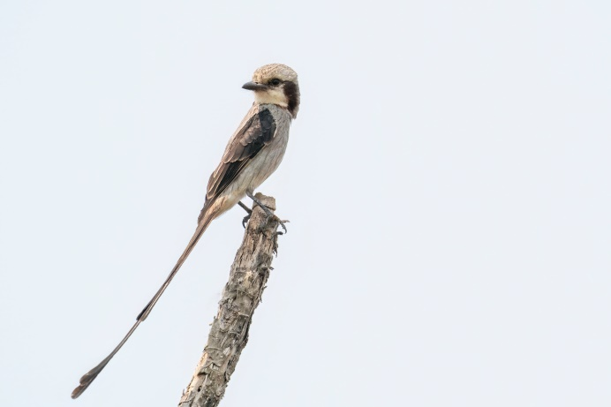 | 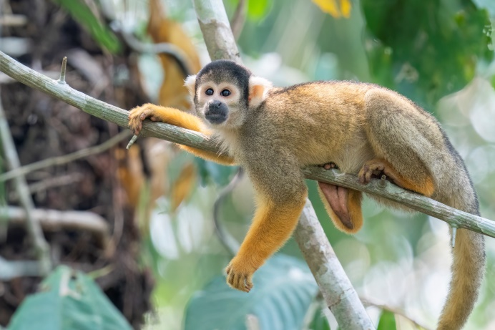
Streamer-tailed Tyrant | Bolivian Squirrel Monkey

We drove this road one more time for 25km during daytime and observed Dark-throated Seedeaters and Large Elaenia. At night we spotlighted back and suddenly saw bubbles in a small rainwater draining pool next to the road. Then Neotropical River Otter stuck its head above the water surface! Not what we would have expected in a dry habitat like this. Except for common species of nightjar and Crab-eating Raccoons we didn’t observe anything of note that night.
Trinidad region -18.10516, -63.5983
Visited dates: 12-20 September 2022

The drive from San Borja towards Trinidad is a very smooth one, and the new tarmac road is the best we’ve driven on in Bolivia. Only when you get closer to Trinidad the road is gravel again. Depending on the season you have to cross one or two rivers with something that the locals call a ferry, but is not much more than a wooden raft. As the water levels were low we only had to take one ferry (50Bs per car). Keep in mind that after rain the slopes towards the ferries are too slippery for most cars and the ferries don’t run after heavy rain.

Good birds to look out for while in Beni are black Seed Finches. There are possibly even two different species, so pay attention and record sound if possible. I won’t reveal any specific locations due to the risk of these birds getting caught for bird-cage trade. They sing from January – April, but gather in bigger feedings groups during the rest of the year. We found a group of at least 3 males and 3 females Large-billed Seed Finch.

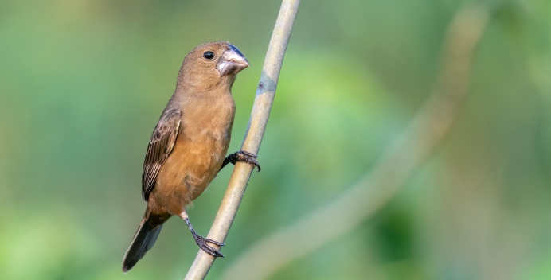 | 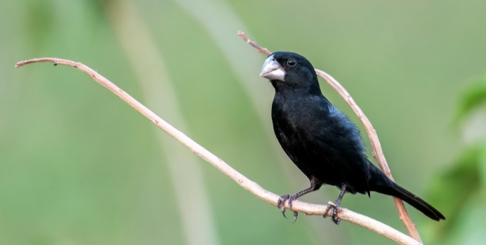
Large-billed Seed Finch female | Large-billed Seed Finch male

Trinidad – Puerto Ballivian -14.79543, -64.97339
About 15km west of Trinidad lies a small town along the river called Puerto Ballivian. South of the town is a trail that goes through some accessible Varzea forest. This is one location where the endemic Unicolored Thrush has been found. We visited this site two times, a week apart from each other. Both times we observed many primates. The first time a group of Bolivian Night Monkeys (active during daytime!), multiple groups of White-eared Titis, Tufted Capuchins and we heard the roaring thunder of Bolivian Red Howlers. The second visit we managed to see one Howler and again saw the Titis and Capuchins. It seems like a good place for the endemic White-eared Titis, and the ones we observed here felt more wild than those we observed in Santa Cruz.
Birding didn’t start all that bad with the tiny Rusty-fronted Tody-flycatcher, multiple Bolivian Slaty Antshrikes and many Fawn-breasted Wrens. The second time we also had the rare Rufous-breasted Piculet in a bamboo patch 100m into the trail! Two species of which the local subspecies will most likely be elevated to species level were quite common: Plain Softtail and Velvet-fronted Grackle. At the lagoon 1-1.5km into the trail we observed Band-tailed Antbird. The first visit we only observed one Thrush, but seeing only the back before it flew, we couldn’t be sure if this was the wanted endemic. The second time a thrush responded to playback, flew around our head and disappeared again in the shrubs. Typical for all the Unicolored Thrush encounters, but we didn’t see it well enough to be 100% sure. After this it didn’t respond again during our visit. On our way back from the first visit a large bird hopped in the tree, which Rob thought would be Spix’s Guan again from earlier that morning. When it flew away it was clearly not a guan! Luckily it landed in a faraway tree, and we were able to ID this as Crested Eagle!!

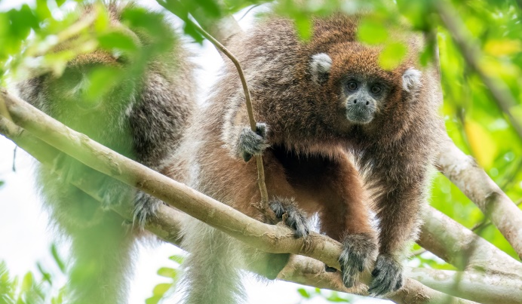 | 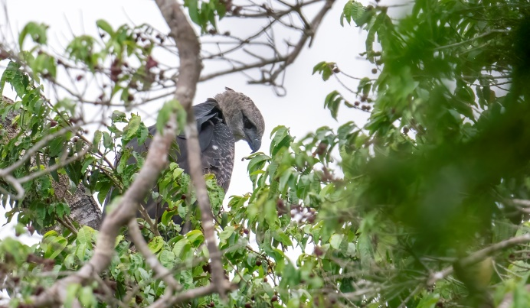
White-eared Titi Monkey | Crested Eagle

Trinidad – Loma Suárez -14.74037, -64.95306
A bit north of Puerto Ballivian is the town of Loma Suárez. The road going north from this town is not that good and should only be driven under dry conditions. A trail goes into the Varzea forest here (-14.74037, -64.95306) and Unicolored Thrush had been observed here too. An afternoon walk yielded almost no birds at all. The morning was livelier, but thrush-wise only Hauxwell’s Thrush and Creamy-bellied Thrush were observed. The vegetation around the bridge, just past the parking spot, yielded Rusty-backed Spinetails.

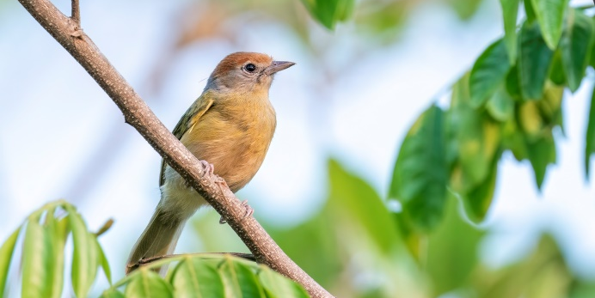 | 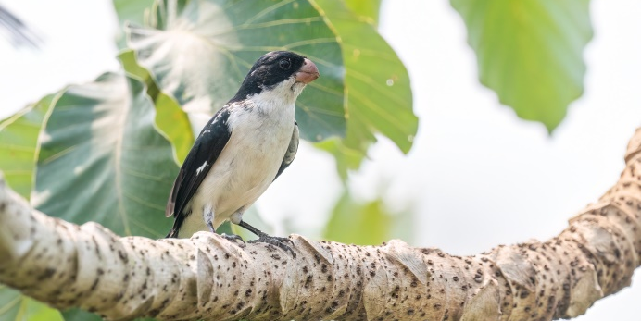
Beni Greenlet | White-bellied Seedeater

Trinidad – Laguna Suarez -14.87462, -64.87507
Laguna Suarez lies about 4km south of Trinidad and makes for a quick stop. Lots of the surrounding habitat has been destroyed for yet another restaurant or hotel, but there is still some left. We birded north of the Laguna (-14.87462, -64.87507) and quickly found multiple Mato Grosso Antbirds. The mysterious ‘Grey-eyed Greenlet’ (locally known as ‘Beni Greenlet’), most likely a new species, was found here as well!

A stroll along the lake shore yielded migratory waders like White-rumped Sandpiper, Pectoral Sandpiper and Stilt Sandpiper. The shrubs along the road (-14.87306, -64.87693) towards the tennis court were full of Brown-throated Three-toed Sloths, and at least 4 were counted, 2 of them with a youngster on the belly. Along this road we also observed Rusty-collared Seedeater and White-bellied Seedeater, both potential Beni splits.

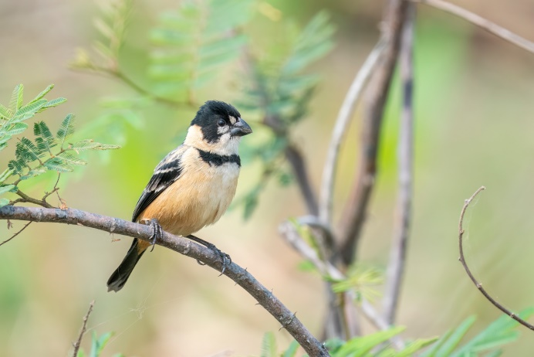 | 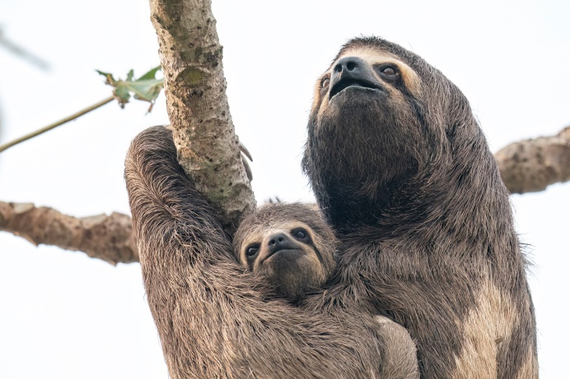
Rusty-collared Seedeater | Brown-throated Three-toed Sloths

Loreto -15.19333, -64.75627
Loreto is a good place to see the endemic Blue-throated Macaw. The drive up there is 50km, toll is 5Bs per car. Asking around in the village we got in contact with Richard Mauricio Barrios (+591 6895 1222), from the local Area Protegida Municipal Gran Mojos (150Bs p.p. entrance). 30 Minutes later we stood behind a tree looking at 6 gorgeous Blue-throated Macaws, while 2 more flew over our head. Rain impeded searching around the village after that until dusk, but we had 2 more flying overhead (besides the many Blue-and-yellow Macaws) just before dusk.

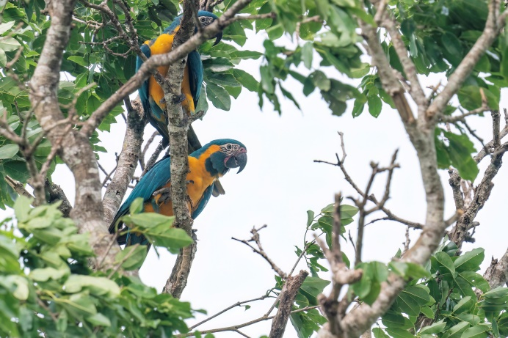 | 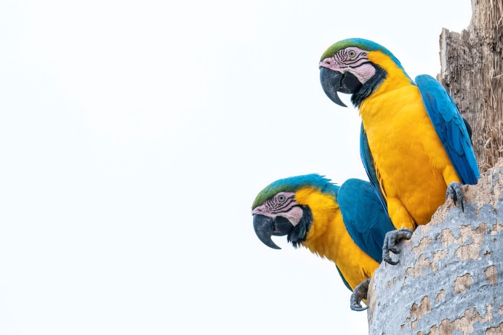
Blue-throated Macaws | Blue-and-yellow Macaws

Spotlighting the road from Loreto back towards Laguna Suarez (total 50km) was mainly interesting for the first 10km. In these 10km we soon found Scissor-tailed Nightjar, Little Nightjar, Great-horned Owls, a couple of Crab-eating Foxes and Crab-eating Raccoons. Romy spotted a family of Azara’s Night Monkeys (ssp. boliviensis) next to the road. While watching those for a while, Rob saw two whitish blobs in a palm tree a bit farther up the road. These turned out to be Brazilian Porcupines, eating the palm fruits! Amazing animals and (finally) our first porcupines during this world travel.

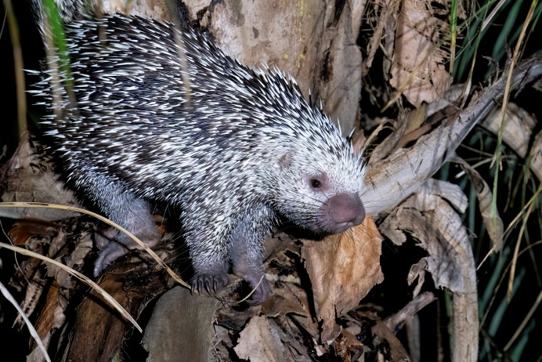 | 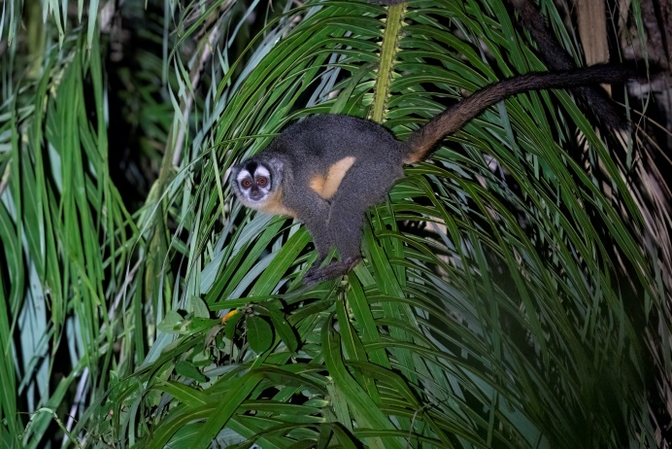
Brazilian Porcupine | Azara’s Night Monkey

Trinidad towards Santa Ana de Yacuma -13.75035, -65.42232
The drive from Trinidad towards Santa Ana de Yacuma is surprisingly good in the dry season (toll 10Bs per car towards Santa Ana). Lots of the habitat adjacent to the road is not too interesting, but we made some nice stops. A stop around some wet grassland (-14.4555, -64.8477) yielded many migratory waders, with Solitary Sandpiper as a new addition to the species at Laguna Suarez. On the way back we found Upland Sandpiper too on the grasslands in this region. After researching eBird and later walking a couple of km where we saw promising habitat along the road, we found a group of Long-tailed Reed-finches. The population in Beni is quite isolated and this might well be a split and thus endemic species in the future. The same holds to some degree for Great Pampa Finches observed at the same location, which have a different song compared to those in the highlands.

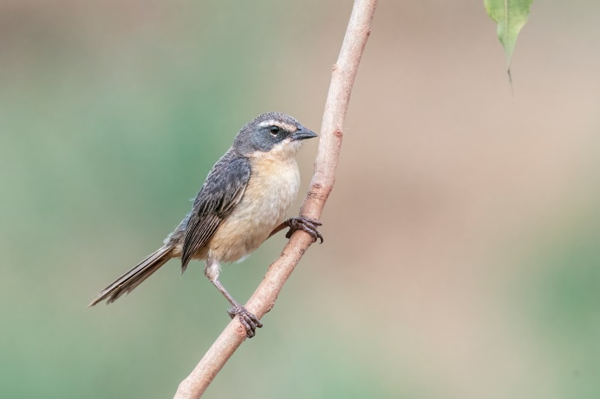 | 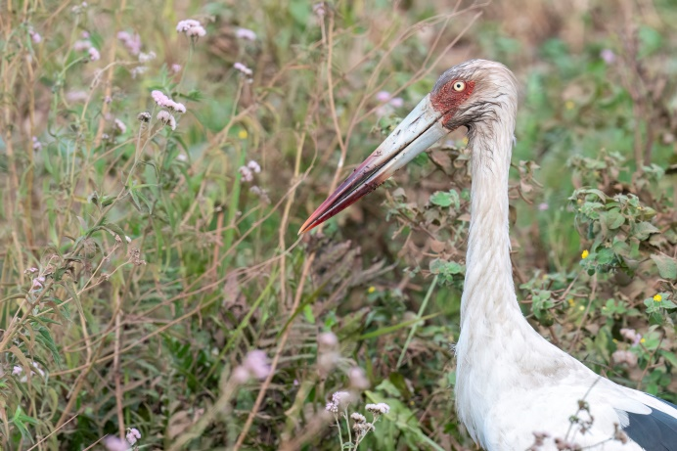
Long-tailed Reed Finch | Maguari Stork

Further north we took a (private?) side road and surprisingly again observed the not so common Reed-finches. Just when we wanted to turn around a Tayra walked on the road, and walked towards the side where Rob was waiting to get some decent pictures!

Take the left turn towards Santa Ana (right goes towards San Ramon) and eventually you will get to the river Mamoré again. Here you find very steep slopes going down towards small wooden rafts which take you across the river for 60-70Bs per car. We wouldn’t attempt this during or after the rain! Just before going uphill there were many waders foraging on the river side, including Pied Lapwing.

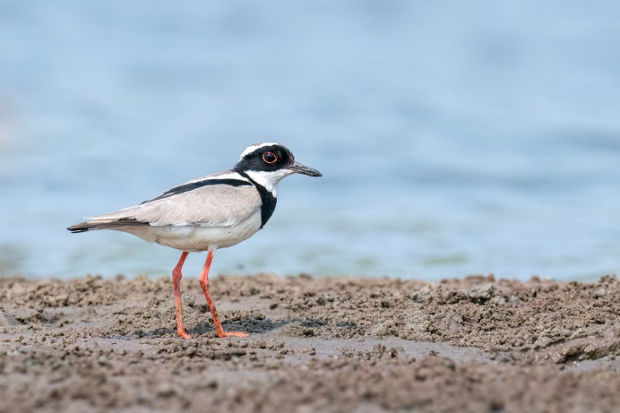 | 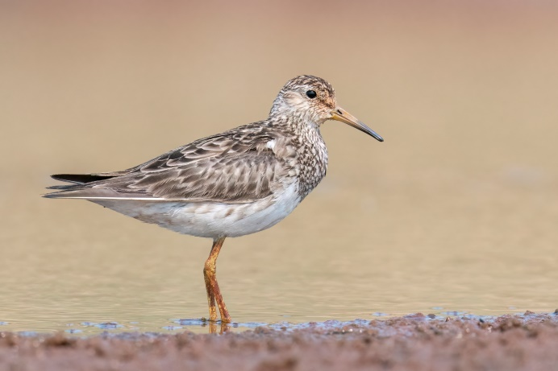
Pied Lapwing | Pectoral Sandpiper

Some marshes (-13.7818, -65.1801) added Rufous-sided Crake and Ash-breasted Crake to the Bolivia list. Pay attention to the famous big water lily leaves (Victoria boliviana) floating on the water at some places (for example -13.76873, -65.39679).

We observed White Monjita, Yellow-browed Tyrant and Yellow-chinned Spinetail in the small marsh on the left side of the road just before Santa Ana.

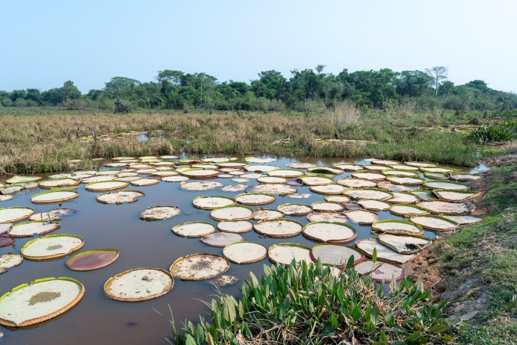
Water Lily - Victoria boliviana | Water Lily - Victoria boliviana

Santa Ana de Yacuma towards Exaltacion -13.75035, -65.42232
Directly north of Santa Ana de Yacuma is another river which has to be crossed by a hand-pulled ferry (15Bs per car). The drive towards Exaltacion is 50km, and the road is not as good as towards Santa Ana, but still ok. There are some interesting habitats along this road. Nice marshy areas (-13.6969, -65.4509, -13.38089, -65.30761 and -13.3594, -65.2788) were good for more common waders, including Paraguayan Snipe. This is where we eventually observed Buff-breasted Sandpipers and an Upland Sandpiper after some searching.

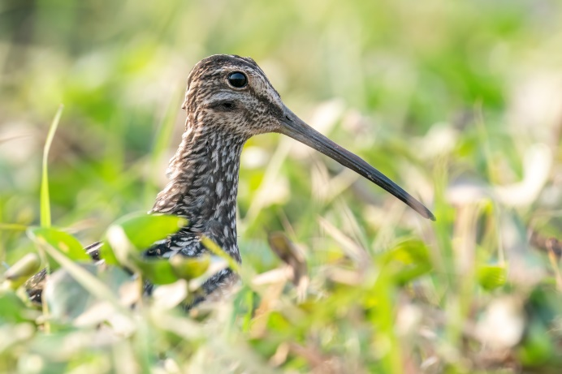 | 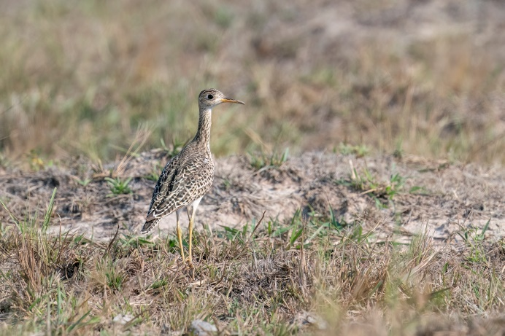
Paraguayan Snipe | Upland Sandpiper

Some other areas had cerrado-like habitat (‘Campo limpo’), and this is where Sharp-tailed Grass Tyrant, Black-masked Finch and Cock-tailed Tyrant were observed. The latter two are possible splits as well due to the isolated nature of their distribution.

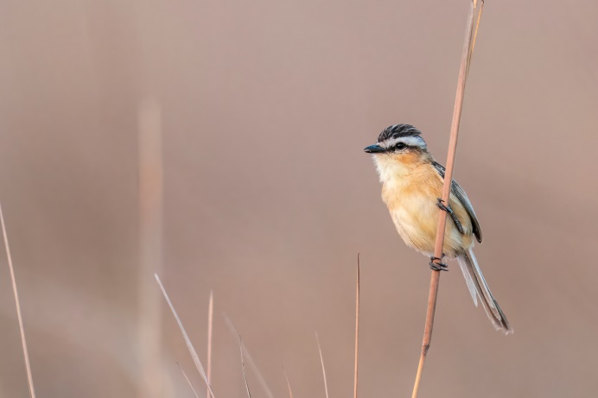 | 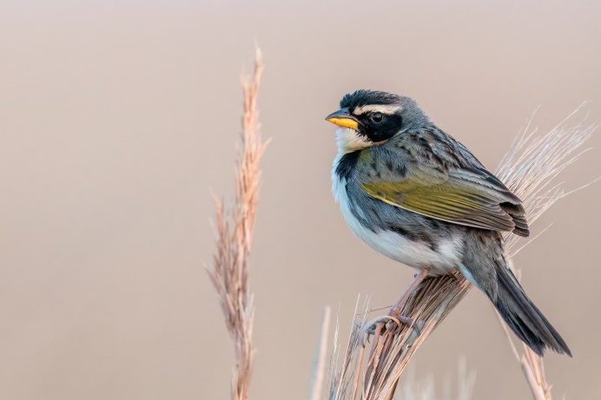
Sharp-tailed Grass Tyrant | Black-masked Finch

Close to the first good looking cerrado-like habitat (-13.6073, -65.4404) we observed a Giant Anteater with a young on the back in the late afternoon! They crossed the road and went for a drink. A good guess made us already sit down at that spot, and we were able to observe them from a 6-7m distance!

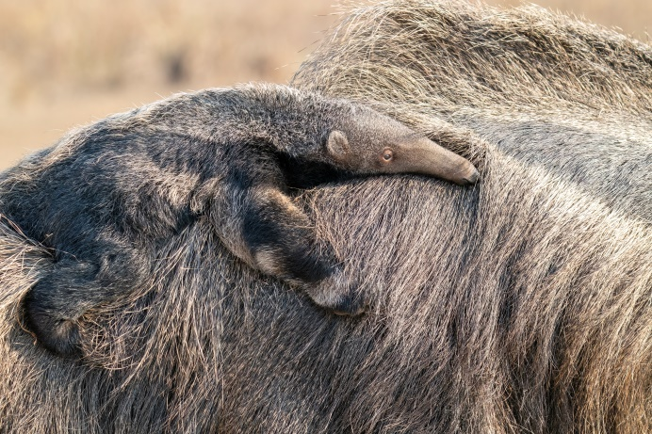 | 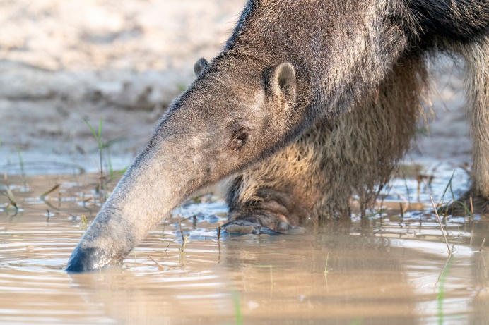
A little Giant Anteater | A giant Giant Anteater

Spotlighting at night didn’t yield much at first. There was surprisingly much traffic (maybe because it was a Friday night), and besides some Crab-eating Foxes we ‘only’ observed Southern Tamandua and Giant Anteater in 2 hours. The biggest surprise came later at the second patch of good looking cerrado-like habitat, when we caught the eyeshine of a nightjar on top of a low termite mount. Immediately Rob realized this could be White-winged Nightjar (WWN), but already from the car we could make out it wasn’t a male. Walking up to it and taking photos we realized this might be a female WWN! Photos were sent to experts in Brazil and Paraguay who worked with the species and they confirmed that this was indeed a WWN!! Only the third observation and the first female ever recorded in Bolivia. The two previous records are male WWN, observed at Beni Biological Station ±150km west of Trinidad (11 September 1987 and 14 September 2003). This female WWN was observed ±168km away from the previous records, 170km north of Trinidad (-13.4186, -65.3781).

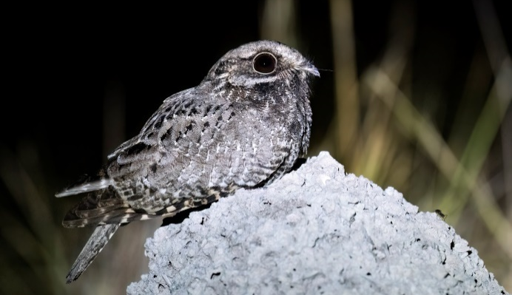 | 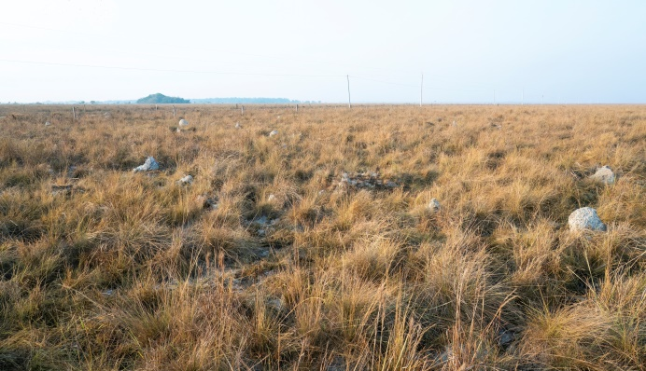
White-winged Nightjar | WWN Habitat

The next day we took pictures of the habitat where the WWN was found in and birded our way towards Exaltacion. At the river we observed Bolivian Pink River Dolphins most of the day (-13.30247, -65.24561. At dusk ±25 Band-tailed Nighthawks emerged from the surrounding shrubs and foraged over the river banks.

 | 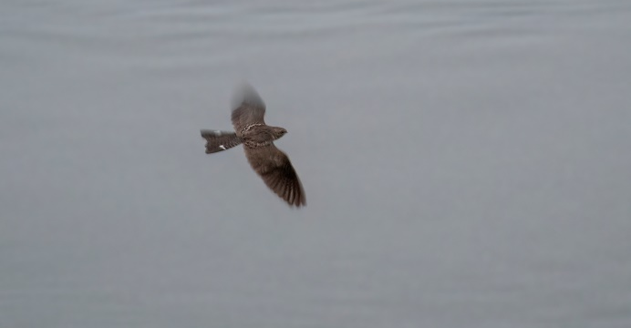
Bolivian Pink River Dolphin | Band-tailed Nightjar

Spotlighting back towards Santa Ana we picked up quite a lot of eyeshine from nightjars, but all identified nightjars in the vicinity of the village were Scissor-tailed Nightjars or Pauraques. Crab-eating Foxes and Crab-eating Racoons were again not uncommon, especially around the marshy areas. Rob picked up strong eyeshine again and said it looked like a cat. Looking more closely it turned out to be Mountain Lion/Puma! Walking up we took some record shots but the cat quickly vanished in the surrounding shrubs. Driving further we stopped regularly to stand on top of the car for a farther reach into the grasslands. Despite the WWN often sitting on termite mounts, the surrounding grass being low (±50cm) and quite open, the birds (and eyeshine) can be difficult to detect from a distance as we found out in Emas NP, Brazil. Romy picked up eyeshine far away in the field (50-60m) and then the bird flew straight towards us and sat down on the road. It turned out to be the exact same female WWN and we were only 50m from the spot of the night before. We observed another nightjar on top of a termite mount about 350m further up the road. This individual flew up and went down between grass tussocks. We had observed this behaviour with the female WWN the night before, as well as in Emas NP, Brazil. The pattern on the wings and style of flight suggested another female WWN. An extensive search through the grass couldn’t relocate this individual. We then drove 2km on the private road perpendicular to the main road, which had the same habitat, but found no other nightjars. Another interesting looking nightjar with a similar flying pattern disappeared in the grass 20km before Santa Ana de Yacuma (-13.6041, -65.4409). Again we couldn’t relocate this individual in the grass, but the habitat was comparable and it might have been another WWN.

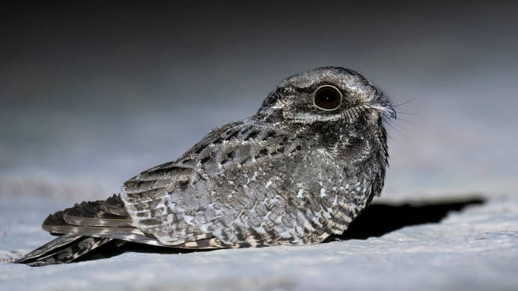 | 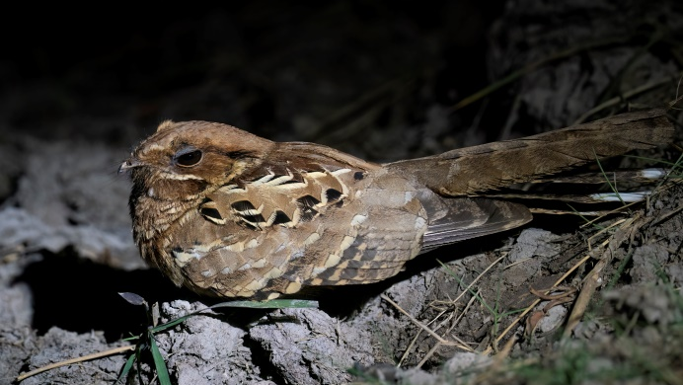
White-winged Nightjar | Rufous morph Common Pauraque

We did come across 3 more Giant Anteaters, one of them being the same individual with the young on the back at the same location as the day before, Southern Tamandua and Six-banded Armadillo. While photographing the armadillo, Rob sat down beside a patch of grass, while Romy hung about 10-20 cm above it to shine the flashlight on the armadillo. Suddenly Romy heard a rustling sound on top of the grass, which turned out to be a Fer-de-lance Viper!

A great night! Despite having two possible other individuals of WWN, we were only able to reconfirm the presence of the individual from the night before.

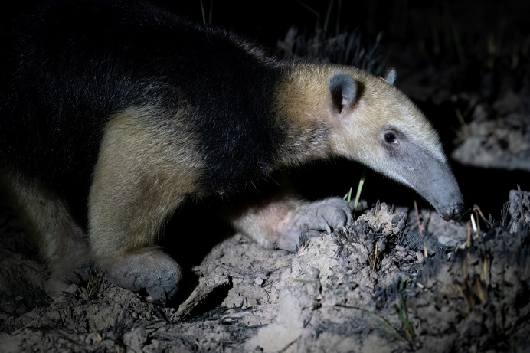 | 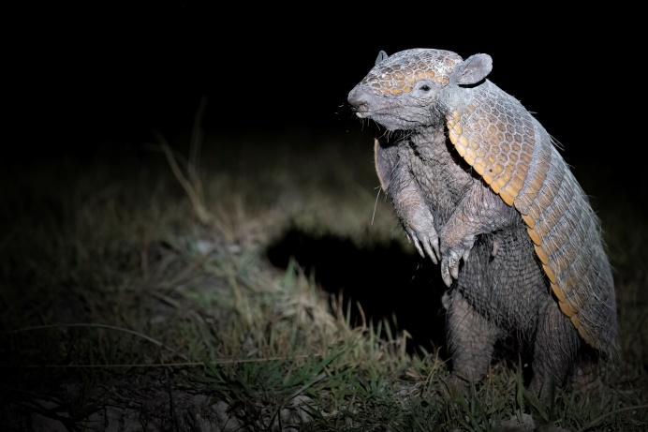
Southern Tamandua | Six-banded Armadillo

Santa Ana de Yacuma towards Barba Azul Lodge -13.75035, -65.42232
We drove the road going west towards Barba Azul Lodge for 45km (starting here: -13.70878, -65.45446). The habitat looked promising for WWN, but with larger suitable areas here, with the same type of habitat, some of it interspersed with small trees. These could be used for courtship display on moonlit nights. Here too we observed Black-masked Finches and Cock-tailed Tyrants. At two different marshy areas we found a total of 5 Pampas Deer. In very short, recently burnt grassland we observed multiple groups of Upland Sandpipers. We spent the day resting at Rio Ori, where we saw Nacunda Nighthawks resting in the grass too (-13.72626, -65.82764).

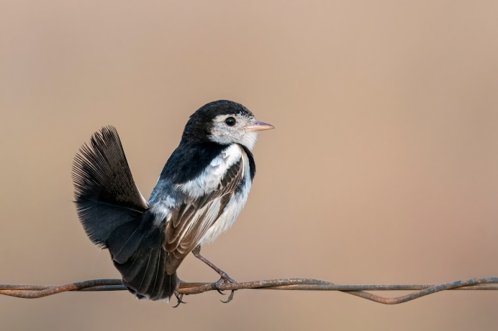 | 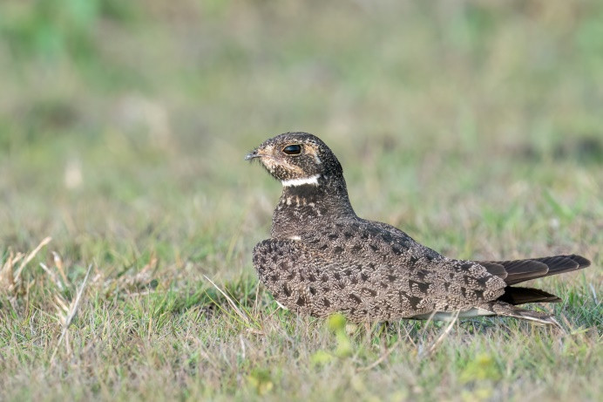
Cock-tailed Tyrant | Nacunda Nighthawk

We started spotlighting back from 19.00 and had another nightjar flying low over the grass within 3km of the start. We were able to follow it and this time we were able to find it back after it landed in the grass. This turned out to be another female White-winged Nightjar!! A great sighting, more than 50km west from the other individual (-13.75782, -65.7261). Despite being good habitat, we didn’t find more WWNs. But still, great news for a very rare species with only 4 known populations! All at least 1400km away in Brazil and Paraguay. Hopefully more can be found and this species can be protected in Bolivia too! Other nightjars turned out to be Scissor-tailed Nightjars, including one sitting on top of a termite mount. Mammal-wise we only observed Nine-banded Armadillo.

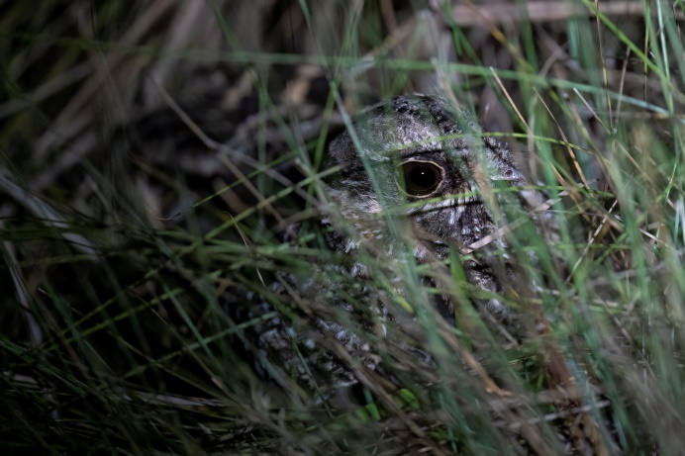 | 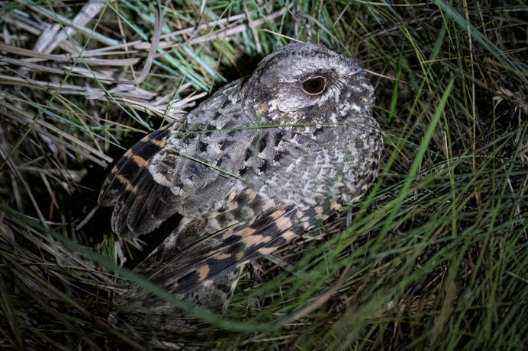
White-winged Nightjar | White-winged Nightjar

Santa Rosa de Yacuma -14.12185, -66.79652
Visited dates: 22-23 September 2022

There is a dirt road going from San Borja to Santa Rosa de Yacuma. The road is bumpy at places and it shouldn’t be driven after rain. It got closed off for a few days a week before because of the rain, but even a week later there were still some deep water pools we had to cross just north of San Borja. Despite this, it is still faster to drive this 80km than going all the way around. You have to cross a river of 15m broad by ferry just south of Santa Rosa, which costs 30Bs per car.

We drank a coffee at the spot where most tourists leave for the Pampas tours (-14.12185, -66.79652). Rob had seen Bolivian Pink River Dolphins really well here in July 2015, sticking their head totally out of the water. Now the river was low and there was only one individual that showed a fin every now and then. We also saw Yellow-spotted River Turtle sunbathing on the river’s edge.
We then drove towards a place we found in a research paper and was mentioned by the restaurant owner in Oriente de Yacuma. The place is called Aguaizal/Awaisal, and we figured this must be the place mentioned by other mammalwatchers as being ‘Aqua Sal’. This road (starting here: -13.9114, -66.80199) is the best place to see the endemic Rio Beni Titi. We found our first groups in the afternoon after driving the road for ±7.5km. Another group was foraging on the opposite side of the road. Then rain came pouring down and we could only start searching again the next morning. The first groups started their mourning chorus around 07.00. The last laughs (the typical Robust Titi sound) were heard around 08.15, so plan to arrive early if you want to hear them. We observed about 6 different groups, but heard many more, deeper in the bushes. We observed groups closing in on each other, making one Titi stand on its hind legs to make its shouting more impressive, while the other Titis bend their backs like a cat and retreated quickly. We observed quite a few groups of which one of the adults carried a young too. A really awesome primate and one of the easiest primates we have targeted so far during our world travel.

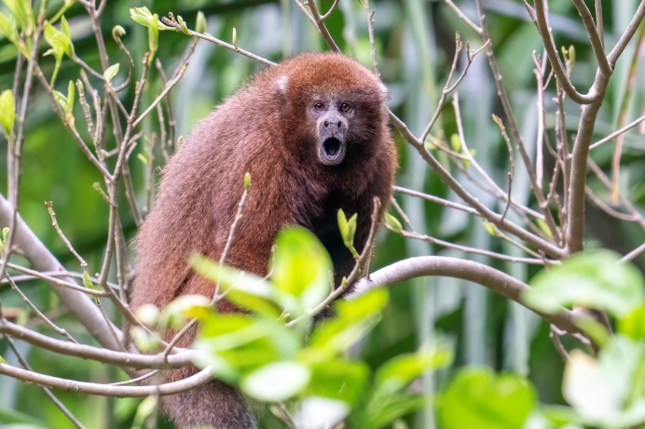 | 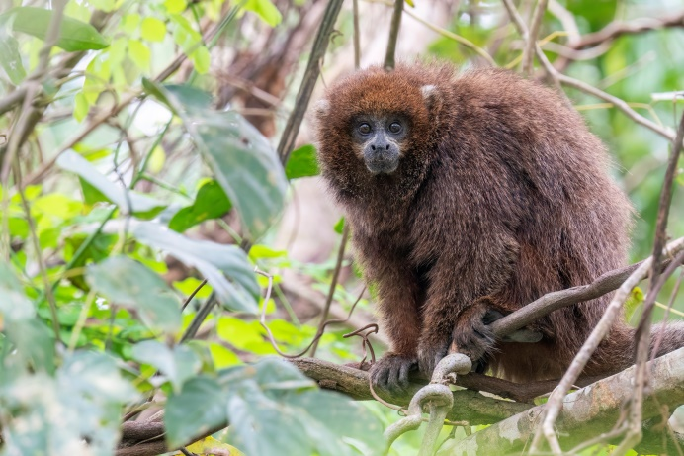
Rio Beni Titi Monkey | Rio Beni Titi Monkey

Madidi NP -14.16893, -67.91774
Visited dates: 29 September – 4 October 2022

We contacted the local guide from Sadiri Lodge, Raul, to guide us in Madidi National Park. The drive from Rurrenabaque to Tumupasa took about 1.5 hours. We had to cross several shallow rivers and streams, but they were busy building bridges. We agreed to meet Raul at 06.30 in the morning at the beginning of the road going from Tumupasa into Madidi NP (-14.15157, -67.88835). Arriving at the pointer we sent, we couldn’t find him. We decided to drive the road and after 5km we saw a sign stating we were at the Madidi NP offices. Opposite there was a sign saying ‘Welcome to Sadiri Lodge’ (nowhere near the pointer in eBird or GoogleMaps), but no Raul. We drove farther down the road and after a while decided to drive back. Doing the drive forth and back a few times, we finally found a Raul near Tumupasa. He didn’t get my WhatsApp messages (he checked it again on his phone), and it turned out he was not the Raul from Sadiri, but coincidentally had the same name^^. After driving the road again, not finding a road towards the lodge itself and not finding Raul, we decided to walk the path behind the sign. It turned out that he was at the lodge (-14.17003, -67.91553), and that there are no roads going to the lodge itself. The walk is a couple of hundred metres through the forest from the sign. After this 4.5 hours search, we were ready to actually search for some birds! As the morning was still cool from the rain that had fallen, there was still nice activity at the time. Three of our targets were quickly found in a mixed flock; Cinnamon-faced Tyrannulet, Yungas Tyrannulet and Yellow-shouldered Grosbeak. Standing on top of the viewing platform White-throated Woodpecker landed in a tree nearby and not long after, Rose-fronted Parakeets followed this example. Far away Black Spider Monkeys were calling loudly. At night we stood on the viewing platform again for nocturnal birds. Best birds were a calling Short-tailed Nighthawk that flew over our heads and two Band-bellied Owls which called close by (but couldn’t be seen).

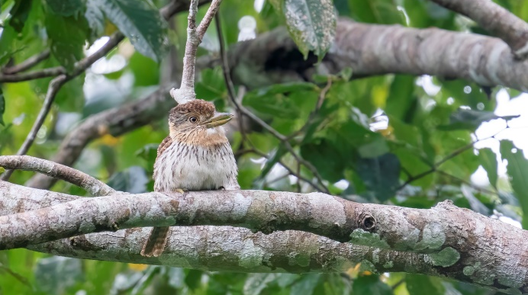 | 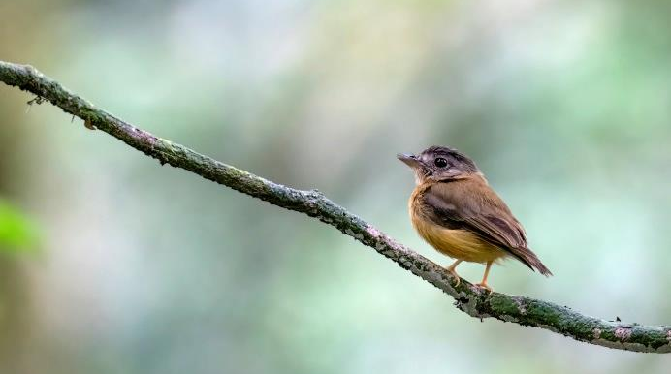
Western Striolated Puffbird | White-crested Spadebill

The next morning we started at 06.00 at the lodge. Chestnut-tailed Antbird was observed next to the dining area, below the hummingbird feeders (best hummingbird species: Many-spotted Hummingbird). Not long after Raul heard Bolivian Recurvebill (e), then we heard it too, but didn’t get to see it. We decided to walk down the main road, where we eventually did most of our birding. On this main road we had multiple observations of the rare Brown-headed Antbird, always near streams. We also got good views of a male Black-faced Antbird. After hearing the low sound of Razor-billed Curassow we walked stealth-mode and thanks to Raul’s sharp eyes we saw two of these amazing birds hopping in the trees! Round-tailed Manakins were quite common, but we also managed to observe Blue-crowned Manakin. Amazonian Royal Flycatcher (observed on two separate occasions), prolonged close-up views of Striped Woodhaunter, a male White-winged Shrike-tanager and seeing both Lemon-throated Barbet and Western Striolated Puffbirds sitting in a tree made it some productive walks! A frog hopped away just in front of my feet, and this turned out to be Brilliant-thighed Poison Frog (Allobates femoralis). When we got lower we heard Tufted Capuchins calling, and White Hawks were watching them from a nearby tree. The walk down eventually brought us to a lookout (-14.17702, -67.92054). This is the best place for Subtropical Pygmy Owl, which we heard 4 out of 4 times we were there, but never got to see. The walk back up is a bit more tiresome, especially in the morning when it gets warmer and bird activity dies out (around 09.00-10.00).

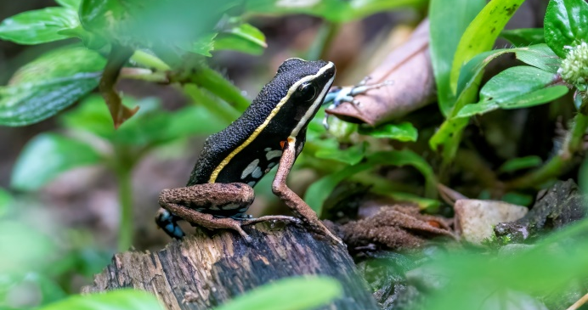 | 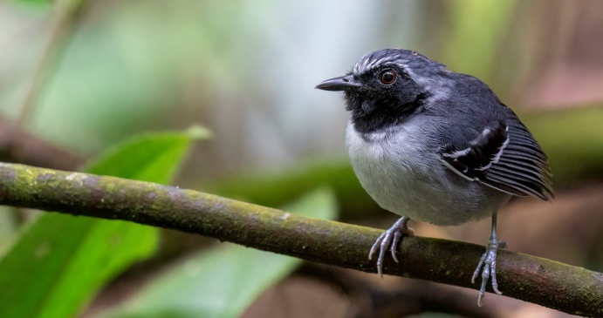
Brilliant-thighed Poison Frog | Black-faced Antbird

One afternoon we birded towards the park offices and a kilometre beyond (towards Tumupasa). A mixed flock produced some other tyrannulet targets, being Red-billed Tyrannulet and Slender-footed Tyrannulet. From the offices we also found Gould’s Jewelfront, which is quite rare in Bolivia. Just after the top Raul heard Bolivian Recurvebill (e) again. It took a while, but then we got good views of this rare endemic! While searching for this bird Raul also spotted Bicolored Hawk sitting in the shrubs and Tawny-faced Gnatwren hopping by. On a second nightwalk we heard the Band-bellied Owls again and also spotted Brown-eared Woolly Opossum high up in a tree.

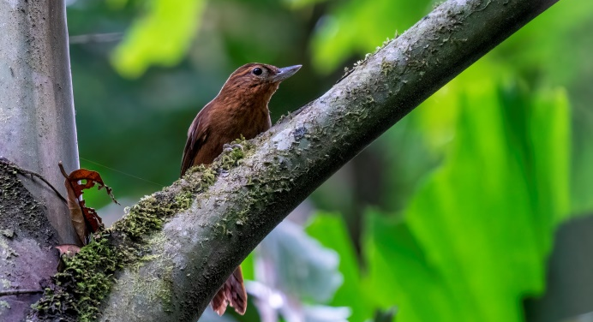 | 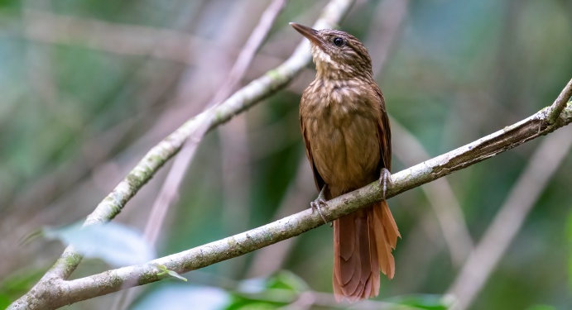
Bolivian Recurvebill | Striped Woodhaunter

The third day we went down to lower altitudes because we had most of our targets higher up (except for Scaled Fruiteater). We drove down to an almost dry riverbed, which was also our campground for the night (-14.19508, -67.96483). As it was still hot we sat down in our chairs, and from that spot observed Three-striped Flycatcher, Grey-headed Flycatcher and White-bellied Parrot. Walking towards San José Raul picked out one bird after another by the aid of their sound, and this is how we observed Bluish-slate Antshrike, Dwarf Tyrant-manakin, Red-billed Pied Tanager and after a lot of work Yellow-breasted Warbling Antbird. We saw multiple Dark-billed Cuckoos during the 2 days on the lower sites. On three separate occasions we observed cuckoos that Raul first IDed as Black-billed Cuckoo. A friend said that it was too early for these cuckoos, which migrate south slower than for example waders. Better looks at the pictures the cuckoos turned out to be Ash-colored Cuckoos, a species we missed in Argentina! Curl-crested Aracari, Ivory-billed Aracari and Golden-collared Toucanet were nice additions to our ever growing list of Toucan-species. During a night walk we heard Amazonian Pygmy-owls, Tawny-bellied Screech-owls and Long-tailed Potoos. We also observed another Brown-eared Woolly Opossum and a distant Kinkajou.

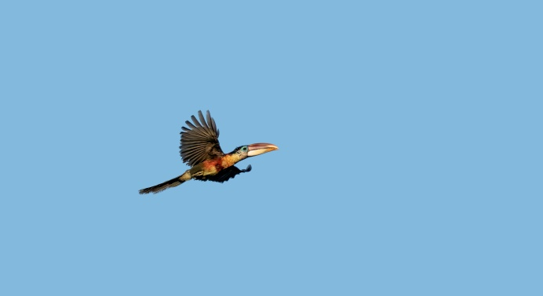 | 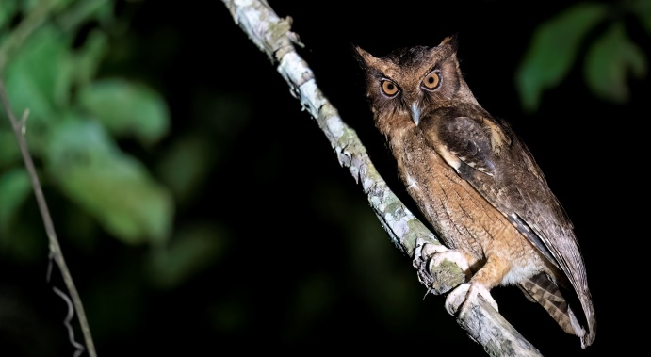
Curl-crested Aracari | Tawny-bellied Screech-owl

The next morning we had amazing views of the weird-but-awesome-looking Hairy-crested Antbird! As we didn’t hear our main mammal-target yet around this campsite, we decided to go to another place after an hour of birding. The river a bit farther towards Sadiri Lodge was supposed to be good for Madidi Titi Monkey. We searched the whole morning in vain, and only heard a very distant group of Titis calling. We were a bit bumped out by this, especially because Raul said this species was ‘easy’ and it turned out he only saw it a couple of times around here. So at lunch we were already making back-up plans and planning where to go the next few days to see this primate. Bare-necked Fruitcrow and Broad-billed Motmot made for a nice distraction from all that ‘planning’. Around 15.00 we went birding again and Raul had talked to some locals about the Titi. It turned out that someone with an illegally build house in the forest actually hears them right next to his house every morning. We went there (-14.211314, -67.940478) and played the sound of Coppery Titi (as that was all we had available). Right away two Madidi Titi Monkeys came out of the bushes and sat in a nearby tree, quickly resuming their daily routine by eating a caterpillar and grooming each other. Excited that we had our main mammal-target and that we got such good views, the slow birding in the afternoon heat didn’t bother us at all.

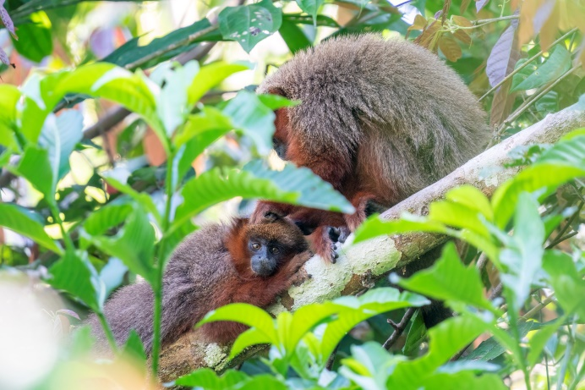 | 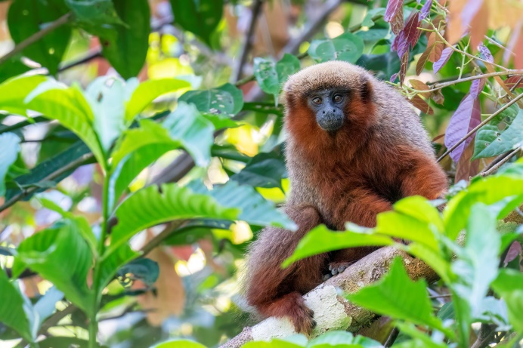
Madidi Titi Monkey | Madidi Titi Monkey

We walked from the second camping place at the river (-14.21242, -67.94306) towards the first camping place and heard Lawrence’s Thrush singing. These birds are not easily observed, but this one came all the way down to eye level! Around the same area we also managed to see Amazonian Pygmy Owl during the day. Spotlighting at night yielded no mammals, but we did hear Crested Owl and Silky-tailed Nightjar.

The next morning Raul picked out White-browed Antbird. Later he heard another sound and then we went deep into the forest, put down the speaker and played the recording once and waited… and waited… After about 5 minutes Ringed Antpipit came walking slowly past the speaker and hopped a few times on the nearby branches. Coming out of the forest, high whistles alerted us to the presence of Weddell’s Saddle-backed Tamarins, which we had only seen very briefly the day before. We had great views of a group foraging, jumping from branch to branch, while Double-toothed Kite watched from a nearby branch to see if he could snatch one.

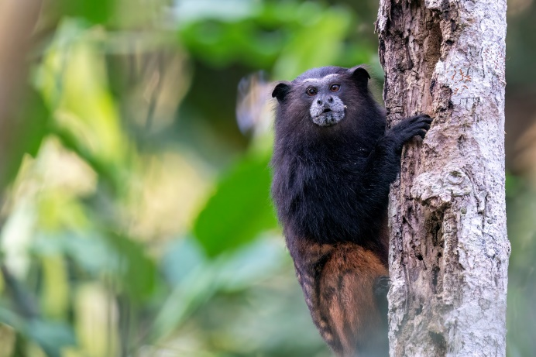 | 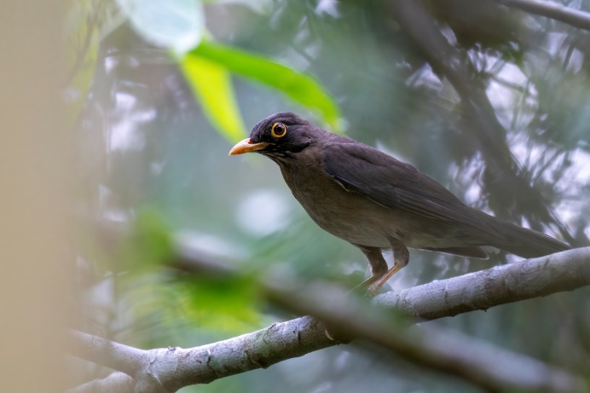
Weddell’s Saddle-backed Tamarin | Lawrence’s Thrush

We walked back to the river and Raul saw a black and white bird sitting on a dead tree. First thought was a Tityra, but a photo revealed the purple patch underneath its beak. It was a male Purple-throated Cotinga! Very rare in Bolivia and only the 3rd documented observation. Walking further towards the river we now heard Madidi Titis calling closer to the road and were able to observe them again. We missed two targets in the lower parts of the valley (Pale-winged Trumpeter and Rufous-vented Ground-cuckoo), but left Madidi NP very content with all the amazing birds and mammals that we had seen!

Sadiri Lodge is located very nicely and definitely the way to go if you want to bird the area. If this lodge is not within your budget, you could opt to sleep in Tumupasa and drive the 5km (about 15 minutes) and bird yourself along the road. Officially there is a 200Bs entrance fee per time you enter the area, but we only paid it once (via Raul). We camped next to the ranger station, but there were no rangers present these days. You can also stay in San José de Uchupiamonas. There should be lodging there for about 10 people, and there should be options to eat as well. As there is no way to reserve this online, Raul said that he can arrange and confirm this for people wanting to visit this region. Raul can be contacted via WhatsApp in Spanish or English (+591 76229388).

Atén -14.94247, -68.32279
Visited dates: 6-7 October 2022

After two nights of relaxing in Rurrenabaque we made the very long drive towards Aten. Luckily there is no road through the PN Madidi (yet…), but it does mean you have to drive about 520km around the park to get to Aten. The part from Rurre to Yacumo is tarmac, flat and easy (±1.5h). The road gets worse between Yacumo and Caranavi (±4h). Caranavi to Aten takes even longer (±7h), as the road makes many turns, you pass quite some villages and the road is not always in the best state. Try to avoid rainy days and the days after, when the road is barely passable. There are multiple places where you have to pay toll for the road (10bs total), but also a fee for the local community (26Bs total).

In Atén we made multiple stops along the roadside, mainly for one of the main targets in the region; the very localized Green-capped Tanager. The name makes absolutely no sense, as the cap has a buffy colour. In fact, the Green-capped Tanager looks like a washed-out version of Burnished-buff Tanager. We stopped at every bigger patch of isolated forest next to the road. These are mostly located in the valleys between the surrounding artificial grasslands. A place where they are sometimes seen is in the valley about 5km after Aten (-14.90663, -68.33581). We walked along this patch of forest and shrubs towards the top (-14.90083, -68.33487, a good place to camp as well, just down behind the curve), but couldn’t find this tanager. Swallow Tanager and Black-faced Tanager were abundant; besides these we saw another 5 species of tanager, including Spotted Tanager.

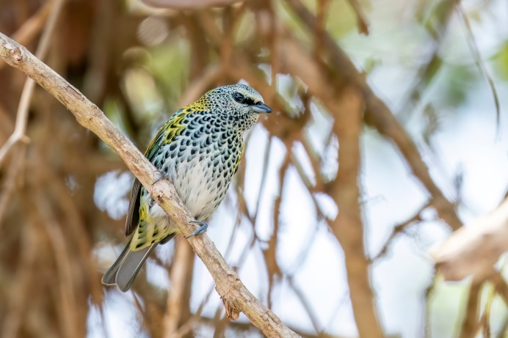 | 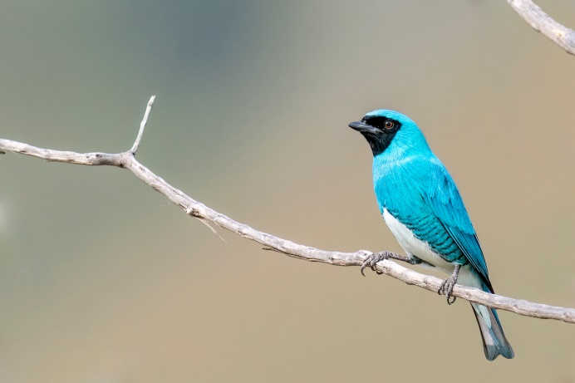
Spotted Tanager | Swallow Tanager

We continued for about 5km towards ‘Pachaque’, a place consisting of two houses (-14.87269, -68.35304). We took the road leading left here for 1.4km. From there the road continues on a small ridge, with sparse vegetation on the sides. This is a good place for the endemic Palkachupa Cotinga (a future split from Swallow-tailed Cotinga). In this valley we also observed White-crested Elaenias. Walking this road until the first hairpins going down (-14.88505, -68.36184) should give you some nice views of this amazing endemic. It took us some time as we were mainly scanning the wrong trees (high ones on the other side of the valley), but it turned out the birds are in the small shrubs and trees. We got very nice views of these colourful birds here, but we heard locals came asking for money to a birding tour the next day and without payment told them to leave.

With great views of our main target we went back to the valley 5km after Atén. Walking down and up again we observed another 3 Palkachupa Cotingas! We also observed Cinereous-breasted Spinetail and had Fork-tailed Flycatcher fly by. We camped at the top of the road, and tried again for the Tanager the next morning, but came up empty handed. Later that day we met a birding tour group at this place, and they did find the tanagers here (behind the small house in the field on the west side of the road).

As our search for the Tanager was not successful yet we decided to drive back to Atén, and walked the dirt road going southeast 2km before Aten (-14.94247, -68.32279). We walked this road with some very nice habitat for 2km and observed another 8 Palkachupa Cotingas! Two of them were already busy building a nest. Along this road we observed Pale-breasted Spinetails. After arriving back at the main road we walked the road towards Atén for 1km. This patch of road has some good habitat next to it too. We saw quite some Lesser Elaenias, and heard even more. Just when we turned around and decided we would search for the Tanager northwest of Apolo, two Green-capped Tanagers flew in the tree next to us! We got great views of this bird, and we were glad that the 7 hours of walking for this bird specifically were finally rewarded.

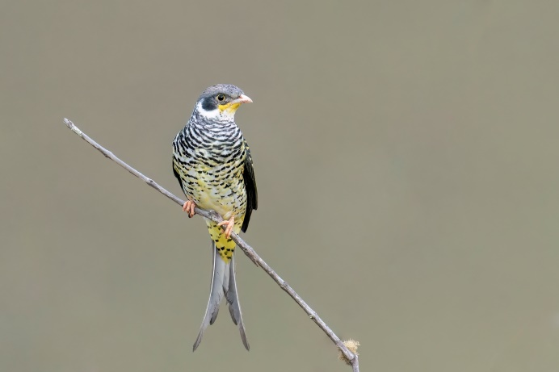 | 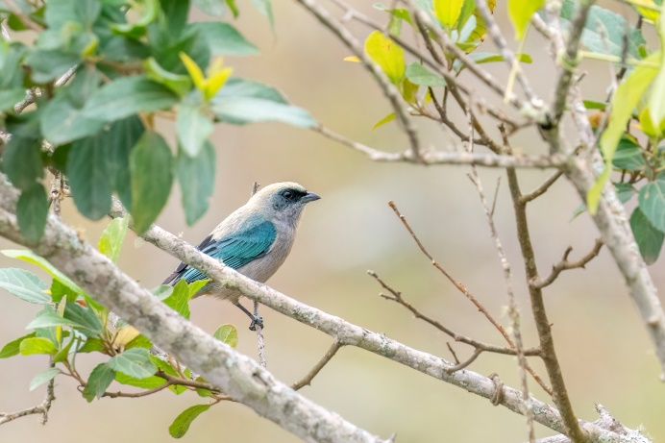
Palkachupa Cotinga | Green-capped Tanager

Apolo – Machariapo Valley -14.44018, -68.53163
Visited dates: 7-9 October 2022

Apolo is a bigger town and one of the few places to get fuel in the region. Fill up on fuel on the way towards Apolo whenever you can, coming from Caranavi, because we had problems getting fuel in Apolo with our foreign car (see intro), partly because they were about to run out of gasoline. Gladly we managed, but keep in mind that there are always some shops selling fuel for a higher price somewhere in town in case the gas station runs out.

In Apolo we waited for the rangers at the Madidi NP office to finish their lunch break. The guide from the birding tour group told us we needed to register and pay the entrance fee (like in Sadiri), but at the office in town instead of an office along the road. It turned out the rangers didn’t know of any entrance fee, but took out a blank paper to write our names down as a way of registration. We didn’t see any gate/rope across the road either, so no control post. If you want to be 100% sure to not have any problems, you can register as well (-14.70919, -68.42005), but it seems like it is not necessary. The opening hours of the Madidi NP office are 08.30-12.30/14.30-18.30.

We drove the 45km towards the Machariapo valley with a little bit of fear. We drive a 2WD and there is a river crossing to be made 10km before the birding location, and it had rained quite a lot 2 days before. The road was still pretty ok, with some slippery and muddy parts, water pools and shallow streams. We arrived at the first river crossing after 20km and waited for a local to lead the way, just to be sure we wouldn’t be hitting any of the big stones hidden underwater. This turned out to be only a nice test drive for the second river crossing. Lots of cars were waiting on both sides, while people were wading through the water to feel where the rocks were, and what the best and shallowest route would be to get through. Luckily there was quite some traffic and we could observe the way to go from the locals. Even our hood went under water at one point, and some of the lower cars from the locals literally floated for some parts.

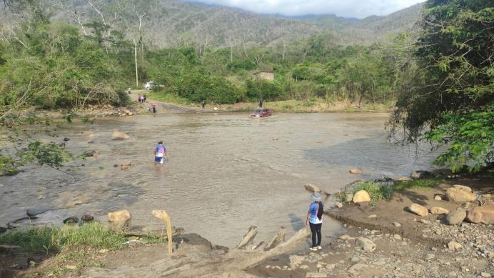 | 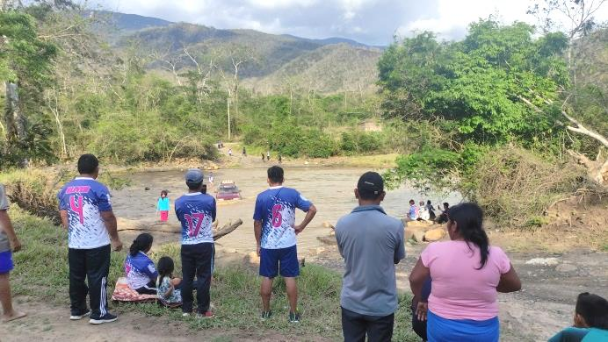
River crossing by another car | River crossing by another car

Glad that we made it to the other side we drove the last 9.5km towards the top of the hill (-14.44018, -68.53163). The big target in this valley is the Inti Tanager (previously known as San Pedro Tanager), a spectacular looking bird, only recently discovered, and described by science as a species only this year (2022). These birds are neotropical migrants, migrating between Peru and Bolivia. The earliest record in the year we could find was on the 9th of October, but most sightings are made in November-December. We hoped that the 7th of October this year would be early enough as well. We parked our car a bit lower from the top, played the tape once and got a response right away! A bird flew into the lower shrubs and hopped through them. Not much later we stood eye to eye with one of our most wanted birds in Bolivia, the Inti Tanager!

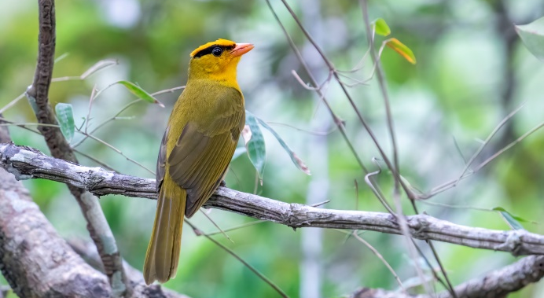 | 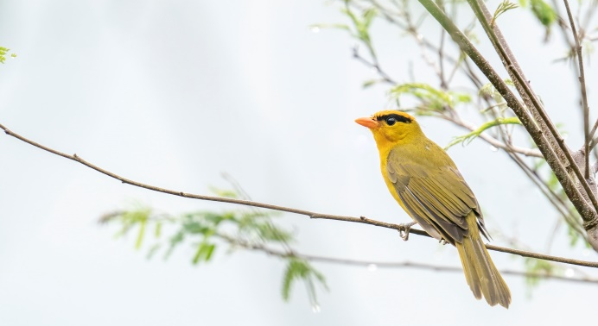
Inti Tanager | Inti Tanager

At night we walked around our camping spot, which was right next to the road (-14.435525, -68.536226) and heard Tropical Screech-owl, Common Potoo, 4 different Ocelated Poorwills and 3 Rufous Nightjars. A better campsite with a tent on the ground would be a little pull-out next to the road (-14.4094, -68.54256), where you are safe from the traffic, driving even at night.

The next morning we walked down from our camping spot for about 2km. We soon observed Black-capped Antwren, which has an isolated population in this valley and is therefore an expected split as Inambari-Tambopata Antwren. Luckily it is quite common and easily encountered. Listening for rustling of leaves made us observe both Black-faced Antthrush and Black-capped Tinamou. Striated Antbirds were heard more often than seen, and to see one we had to crawl into the shrubs and dense vines.

Back at the car we walked up the hill again and quickly heard Inti Tanager calling around 08.30, about 200m lower on the road than the afternoon before. Again it responded well and came up quickly, first going in the lower dense shrubs before hopping between the branches a bit higher up. Walking farther to the top we observed two more Inti Tanagers calling in the distance. The birding group we met at Atén arrived very late and didn’t encounter the Tanager in the morning. In the afternoon we took them to the spot where we had the very cooperative individual, but surprisingly (and disappointingly) the Tanager decided to stay on the other side of the valley this afternoon. Ironically the next morning the Tanagers were already singing at 06.30 and another just before the top (without using playback).

White-browed Brushfinches and White-bellied Pygmy-tyrants were seen near the top, and both Upland Antshrike and Barred Forest Falcon were heard during the two mornings we spend here. Only the last morning we finally connected with Black-bellied Antwren, which also has an isolated population in this valley and is therefore a possible future split. In a tree we observed Grey-bellied Hawk.

We also birded a trail 5km lower in the valley (starting here: -14.39604, -68.54148). Inti Tanagers have been observed farther in this valley, but we didn’t find them here. We did observe another Black-capped Tinamou. About 800 meters in we found the other target in this area; Ashy Antwren. It seemed to have a territory there, as it was still present 4 hours later when we past the spot again and we were able to observe it foraging for about an hour before we went on our way again.

We missed Ocellated Piculet and White-rumped Sirystres, which can be seen in this valley too. On the way back the river was lower and the crossing way easier. Just before the crossing we observed Hooded Tanager and just after the crossing Bluish-fronted Jacamars.

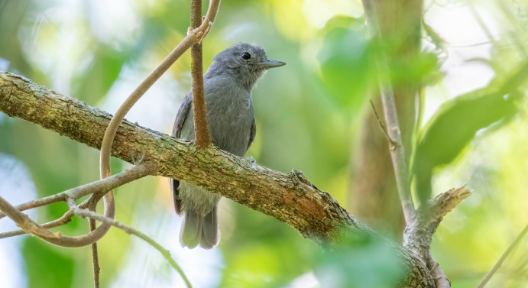 | 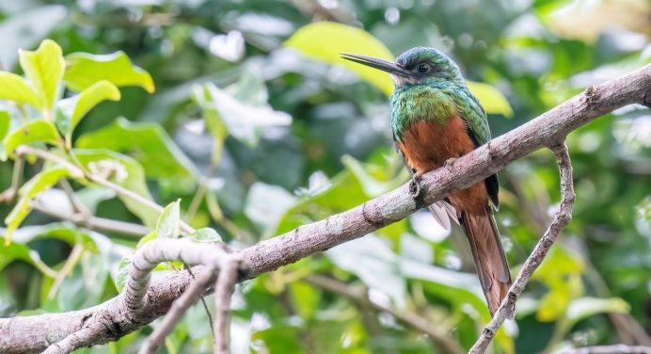
Ashy Antwren | Bluish-fronted Jacamar

Apolo – Lake Titicaca (R16) -15.18523, -68.89046
Visited dates: 9-10 October 2022

On the way from Apolo to Lake Titicaca we spend the night at a camping spot close to the river (-15.18523, -68.89046). Spotlighting along the road we found multiple Lyre-tailed Nightjars, including some males with extraordinary long tails!

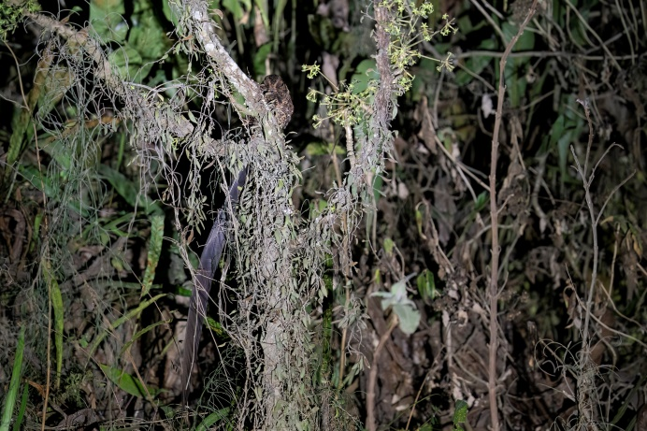 | 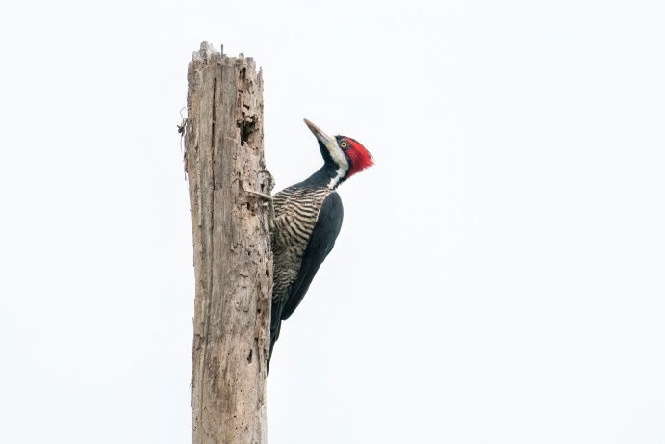
Lyre-tailed Nightjar | Crimson-crested Woodpecker

Mammal-wise we observed Amazonian Grey Brocket/Amazonian Brown Brocket (Mazama nemorivaga, big thanks to Javier Barrio for the ID). Thanks to a tip from Jacob and Tini, the biggest spectacle had yet to come that evening. About 2km farther from our camping spot is a small wall on the right side of the road, with a small water pool beneath (-15.18082, -68.90536). Already around 19.00 we saw the first silhouette flying in the air, and within an hour we heard about 12 Oilbirds clicking above the road! An amazing spectacle to witness!

Sorata -15.82446, -68.64348
Visited dates: 10-11 October 2022

We drove to Sorata to see one of the last endemic birds species in Bolivia we hadn’t seen yet; the Berlepsch’s Canastero (e). We parked on the left side of the road (-15.82446, -68.64348) and walked between the shrubs on the other side. It didn’t take long before a Canastero came up in a shrub next to us, but this individual didn’t allow for good views. Climbing a bit higher in the field another individual climbed up in a tree and started calling. While scouring through the field, we flushed Huayco Tinamou, which we heard again later that afternoon. We climbed up higher and crossed the road and encountered two more Canasteros (-15.82843, -68.64415). This is also the place where we camped for the night, as it was a bit farther from the main road. Walking down the road, past our car, there is a small trail through the shrubs (-15.82295, -68.64257). Here we found yet another couple of Canasteros, which brought the total to 6 this afternoon! Surprisingly, we only found 2 the next morning, even though we visited the same locations. Other nice birds in the area are Black-throated Flowerpiercer (very common), White-winged Black Tyrant (common) and if you are lucky you can observe Black-hooded Sunbeam (e) or Yellow-bellied Siskins.

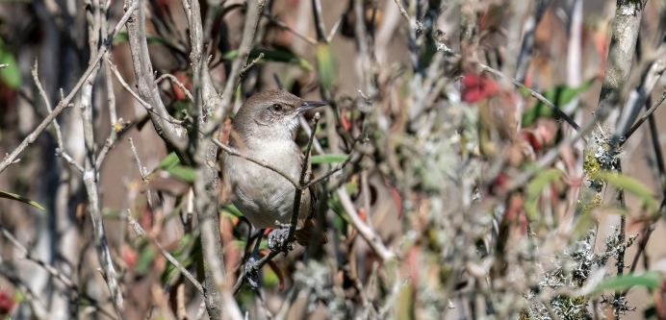 | 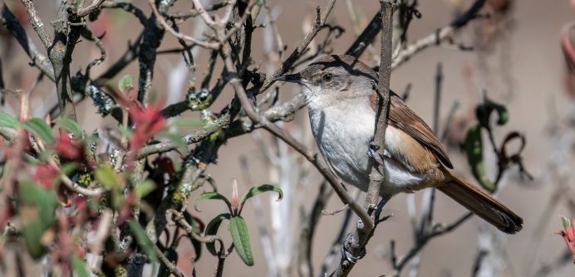
Berlepsch’s Canastero | Berlepsch’s Canastero

Lake Titicaca -16.23075, -68.58554
Visited dates: 11-12 October 2022

The main reason to visit Lake Titicaca is of course the Titicaca Grebe, also called Short-winged Grebe. We made multiple stops along the lake and encountered quite many during the day. Our first stop was at Hotel Lake Titicaca (-16.20456, -68.63038). Here we observed 7 Grebes with the aid of our telescope. In the ‘tule’ bulrush reed beds we viewed Yellow-winged Blackbirds, Wren-like Rushbirds and Many-colored Rush-tyrants, which all turned out to be common during the rest of the day. A stop at the Inca Utama Hotel (-16.21454, -68.6832) added Black Siskin and Plumbeous Rail to the daylist. A third stop on the eastern side of the lake made for a nice walk on a small dyke-road towards an island (-16.23075, -68.58554). All the species above were seen here too. Puna Teal, Yellow-billed Teal (Inca Teal) and White-tufted Grebe were all seen from this road. We camped on this island and had Cinereous Harriers fly by in the evening. A fourth place that could yield nice views of the Grebes is Hotel Las Balsas (-16.28473, -68.60229). Here you could rent a boat or even a paddle boat to get another view of the lake. Short-billed Pipit and Short-eared Owl have been seen around the eastern side of the lake, so keep an eye open.

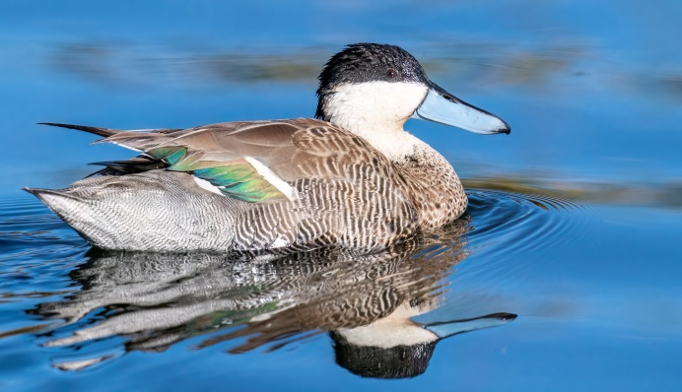 | 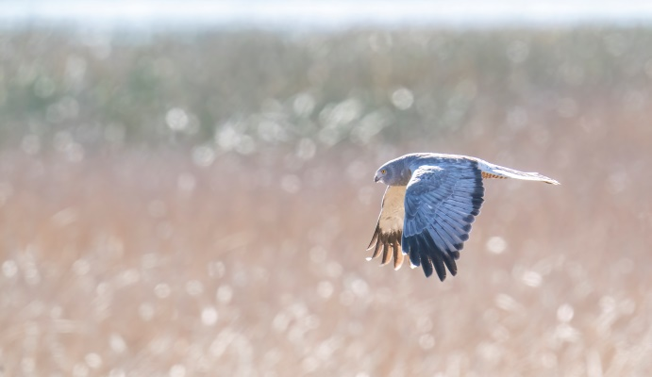
Puna Teal | Cinereous Harrier

On our way to the border with Peru we made one last stop at a very nice wetland (-15.93321, -68.75334), with many ducks, White-backed Stilts, Baird’s Sandpipers and our last addition to the bird list of Bolivia for now: Andean Negrito. After this we drove to the border for our next country and said goodbye to Bolivia. A wonderful country in its own way, which we will happily visit again next year on our way back to Chile!
Cobija – Tahuamanu Station -11.40711, -69.01799
Visited dates: 15-16 September 2023

After reading a scientific article about Goeldi’s Monkeys at Estacion Biologica Tahuamanu Station I wrote this location down while preparing our world travel. During our journey I read two reports from mammalwatchers who had been there, one of which actually observed Goeldi’s! That made me search for contacts and more info, and in the end we got permission from the Pando University to visit. One can arrange it through the manager of the station; Paulo Sergio Alvez, a.k.a. ‘Canela’ via WhatsApp (+591 7111 7679, Spanish only. He leaves only spoken messages, so use the translate app mentioned in the intro - literature).

Getting there turned out to be more difficult. We went west on the F18 not far south of Cobija (-11.13397, -68.795004) and then south after 48km (-11.321278, -69.111285). From there we knew we had to pass the community of Puerto Oro, but our map gave only one location (the wrong one). It turned out that we just had to follow the road south, until the sign of the station (-11.400952, -69.006058). There you have to turn right, into the forest. It’s about 1.5km through the forest here, and especially this part is preferably driven with a high clearance 4WD. It’s not much of a road, and even a walking trail through a Dutch forest would look better. Getting to the station (-11.407276, -69.018099) should take about 2 hours from Cobija.

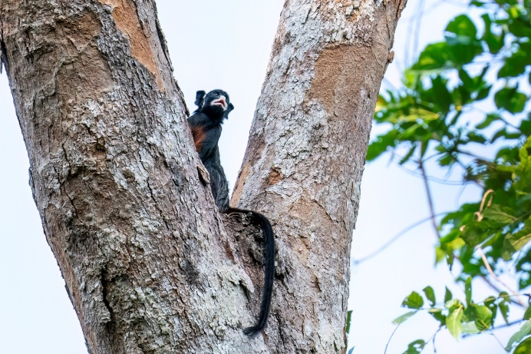 | 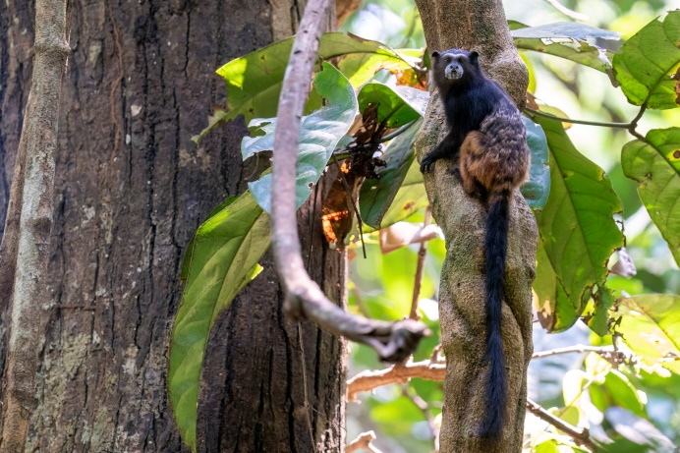
White-lipped Tamarin | Weddell’s Saddle-backed Tamarin

We arrived about 5h later than we had left Cobija due to all the wrong roads and searching we had to do. When we arrived we met Paulo, better known as ‘Canela’. He is the manager of the station and knows the primates very well. We went into the forest right away and after an hour of searching we stood still at an intersection. After 2 minutes he pointed up and there were multiple White-lipped Tamarins. They were pretty skittish and shy, and we got distant but nice views of them. Mixed with this group was Weddell’s Saddle-backed Tamarin, but no Goeldi’s. Canela was superb; he is very friendly, smiling a lot and he sees everything without binoculars and localizes sounds we didn’t even notice. One moment he stood still and took a big deep breath through his nose. I thought he was about to sneeze, but apparently he smelled the monkeys and could tell they passed through there. As our guide turned out to have sniffing dog capabilities, I was extra happy for that shower I took in the morning. He told us the monkeys pee when they are on the go, and that you can smell that, but can’t differentiate between the species. Besides mammal sounds, I apparently have another thing to study back home while preparing my travels next time.

We were happy to camp and sleep in our roof top tent, as the biological station is pretty run down. Most of the buildings don’t have roofs, and bats are the only occupants of the rooms. Better bring a tent or hammock to sleep in.

The next morning we woke up at 04.45, as we had agreed to leave at 05.00. As is often the case in these countries, we had to wake up the guide and left 15-30 minutes later. We walked for about 2km, crossing very wet grassland to another forest. Canela had said that we had a 90-95% change of seeing Goeldi’s Monkey there. According to him 8 out of 10 groups that had come for them had seen them. My calculations then add up to 80%, but still good odds. He knew there was a territory of about 100ha that the group used, and we waited and walked, waited and walked. This way we went straight through the forest, zigzagging through the territory. We only stumbled upon 2 Gray’s Bald-faced Sakis, but even though we were more than 50m from the tree, they bolted off very quickly. According to Canela there has been a family of 15 people that moved into the forest and killed many monkeys. Within a year the monkey population has declined rapidly and they have become shier.
Canela said that the Goeldi’s would only be good until 09.00-10.00 in the morning, after which it would get too warm. After 10.00 even Canela was not very optimistic anymore and mentioned multiple times how quiet the forest had become. We tried some spots, but around 10.30 I decided to turn around back to the station. On the way back Romy played the tape of the Goeldi’s and suddenly we got a response. Canela thought it was still our tape, but we looked with big eyes asking him to confirm what we thought. When he realised it wasn’t us making the sound, he started laughing hard and already gave us high fives. Despite being happy for hearing them, we obviously wanted to see them first before celebrating. It didn’t take long before some adult Goeldi’s Monkeys came hopping into view, leaping from tree to tree. Amazingly we saw 4 of them sitting on one branch! We counted at least 6 adults, 1 juvenile and 1 little baby on the back of one adult. It was still very difficult to photograph them with the harsh light and many branches, but we got amazing views!

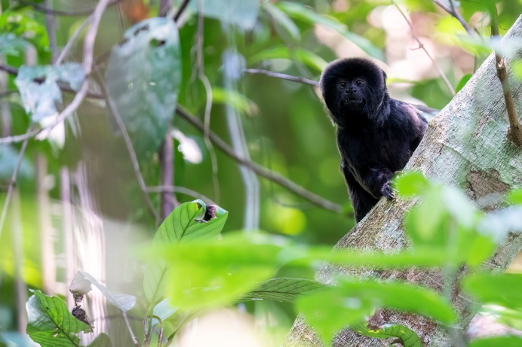 | 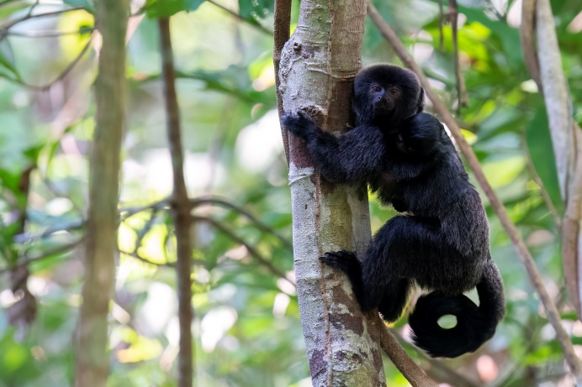
Goeldi’s Monkey | Goeldi’s Monkey
Riberalta -11.02534, -66.08329
Visited dates: 19-21 September 2023

We were happy we left the station early, as driving to Riberalta we got our first Bolivian paro (strike). They didn’t care for us being foreigners, nor for the little kids in other cars that had to spend several nights in the car. We arranged a local who said he would sneak us through at night via a good road in the woods. He didn’t show up at 19.00, and only after promising him a good reward he came to our car at 21.30. Not far into the horrible trail, on which we broke our car’s muffler, we ran into a group of angry locals who made us turn around. We were finally able to pass after waiting 50+ hours/2 full days and nights. Welcome back to Bolivia…. -_-

Southwest Riberalta
After fixing the worst damage to our muffler in Riberalta we decided to just focus on the specialty; the endemic Antpitta. For this we birded a road going through some nice forest southwest of the city. Drive towards the southwest side (-11.020771, -66.078196) and continue on this road. We parked the car on a spot where we could camp as well and walked from there (-11.02534, -66.08329). The sound of the Antpitta supposedly sounds very similar to the local sound of Amazonian Antshrike, and it’s questionable if they are separable at all in the field. This gave an extra incentive to make 100% we would see one. It didn’t take too long before we got a response and upon entering the forest we very quickly got Masked Antpitta (e) jumping on a branch nearby (-11.027607, -66.085129). Unfortunately it hopped to another branch every time I had it in the open for a photo, but we got splendid views of this amazing-looking bird! In a nearby tree we found a roosting Great Potoo (-11.027350, -66.085281). We heard another Antpitta and besides some more common birds like Moustached Wren, Fawn-breasted Wren, Flammulated Bamboo-tyrant and Guira Tanager we didn’t observe much of note bird-wise. A group of Bolivian Squirrel Monkeys went through the trees. Considering the many trails and a couple of hunters with slingshots and shotguns we came across, it seems like a miracle to observe anything mammal-wise.

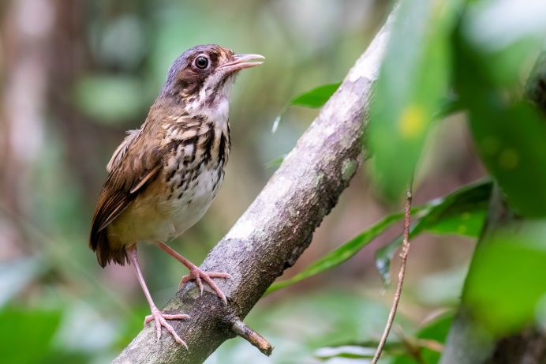 | 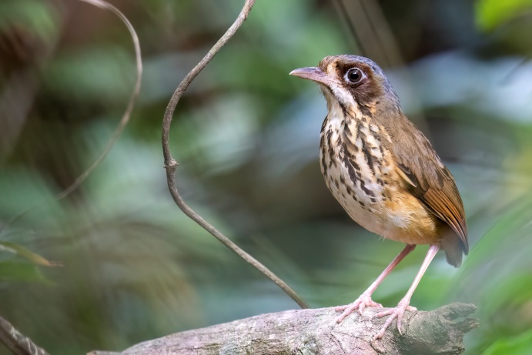
Masked Antpitta | Masked Antpitta

At night we heard Tawny-bellied Screech-owl and saw Black-banded Owl. Mammal-wise we only got some arboreal rodents, but not the hoped for Yellow-crowned Toró that is seen in the forests around here (see iNaturalist).

The next morning rain impeded most birding until 09.00. While waiting in the car we still observed Russet-crowned Crakes walking right past our car, Rufous-breasted Hermit flying towards our red taillights, Pavonine Cuckoo (HO) and Peruvian Warbling-antbird (HO). After the rains had gone we soon heard another Masked Antpitta (-11.026042, -66.083641) and again got stunning views of this individual, and this time also photos!

Northeast Riberalta
As we were all the way here in the north of Bolivia, we could just as well bird some other parts after seeing the main target. We went to a road northeast of Riberalta (-10.861509, -65.970596). We walked the trail going towards the oxbow lake for about 2.5km, but never got to the lake. We’re not sure if we were supposed to take a side trail or continue walking to reach that. At the beginning of the trail we encountered quite a lot of bamboo, with in there Yellow Tyrannulet, Sulphur-bellied Tyrant-manakin (HO), Riparian Antbird and Johannes’s Tody-tyrant. Some drumming turned out to be White-wedged Piculets. While looking up we observed Lettered Aracaris hopping in the tree tops, as well as a male White-vented Euphonia. Some cool sounds turned out to be Green Oropendola. A mixed flock is what we hoped for, but when we got one we only heard Cinnamon-rumped Foliage-gleaner. Pay attention in mixed flocks for Leaden Antwren, Grey Antwren, Sclater’s Antwren or maybe even Slender-billed Xenops. We played a local recording of Amazonian Antshrike and got some response, but were never able to lure a bird in closer.

At night we tried again for Yellow-crowned Toró, which has also been seen around here. We found Black-banded Owl, Ocellated Poorwill (HO), Tawny-bellied Screech-owl (HO) and a sleeping Amazonian Streaked Antwren. In a fruiting tree we found Brazilian Porcupine with the aid of the Lahoux Spotter Elite 35V thermal camera.

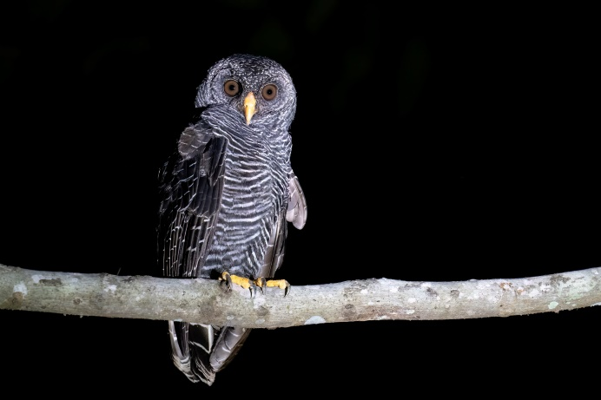 | 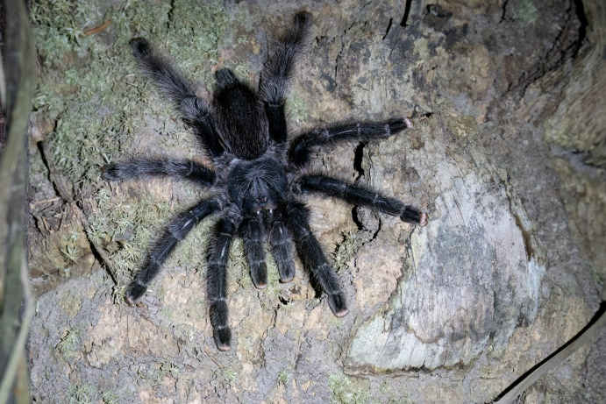
Black-banded Owl | Tarantula

We planned to drive to Trinidad to do some birding on the way, search for Seed Finches, White-winged Nightjars and migrating waders. By driving via Cochabamba we hoped to also try for Horned Curassow that has recently been (re)discovered at a certain spot. Unfortunately there were at least 3-4 roadblocks on the way towards Trinidad, forcing us to go via La Paz and giving up on those plans. We visited the Potosí mines and Salar de Uyuni, but didn’t do much birding along the way.

Salar de Uyuni | Salar de Uyuni

You made it! Thank you for reading
For all photos of our Bolivia trip, comments, compliments, any specific questions, visit and/or contact us via our website. We would love to hear from you!

If you enjoy my wildlife photos and trip reports, support my creative journey by buying me a coffee. Your generosity brings me closer to capturing impressive wildlife and untold stories

www.robjansenphotography.com/bolivia www.instagram.com/robjansenphotography

All observations made by us in Bolivia can be found on Observation.org. We observed a total of about 836 bird species and 47 mammal species in Bolivia. Click here for the: total bird list, total mammal list or the total species list.

Our Top 10 | Birds | Mammals
1 | Inti Tanager | Goeldi’s Monkey
2 | Red-fronted Macaw | Madidi Titi Monkey
3 | Palkachupa Cotinga | White-lipped Tamarin
4 | Blue-throated Macaw | Puma
5 | White-winged Nightjar | Giant Anteater with cub
6 | Black-hooded Sunbeam | Olallas’ Titi Monkey
7 | Hairy-crested Antbird | Jaguarundi
8 | Crested Eagle | Bolivian Pink River Dolphin
9 | Masked Antpitta | Rio Beni Titi Monkey
10 | Cloud-forest Screech-owl | Brazilian Porcupine
Purchasing Photos
If you like my pictures, you are in luck: they are for sale! For publication, presswork or just as artwork in your office or at home. A great memory of those great species you’ve seen during that trip! We donate 10% of our profits to WWF. My photos can be used for free for conservation or educational purposes after consultation. Have a look on my website and/or contact us via the website for the possibilities if you are interested: www.robjansenphotography.com/shop

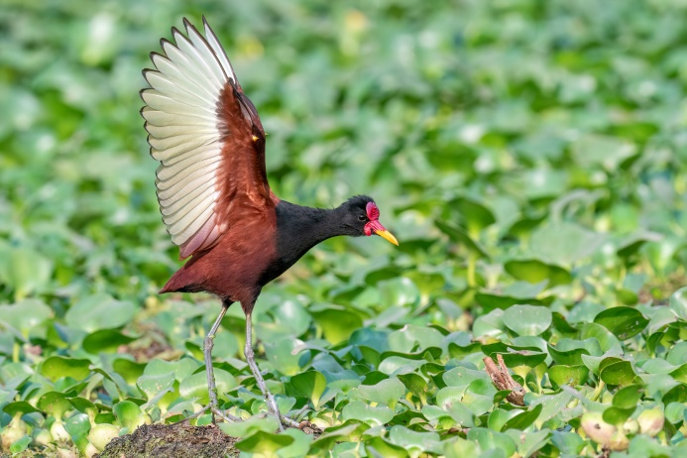 | 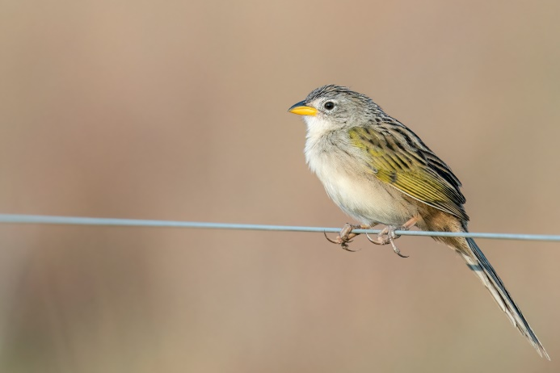
Wattled Jacana | Wedge-tailed Grass Finch

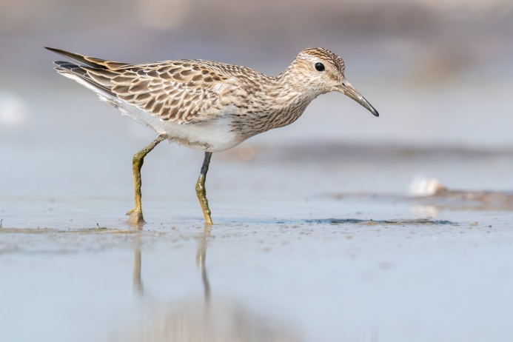 | 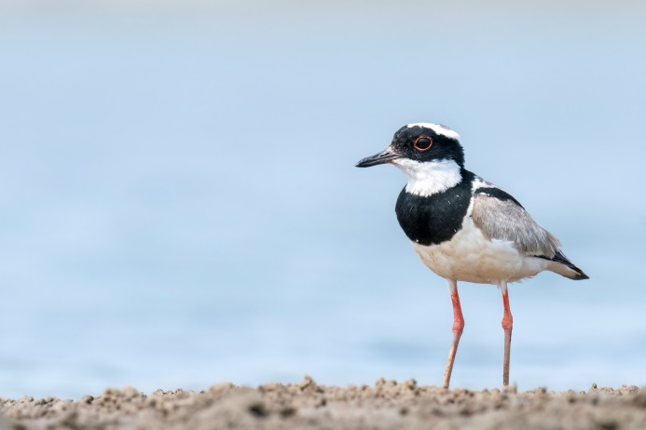
Pectoral Sandpiper | Pied Lapwing

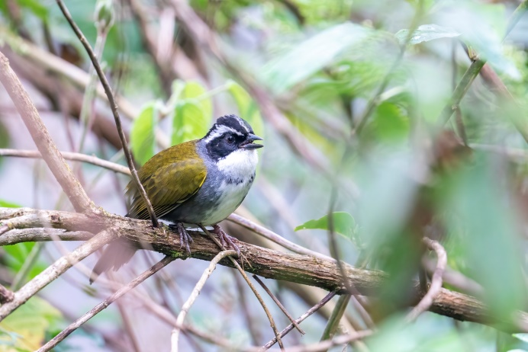 | 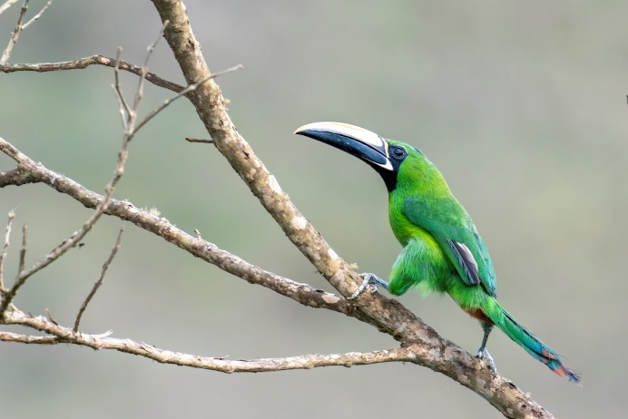
White-browed Brushfinch | Black-throated Toucanet
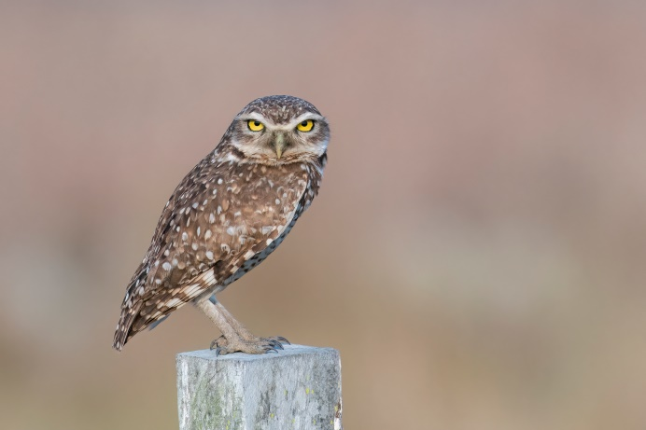 | 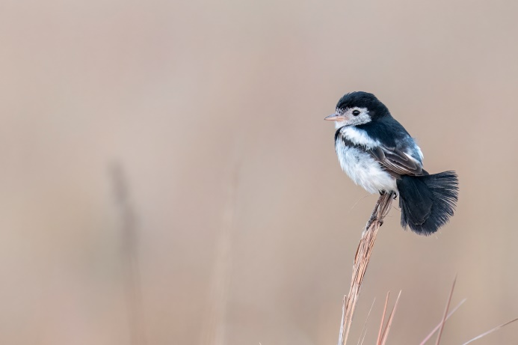
Burrowing Owl | Cock-tailed Tyrant

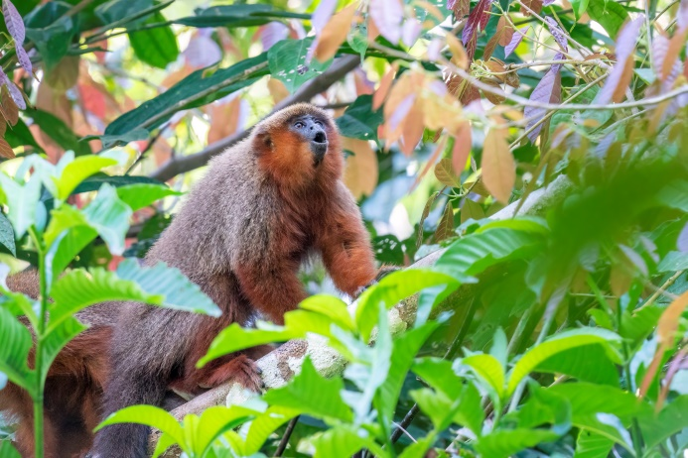 | 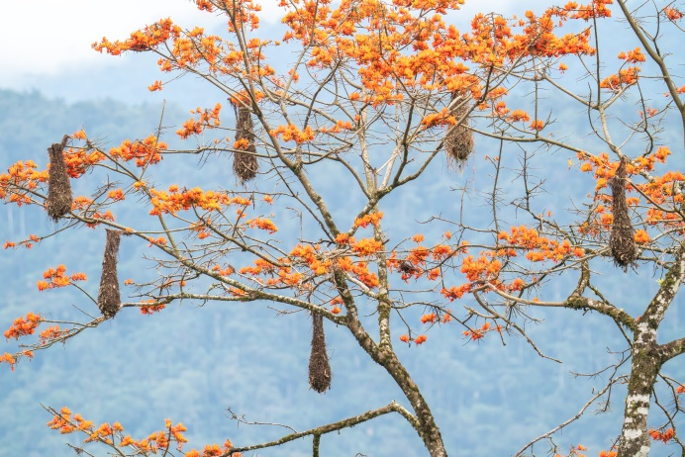
Madidi Titi Monkey | Oropendola nests in a flowering Erythrina tree

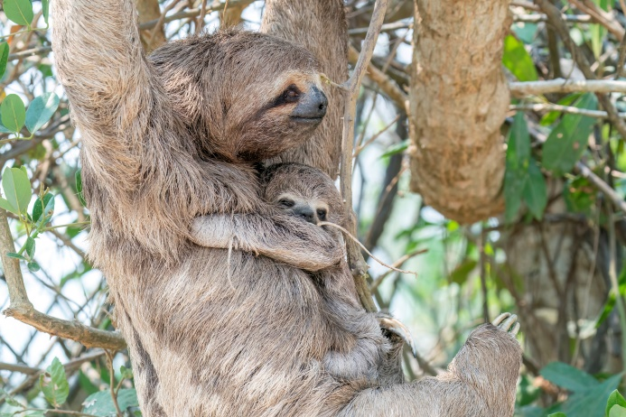 | 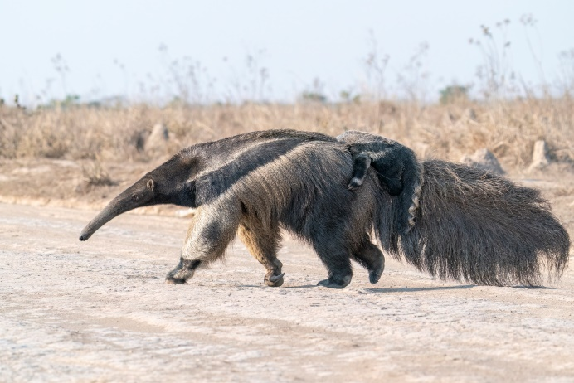
Brown-throated Three-toed Sloth | Giant Anteater with little Giant Anteater

Many report this species as Tufted/Brown Capuchin. There is a lot of discussion about the Robust Capuchins, and field ID is difficult because there is a lot of variation in a group due to age and sex. According to a recent paper the Capuchins at in the region of Santa Cruz towards the border of Bolivia should be Azara’s Capuchins.
Martinez, J., & Wallace, R. B. (2021). An update on the distribution and abundance of the endemic and threatened Olalla’s titi monkey (Plecturocebus olallae). Primate Conservation, 35, 1-8.
Barreta Pinto, J., Martinez, J., Bernal, Y., Sánchez, R., & Wallace, R. (2019). Genetic differentiation and diversity of the Bolivian endemic titi monkeys, Plecturocebus modestus and Plecturocebus olallae. Primates , 60 (6), 565-573.

